We hope you have had an enjoyable Easter break and enjoy reading about all of the exciting learning that will be taking place in Year 6 this half-term. The children have made a great start back, already working hard and staying focussed. Just a reminder that week 4 of this half term (beginning Tuesday 9th May) is SATs week. A letter will be sent out over the next week or so about a Breakfast Club for that week, and any other information you may need. As always, if you have any questions, please contact Mr Hopper or Mrs Stephenson at school.

**Maths**

We shall continue to learn about and apply all areas of Arithmetic skills, and the children are continuing to score well in weekly arithmetic tests – be sure to ask them their scores if they haven’t told you already!

The children will also be continuing to apply their skills and understanding to Reasoning and Problem Solving tasks. This requires resilience and determination – something that Year 6 has developed lots of this year!

Some children are working with other members of staff to reinforce their understanding in preparation for the upcoming SATs. This is often on top of the usual class lesson.

**Children should use Times Tables Rockstars to practise their multiplication tables.**

**English**

We have already begun reading our class novel and have got excited by the film trailer, which we hope to watch at the end of the term. Children will be fine-tuning their grammar understanding, but also becoming familiar with the characters in the book and the settings in which it takes place to be able to write descriptions. This will allow the children to show off all of the skills they have been learning this year.

In Reading, children shall be developing their strategies for understanding what they have read – our class novel is **Percy Jackson and the Lightning Thief.**

**Children should be reading a variety of material at home at least 3 times and have it recorded in their reading record. Remember that all children can access MyON, which is the online library, at home as well as in school.**

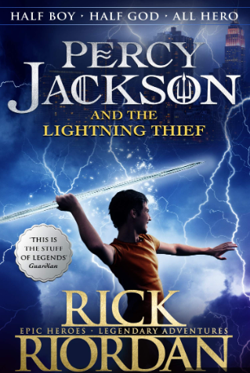

**Homework**

**Children should:**

Practise times tables on TTRS.

Read **at least** 3 times per week and record it in their reading diary.

Be working through their CGP books in preparation for their SATs. This will reinforce what has been covered in class.

**P.E**

**Our P.E day is:**

**Tuesday**

Please make sure that your child has their P.E kit at school with them all week. Many P.E lessons shall take place outside.

**Our P.E unit this half term are:**

Cricket

**Science**

We shall be continuing our topic of Evolution and Inheritance and leaning more about the characteristics that we have inherited from our grown-ups.

Children will also be learning about the origins of human beings and the stages of man. This will reinforce the learning that children did last half term about Charles Darwin.



Group Of Children Writing Clipart 2018 (With images) | Elementary ...

**Other Subjects**

In art, we will be using clay to create clay pots, recreating designs of Ancient Greece.

In computing, children will be using code.org to design and create a capstone project to share with friends.

In R.E., the children will be learning about Muslim beliefs, and how the children can motivate themselves to do good.

In PHSE, Year 6 will be discussing Mental Health, and what this means for them and for others.

.

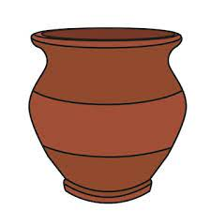 

**History & Geography**

Our History Topic this half term is the Ancient Greeks. We have already discussed how influential they were and some things that we still have in place today that originated in Ancient Greece – democracy, for example.

We shall be finding more out about the Gods and Goddesses, Trojans and the History of the Olympics. Get ready for SKA’s very own Olympic Games!



**Year 6 Curriculum Newsletter**

Summer 1

**Diary Dates & Messages**

Please add these dates to your calendar.

**May Bank Holidays Coronation Celebration**

Monday 1st May Friday 5th May

Monday 8th May

**SKA Exhibition**

**SATs Week** Thursday 25th May

Tuesday 9th – Friday 12th May

**Half Term Ends**

Friday 26th May