We hope you had a great Easter holiday break and are all refreshed ready for the new term. Please make sure you send your child with a water bottle every day. Our P.E days continue to be on a Monday and Tuesday. Children will get changed in school so please send them in their school uniform and we will organise a time for them to change into P.E kit. Please label all items of clothing to avoid anything becoming lost. If you have any questions or would like to speak to us either catch us at the end of the day or let the office know and we will get in contact. Thankyou for all your support, Mrs Hall and the Year 5 team.

**Maths**

This term we will be learning to understand Volume. We will look at what Volume means and relate it to the volume of a shape. Included in this will be our usual taught methods for multiplication.

Children will do daily rapid recall to ensure they retain previous knowledge surrounding .

We will also be working hard to learn our times tables moving on to the 4 times table.

Children should use Times Tables Rockstars to practise their multiplication tables on a weekly basis at home.

**Their log ins for TT Rockstars are on their reading records so if you need the log in for it please find them in there.**

**English**

This half term we are going to be reading a text called Streetchild. Throughout the term both our reading and writing lessons will be based around this with the aim of writing a character description, a setting description and looking closely at dialogue.

Later in the term we will be focusing on non- fiction and will look at creating our own non-chronological reports based on Barnardo.

**Please remember children should be reading a variety of material at home (including MyOn at least 3 times per week and have it recorded in their reading record by an adult. Reading records and books need to come into school every day.**

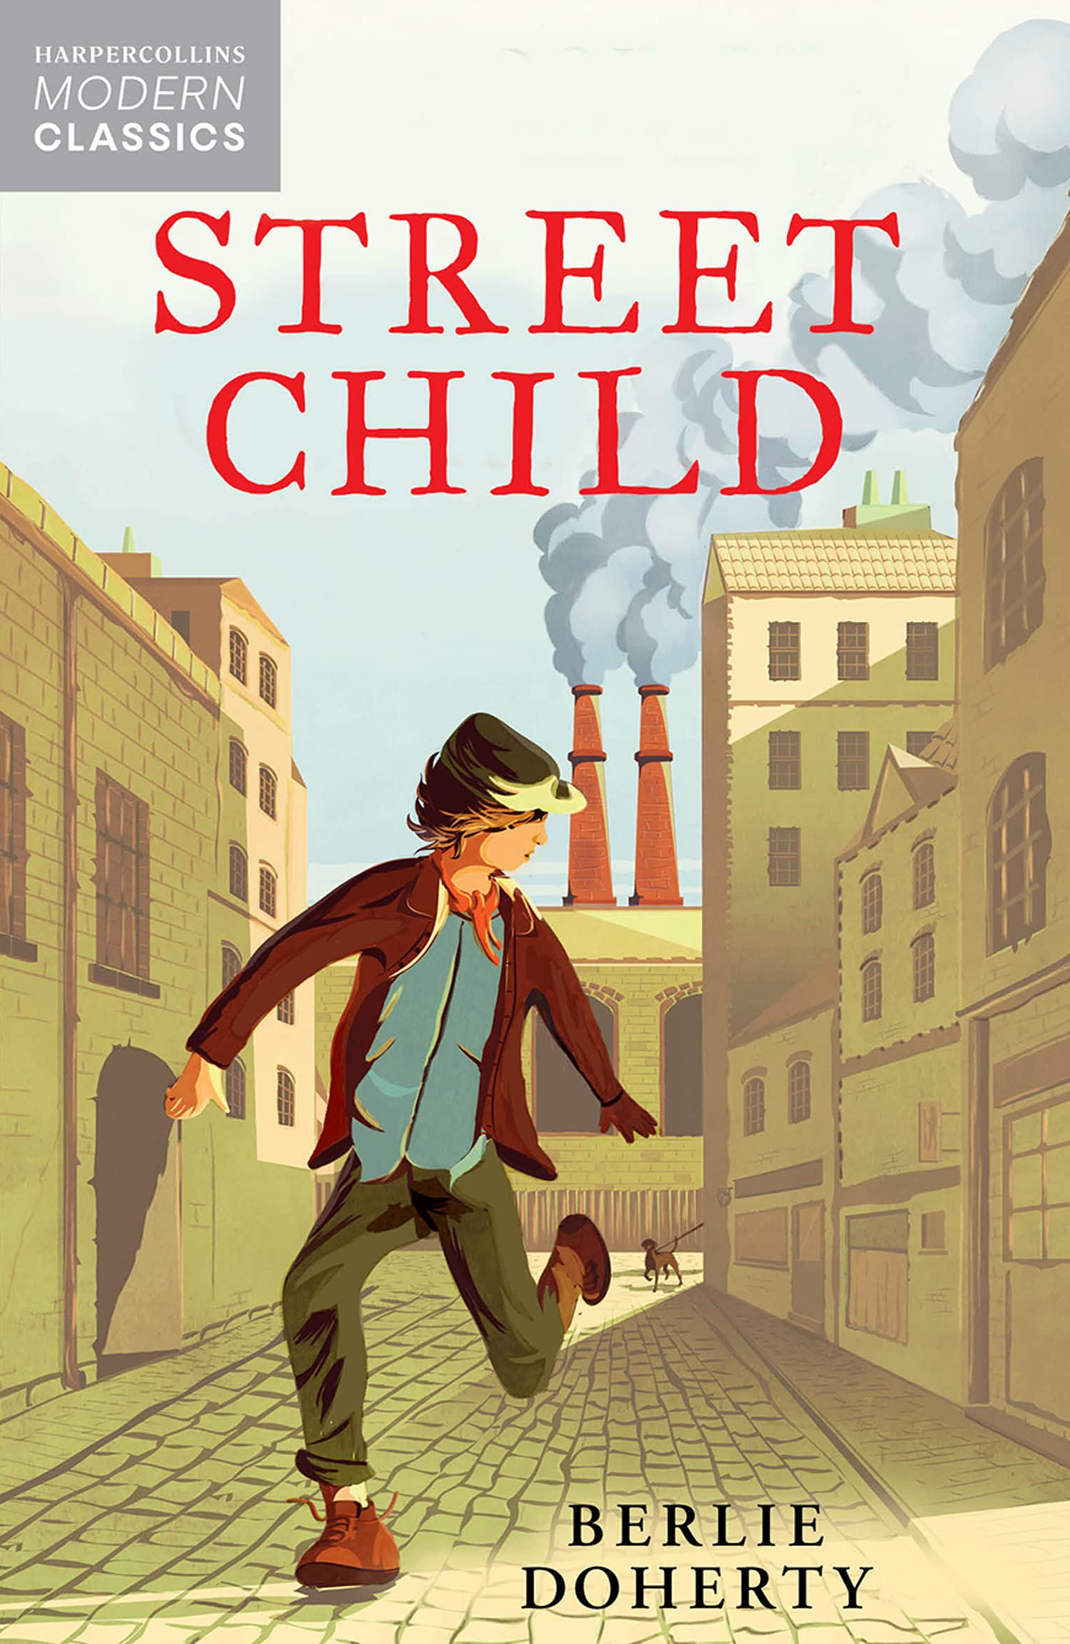

Group Of Children Writing Clipart 2018 (With images) | Elementary ...

**Year 5 Curriculum Newsletter**

Summer 1



**Diary Dates & Messages**

Please add these dates to your calendar.

Summer 1 half term

School trip: Tuesday 18th April – Beamish

Monday 24th April – Year 5 to go to South Elmsall Library

Monday 1st May – Bank Holiday

Friday 5th May – SKA Coronation Celebration day  
Monday 8th May – Bank Holiday

Wednesday 24th May – Whole School Movie Night

Thursday 25th May – SKA Exhibition

Friday 26th May – End of Summer 1 = Break up for half term.

Break up for half term: Friday 10th February 2023

Back to School: Monday 20th Februrary 2023.

**History**

We will be learning about the Victorians.

We will learn what the Victorian way of life was like as well as looking at the life of a miner. We will also look at the workhouse and find out about the role children played.

**P.E**

**Our P.E days are Monday and Tuesday**

Please make sure that your child brings their PE kit in their bag on this day and it is suitable for the weather as the lessons will take place outside. The children will be getting changed for PE at school.

On a Monday it will be outdoor P.E and we will be understanding Cricket skills.

On Tuesdays it will also be outdoor but looking at Orienteering.

** R.E**

This half term we will be studying **Hinduism.** The children will be looking at how people show **commitment to God**. They will compare this to how they show commitment to things in their life.



**Science**

This half term we will be studying **Animals including Humans.** We will look at lifecycles and what is needed to survive. We will look at the parts of the body and lifestyle/ fitness.

**PSHE**

We will be learning about our health, lifestyle and changes to our bodies.

**Homework**

**Children should:**

Read **at least** 3 times per week and record it in your child’s reading diary.

Practise times tables on TTRS.

High frequency spellings will usually be given out to learn each week on a Friday to be practiced and returned by the following Friday.