We have so many exciting projects coming up this half term. Please make sure your child comes to school with a named water bottle. Don’t forget to have all uniform labelled with a name too so it is easy to find an owner if it is lost. As it is still cold, please make sure your child has an appropriate coat in school. As always, if you have any questions about your child’s learning, catch one of us at the end of the day. Best Wishes Mrs Borthwick, Mrs Eckles and the Year 4 team.

**Maths**

This half term we will be continuing to learn all of our times tables focussing on the **6 and 9 times tables.**

Our main focus in lessons will be to understand **fractions** and **fractions greater than 1**. We will learn about mixed numbers and add and subtract fractions with the same denominator.

Children should use Times Tables Rockstars to practise their multiplication tables on a weekly basis at home.

**Their log ins for TT Rockstars have been given out, if they can’t find them please let us know and we will send them home again.**

**English**

This half term children will be building on the skills we have already learnt this year. We will be focusing on editing our work independently as this is a skill they will need in year 5.

They will be writing a **diary entry** based on a character in the book **‘Across** **the** **Roman Wall’ by Theresa Breslin** and also a **discussion text** around the Romans and if they can be considered the best inventors in history.

In reading, children shall be developing their strategies for understanding what they have read, in particular around inferring things from the text and using evidence to support this.

**Children should be reading a variety of material at home at least 3 times per week and have it recorded in their reading record by an adult. Reading records and books need to come into school every day.**

Group Of Children Writing Clipart 2018 (With images) | Elementary ...

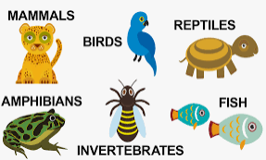 **Science**

This half term we will be starting our topic of **Living Things and their Habitats**. The children will learn how to **classify** animals with different criteria. After this, we will look at **extinction** and what animals are extinct alongside how Earth has changed over time and has affected different animals.

**Year 4 Curriculum Newsletter**

Summer 1

**Diary Dates & Messages**

Summer 1 half term

Back to School: Monday 17th April 2023

Bank holiday Monday 1st May 2023

Bank holiday Monday 8th May 2023

Break up for half term Friday 26th May 2023

Return to school Monday 5th June 2023

Visit to Murton Park Thursday 15th June 2023

Back to School:

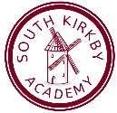

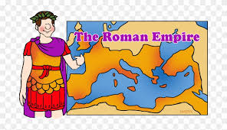

We will be learning all about the **Romans and their invasion of Britain.**

We will learn about how we know so much about the Romans from Primary and secondary sources, the key events and opinions and actions from significant people of the time.

**P.E**

**Swimming**

Swimming lessons take part every Monday. Every child is expected to take part except for medical reasons

**Our P.E day is Wednesday**

Please make sure that your child brings their PE kit in their bag on this day and it is suitable for the weather as the lessons will take place outside. The children will be getting changed for PE at school. This half term we are doing **Cricket**

**RE**

This half term we will be studying **Judaism.** They will be looking at how Jews show commitment to God in a variety of ways including how they look after the environment and how their beliefs are put into practice on a daily basis.

**Homework**

**Children should:**

Read **at least** 3 times per week and record it in your child’s reading diary. Read eBooks and do quizzes on MYON.

Practise times tables on TTRS.

Practice the class weekly spellings.

Other homework will be given out as appropriate.



**PSHE**

The children will look at Relationships and the emotions you can feel around these. This will explore relationships with different people such as family and friends.

this half term. We will look at how to **respect** others similarities and differences along side **anti bullying.**