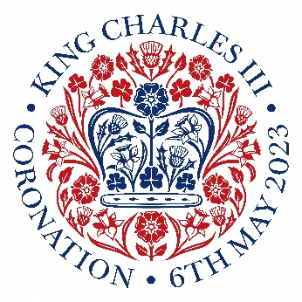

**SKA Coronation Celebration**

Dear families,

We will be marking the occasion of the coronation of His Majesty the King by holding a day of celebrations on **Friday 5th May 2023**.

Children are invited to wear red, white and/or blue for the day. There will be an assembly during the morning led by myself and the children will spend the morning learning about the event and creating red, white and blue decorations.

The children will use their decorations to dress up the ‘The SKA Street Party’ where tables will be set out in long rows outside (weather permitting). Children will eat their dinners with staff at their decorated tables with music followed by some games, street party style.

If your child would like a school dinner on this day, picnic bags consisting of a sandwich (ham, cheese or tuna), homemade sausage roll or vegetarian alternative, crisps, red white and blue bun and fruit will be available to order. **There will be no hot meals served on Friday 5th May 2023.** Children can of course bring their own packed lunch as normal if they wish.

Born in 1948, King Charles III would have been primary school age in the 1950s, so we will be holding a ‘1950s Sports Day’ during the afternoon (weather permitting) where the children will learn some new games and take part in classic activities such as sack and egg and spoon races.

We are looking forward to celebrating an event never seen before by our children or staff.

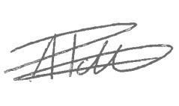

Mr Adam Potter

**Head of School**