**Computing**

* Practise on TT Rockstars.

**History**

* Build your own junk model of an aspect of ancient Egypt to present to the class (e.g. Pyramids, tombs, mummy)
* Can you find out how ancient Egyptian homes looked like, then show in pictures, words or a model?
* Can you research the ancient Egyptian hieroglyphic alphabet and write it out? Use it to write your name.
* Find out more about the construction of the pyramids. Could you also include a labelled diagram?

**Year 4 Homework**

This homework is optional. Class dojos will be awarded to children who complete optional homework.

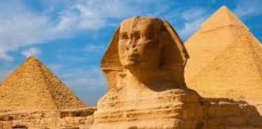

**Music**

* Plan, learn and perform a song/play/dance about the discovery of the Valley of the Kings.
* Write an ancient Egyptian rap or song. It could be a song to honour one of the Egyptian gods.

**Science**

* Make a model or a poster of an ear. Find out the names of the main parts of the ear and add labels.
* Research: What are sound waves? Who discovered them? How do they travel? Present your research as a poster, booklet or PowerPoint.
* Make a string telephone. Research how to make one by viewing: <https://www.youtube.com/watch?v=3yqB2KFwJCo> Investigate different types of string, lengths of string or size of cup. Which works best? Present your findings.
* Can you make your own instruments form junk?

**WONDERS OF THE WORLD**

**R.E / SMSC**

Research the Ancient Egyptian Gods. How many were they? What were they like?

Research and find out any religious festivals or ceremonies the ancient Egyptians would have had.

**Art and Design**

* Find and make some Egyptian recipes. You could put your best recipes in a recipe booklet to share in class.
* Design a piece of jewellery for an Egyptian prince or princess.
* Create a painting or drawing of an ancient Egyptian God using your choice of materials.

**Geography**

* Research and find interesting landmarks in Egypt on a map.
* Research holidays to Egypt. Design a leaflet to encourage tourism to the country.
* Find some interesting facts about the Nile and create a booklet to share in class.