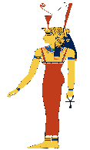
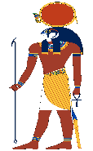
ANCIENT EGYPT
KNOWLEDGE ORGANISER
Diagram – Social structure of Ancient Egypt |  |  | Places, Objects, and Occupations in Ancient Egypt
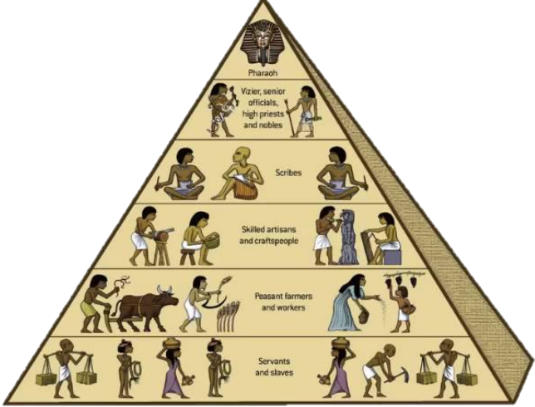  Ancient Egypt Social Class Structure  The pharaoh and those that were linked to religion were the most powerful in society. Pharaohs were believed to be gods in human form, and so they had power over everything. Skilled workers made up the middle classes. Those at the bottom had no power, and worked long hours for little return. |  |  | The Great Pyramid of Giza | 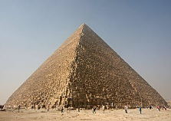 | The Great Pyramid of Giza is the oldest and largest of the Great Pyramids complex near Cairo. It is the oldest of the 7 wonders of the Ancient World, and the only one still intact. It was built for pharaoh Khufu. | Where?  Cairo, northern Egypt | Key Fact:  The Great Pyramid is 146 metres tall.
 |  |  | Valley of the Kings | 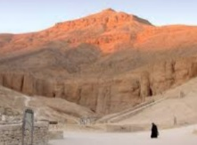 | The Valley of the Kings is a place where pharaohs were buried for nearly 500 years, between 16th-11th Century BC. Tombs were cut out of the rock. Tutankhamun’s famous tomb is located in the valley. | Where?  Banks of the River Nile, Luxor, southern Egypt | Key Fact:  The tombs were stocked with goods that the pharaoh would need in the next world.
 |  |  | The Great Sphinx | 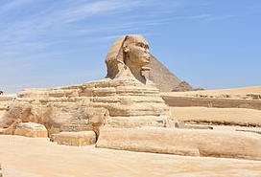 | The Great Sphinx is a large limestone sculpture of a sphinx: a mythical creature with the body of a lion and the head of a human. At some point in the past, the nose has been removed. It is one of the oldest monuments in existence. | Where?  Cairo, northern Egypt | Key Fact:  The Great Sphinx is 73 metres long from head to tail!
 |  |  | The River Nile | 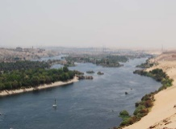 | The River Nile is the life source upon which life in Ancient Egypt flourished. It created (and still creates) banks of fertile soil for the Egyptians to live and farm on. In total it is 4,160 miles long! | Where?  North to south across Egypt (and beyond!) | Key Fact:  The Nile is often considered the longest river in the world.
 |  |  | Ancient City of Thebes | 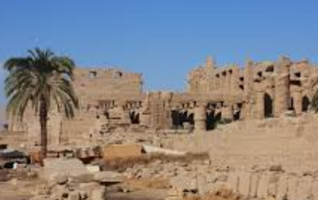 | Thebes was an Ancient Egyptian city that was the capital during the Middle Kingdom and New Kingdom. Its ruins lie within what is now the city of Luxor. | Where?  Luxor, southern Egypt | Key Fact:  It is often called the ‘world’s greatest open air museum.’
Ancient Egyptian Pharaohs
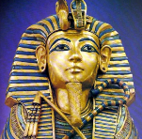  Tutankhamun  Tutankhamun is often known as ‘The Boy King’, as he ruled from when he was 9 years old, and died when he was just 18 (between 1332 and 1323BC). His golden coffin was buried in the Valley of Kings, and was surrounded by around 5,000 priceless treasures. His tomb is one of the few that was found with everything still in it (by Howard Carter in 1922), meaning he has become possibly the most famous pharaoh of all. | 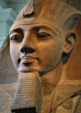  Ramesses II  Ramesses II is often considered as the greatest, most powerful Egyptian pharaoh of all – later Egyptians often called him ‘The Great Ancestor.’ He led the Egyptians into many battles (which were almost always won), and constructed many temples and buildings. His queen, Nefertari, was famed for her beauty. Ramesses II lived until the age of 92, which was an exceptionally old age back in Ancient Egyptian times. |  | Mummies | 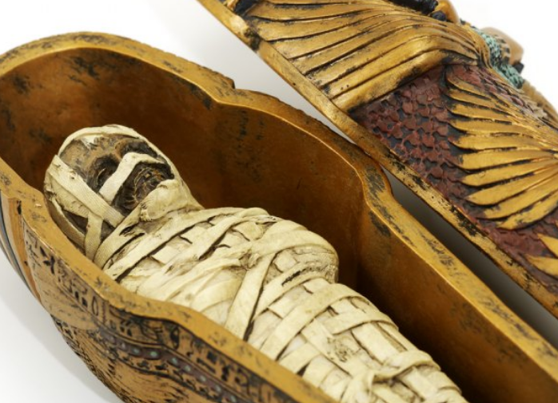 | Egyptian believed that their bodies would be needed for the afterlife. So, the rich paid for their bodies to be mummified: purified, preserved & wrapped in linen. | How?  Salts were used to dry out the body. | Key Fact:  It could take up to 70 days to mummify a body!
 |  |  | Clothes | 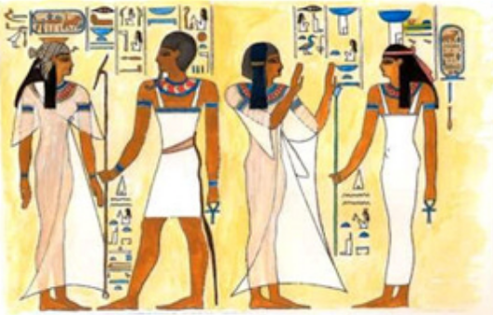 | As Egypt is a hot country, people wore lightweight linen clothes to keep them cool. Until the age of six, most children would not wear any clothes. | How?  Linen is made from the flax plant. | Key Fact:  Egyptians wore jewels & make-up to please the gods.
 |  |  | Farming | 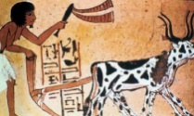 | The pharaoh made peasants farm on the fertile lands. The people of Egypt were able to grow things like wheat, barley, fruit, vegetables, figs and melons. | How?  Fertile Nile soil was ideal for farming. | Key Fact:  Every June, farming stopped as the Nile flooded.
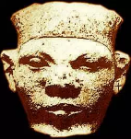  Menes  Menes is believed by many to have been the first pharaoh of Ancient Egypt (between 3407 and 3346 BC) – it is said that he did so by bringing upper Egypt and lower Egypt together for the first time. He is thought to have even worn both crowns: the white crown of lower Egypt and the red crown of upper Egypt. He built the city of Memphis and made it the capital. He may have been killed by a hippopotamus. | 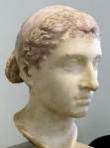  Cleopatra  Cleopatra was the last pharaoh of Ancient Egypt, living between 69 BC and 30 BC. After her father’s death, the throne was left to 18 year old Cleopatra and her 10 year old brother, Ptolemy, and the two were married. She quickly became the main ruler. It is believed that then, as ruler, she had all three of her siblings killed. She became a close ally of Julius Caesar of Rome, and had his baby. It is said that she could speak 7 languages.
 |  |  | Sports | 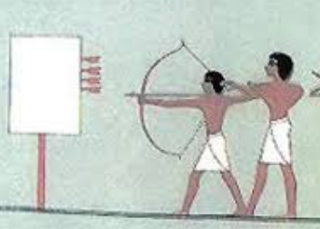 | The Ancient Egyptians enjoyed many sports. Most were designed to prepare young men for battle, for example wrestling, boxing, chariot racing and archery. | How?  Egyptians invented rules for many sports. | Key Fact:  Many sports they played are still played today!
 |  |  | Festivals | 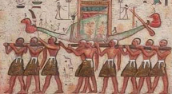 | Throughout the year the Egyptians held various festivals. Many of these were in honour of the gods, and there would be both offerings and celebrations. | How?  Some took place according to the moon. | Key Fact:  The most well-known festival was the Opet Festival.
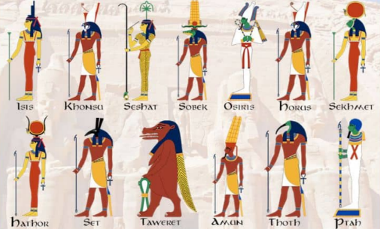  Egyptian Gods  The ancient Egytpians worshipped many gods and goddesses (there were around 2000 in total!) Some of these looked very much like humans, whereas others were part human and part animal. Animals were chosen to represent the powers of the god. Ra was possibly the most important god. He was deemed to be the god of the sun and the lord of all of the other gods. He was often presented as having the head of a hawk. Another important god was Anubis, who was the god of the dead. Jackals were often seen in cemeteries, as it was believed that they were watching over the dead. So, Anubis was often shown with the head of a dog. |  |  | Hunting | 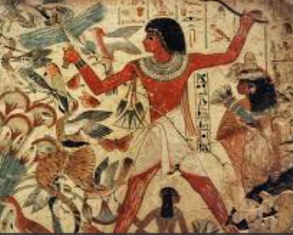 | The Egyptians hunted for both food and entertainment. This was normally an activity for the rich, however the poor also enjoyed hunting when there was time. | How?  They used spears, arrows and sticks. | Key Fact:  Even dangerous animals like lions were hunted.
 |  |  | Hieroglyphics | 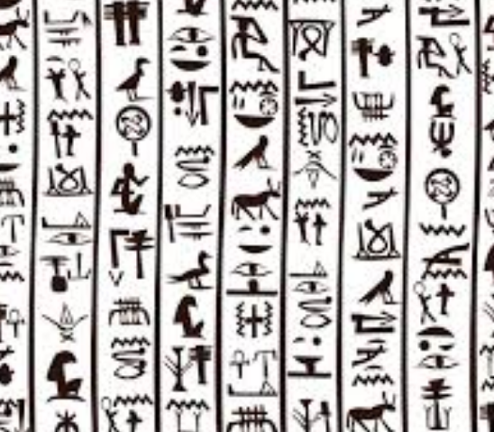 | Hieroglyphics were pictures that Ancient Egyptians used to represent objects, actions, sounds, and ideas. In total, there were more than 700 different hieroglyphics. Some of the pictures stood for whole words. | How?  Plants were crushed to make ink. | Key Fact:  Hieroglyphics were often carved onto the walls of tombs.

3o BC – Queen Cleopatra died, signalling the end of Ancient Egypt as is it is normally known
1325 BC– King Tutankhamun was buried in the Valley of Kings
1550 BC – Many of the royal tombs are built in the Valley of Kings.
3000 BC– Walled towns and villages begin to be built, made of mud brick
2500 BC – The Great Sphinx and the Great Pyramid are built at Giza.
3500 BC – Craftsman begin to create wall paintings using hieroglyphic symbols
5000 BC – Egyptians farmed sheep and cattle, and grew wheat and barley
6000 BC – People began to settle in the Nile valley
Ancient Egypt Timeline

