**Computing**

Create a PowerPoint about Queen Victoria. Be as creative as you can.

**Year 5 Homework**

This homework is optional. Class dojos will be awarded to children who complete optional homework before Friday May 28th.

**History**

Find out what kind of work Victorian children did. What jobs were they expected to do? How many hours a day did they work? Why didn’t they go to school? Research to find out as much as possible.

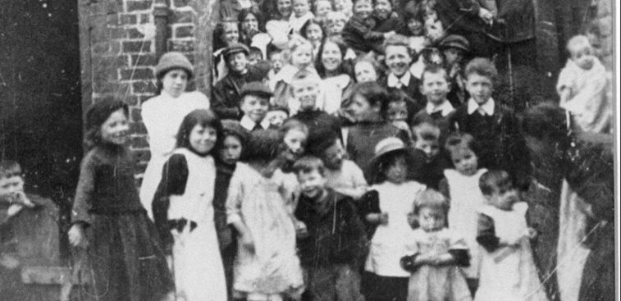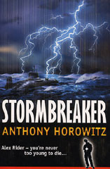

**French**

Create a poster or bunting showing the French numbers 1 – 10. You will need to include each numeral, the word for each number in French and the word for each number in English.

VICTORIAN

CHILDHOOD

**Music**

In Victorian times, street sellers would make up songs to help them when selling their goods. What would you sell if you were a street seller and can you come up with your own song about that item?

**R.E / SMSC**

Choose an inspirational figure that you admire. Write a short biography of this person and explain why you have chosen them.

**Science**

Explore some outdoor space and look for different flowers and leaves. Write down your observations (e.g. shape, size, colour of flowers and leaves that you find):

**Geography**

Then and Now – Thinking about the photographs in your classroom that show what South Kirkby used to look like, can you find these places now and take an up to date photograph, so that we can compare them.

**Art and Design**

Poor Victorian children used to make their own toys with items they had around the house. What toy can you design and create? Research Victorian toys to generate ideas before making your own.