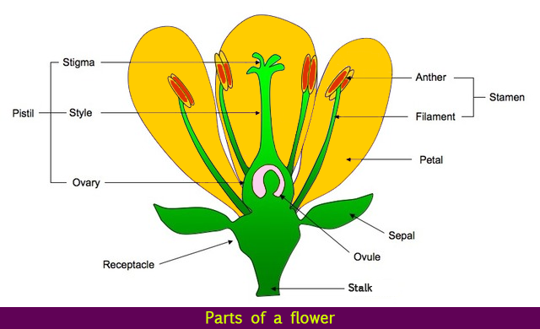

**Key Vocabulary**

**Amphibian – A cold-blooded vertebrate animal that compromises frogs, toads, newts, salamanders and caecilians**

**Asexual reproduction – Offspring get genes from one parent so are clones of their parents**

**Bird – A warm-blooded egg-laying vertebrate animal distinguished by the possession of feathers, wings, a beak and typically able to fly**

**Habitat – The natural home or environment of an animal, plant or other organism**

**Insect – A small animal that has six legs and generally one or two pairs of wings**

**Invertebrate – An animal lacking a backbone**

**Life cycle – The series of changes in the life of an organism including reproduction**

**Mammal – A warm-blooded vertebrate animal, distinguishable by the posession of hair or fur, females secreting milk for young and typically giving birth to live young**

**Metamorphosis – The process of transformation from an immature form to an adult form in two or more distinct stages**

**Sexual reproduction – Offspring get genes from both mum and dad, inheriting a mix of features from both**

**Vertebrate – An animal with possession of a backbone/ spinal column**

**Living Things**

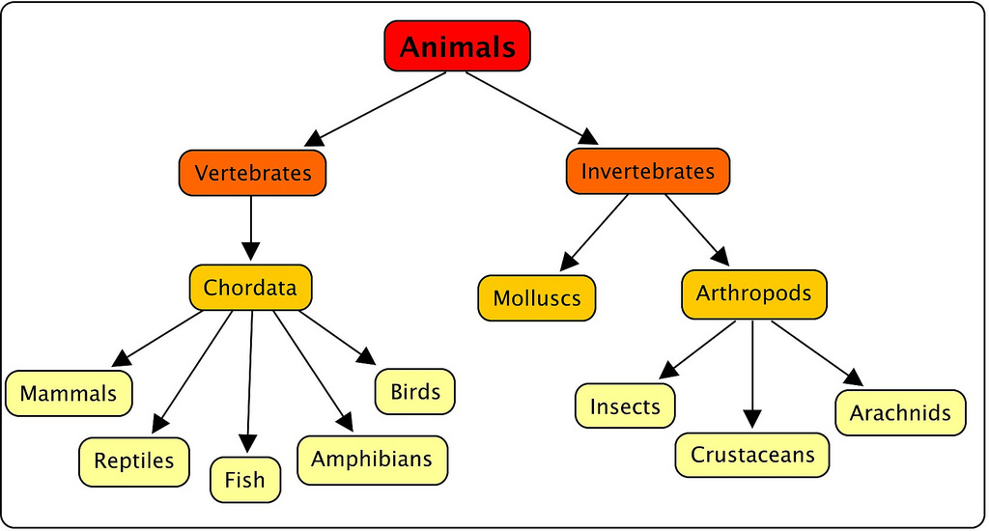

**Classification**