Knowledge Organiser
Composer – Year 4

Johann Sebastian Bach (1685-1750)
Baroque Period
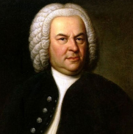
Johann Sebastian Bach was born in Germany, where his father was a town musician. By the time Bach was 10 both his parents had died, so he was brought up by his older brother, who was a church organist. Johann Sebastian Bach held three jobs in his life: first he worked for a duke, then for a prince, and finally, he became the director of music at the St. Thomas Church School in Leipzig, Germany. In spare time, Bach conducted a group of musicians who liked to get together to perform at a local coffee house.
During his lifetime, people thought Bach as just an ordinary working musician. No one really know much about his music until 100 years after his death, when another composer, Felix Mendelssohn, conducted a performance of Bach’s St Matthew Passion.
Bach is now seen as ne of the greatest geniuses in muisic history.
Music you could listen: Brandenburg Concerto No. 2: Movement 1

Antonio Vivaldi
(1678-1741)
Baroque Period
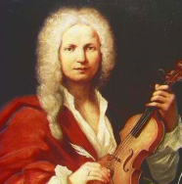
Antonio Vivaldi was born in Venice, Italy, which is where he spent most of his life. His Father taught him to play the violin, and the together would often perform together.
Antonio continued to study and practice the violin, even after he became a priest. He was called the red priest because of his flaming red hair. However, after a while, his bad asthma kept Antonio from saying Mass.
After that, Vivaldi spent all his time writing music and teaching. He taught at an orphanage for girls, and wrote a lot of music for the girls to play. People camse from miles around to hear Vivaldi’s talented students perform the beautiful music he had written.
Many people think Vivaldi was the best Italian composer of his time. He wrote concertos, operas, church music and many other compositions. In all, Antonio wrote 500 concertos. His most famous set of concertos is The Four Seasons.
Music you could listen to: The four seasons Spring

George Frederick Handel
(1685-1759)
Baroque Period
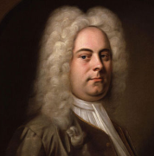
Georg Frederick Handel was born in Halle, Germany but he spent most of his professional life in England.
Even though Handel was very interested in music, his father (who was a barber and surgeon) was not. There’s a story that Handel smuggled a clavichord – a very quiet instrument- into the house so that he could practice in secret. Handel’s father insisted that his son became a lawyer, until the day that Handel sat down at the keyboard and dazzled a duke. The duke convinced Handel’s father to let his son study music.
Music you could listen to: Water Music: Hornpipe

Henry Purcell
(1659-1695)
Baroque Period
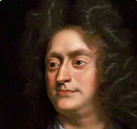
Henry Purcell, who lived during the Baroque era, was one of the greatest English composer of all time. As a youth, he studied under some of the finest English musicians of the period. IN 1679, he was appointed organist for Westminster Abbey, where he is buried.
Purcell was also an organist fot the Chapel Royal, the royal instrument keeper ans a court composer. He wrote many works for church use, including anthems and settings of the liturgy and was also known for his songs, instrumental music, one opera, Dido and Aeneas, and music for stage productions. Despite the fact that he was an organist, he wrote little for this instrument.

Franz Joseph Haydn (1732 – 1809)
Classical Period
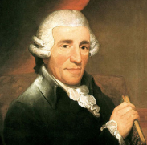
Franz Joseph Hayden was the most famous composer of this time. He helped develop new musical forms, like the string quartet and the symphony. In fact, was born in the tiny Austrian town of Rohrau, where his father made huge wooden carts and wagon wheels. His mother was a cook. When he was 8, Joseph went to Vienna to sing in the choir at St. Stephen’s Cathedral, and to attend the choir school. His younger brother Michael joined him a short time later. Joseph could never resist a playing joke, which got him in trouble at school. His younger brother was much better behaved than his brother, everyone thought he would be the more successful musician. Wrong!
At first, Haydn struggled to earn a living as a composer. Then, he got a job with a rich, powerful family named Esterhazy. It was Haydn’s job to write music for the Esterhazy princes, and to conduct their orchestra. Haydn composed symphonies, operas, string quartets, and all kinds of other music for performance at the Esterhazy court.
Hayden was also a good businessman. Music publishing made him and his music famous all over Europe. After he retired from working for the Esterhazy family, Hayden made two very successful trips to England, where his audience at the concerts of his music treated him like a superstar.
Music you could listen to: Symphony No. 94, ’Surprise’: Second Movement

Wolfgang Amadeus Mozart
(1756-1791)
Classical Period
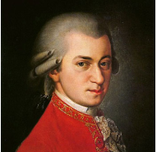
Wolfgang Amadeus Mozart was born in Salzburg, Austria, where his father Leopold was a violinist and composer. Wolfgang was a child prodigy. He composed his first piece of music at the age of five; he had his first piece published when he was seven; and he wrote his first opera when he was twelve. By the time Wolfgang was six, he was an excellent pianist and violinist. He and his sister Maria Anna travelled all over Europe performing for royalty.
When he grew up, Mozart moved to Vienna, and tried to earn a living as a pianist and composer. But he had a lot of trouble handling the fact that he was no longer a child prodigy. Mozart was still a musical genius, but after he stopped being a cute kid, people stopped making a fuss over him. Back then, musicians are treated like servants, but Mozart did not, and could not think himself as a servant.
Mozart was only 35 when he did. Dusing his short life, he composed in all different musical forms, including opera, symphonies, concertos, masses, and chamber music. Today, he is still considered a genius!
Music to listen to: Piano Sonata No. 11 in A: Turkish Rondo

