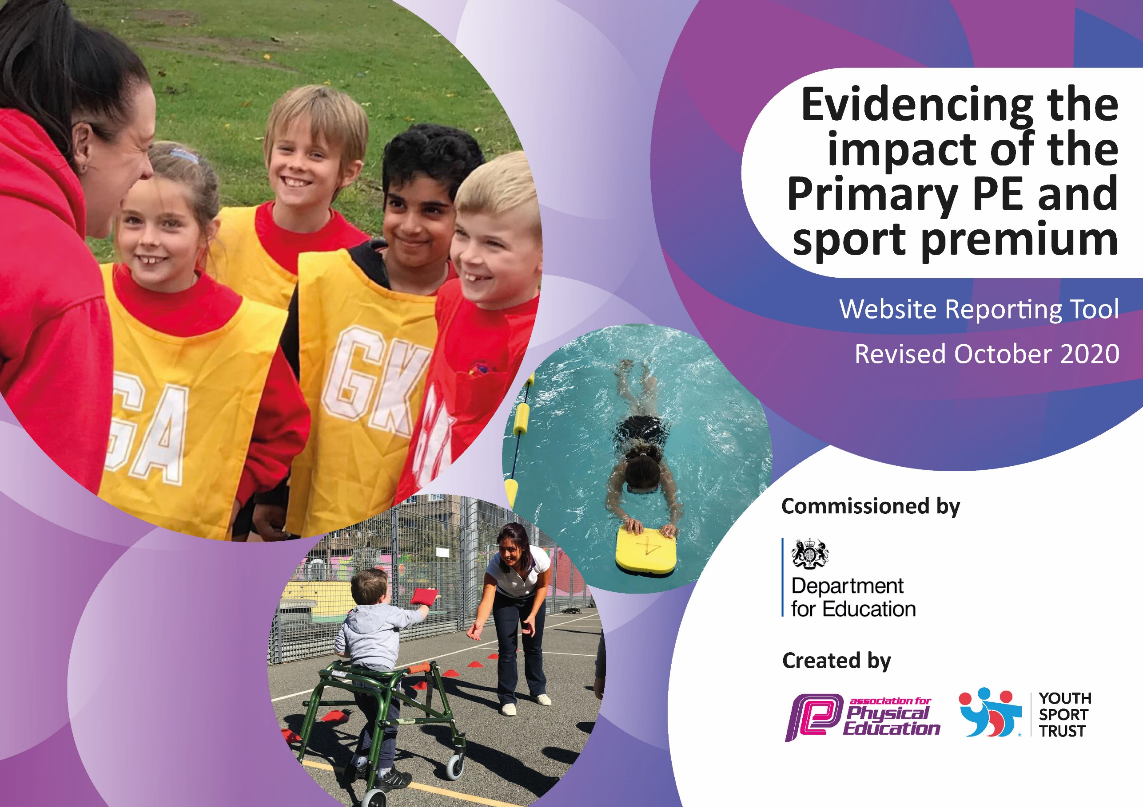
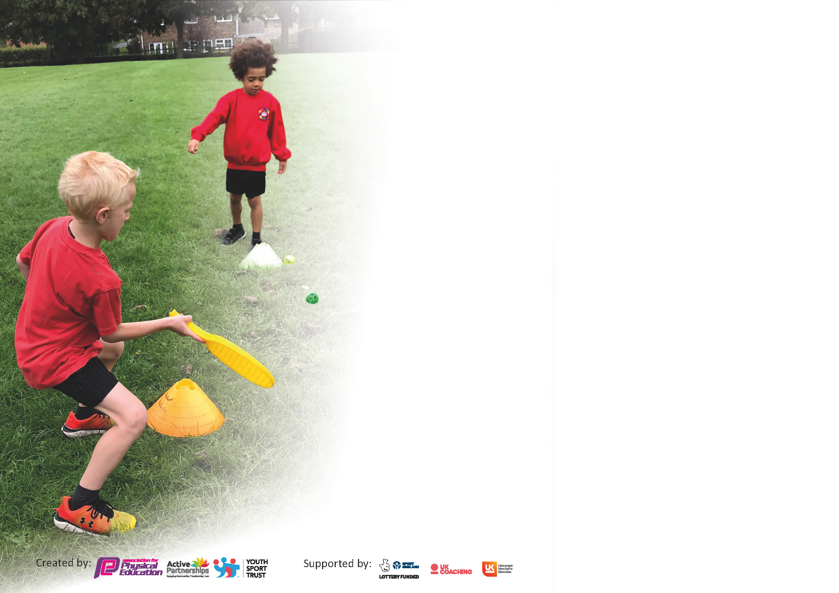

It is important that your grant is used effectively and based on school need. The Education Inspection Framework (Ofsted 2019 p64) makes clear there will be a focus on ‘whether leaders and those responsible for governors all understand their respective roles and perform these in a way that enhances the effectiveness of the school’.

Under the Quality of Education criteria (p41) inspectors consider the extent to which schools can articulate their curriculum (INTENT), construct their curriculum (IMPLEMENTATION) and demonstrate the outcomes which result (IMPACT).

To assist schools with common transferable language this template has been developed to utilise the same three headings which should make your plans easily transferable between working documents.

Schools must use the funding to make additional and sustainable improvements to the quality of Physical Education, School Sport and Physical Activity (PESSPA) they offer. This means that you should use
the Primary PE and sport premium to:

- Develop or add to the PESSPA activities that your school already offer
- Build capacity and capability within the school to ensure that improvements made now will benefit pupils joining the school in future years

Please visit gov.uk for the revised DfE guidance including the 5 key indicators across which schools should demonstrate an improvement. This document will help you to review your
provision and to report your spend. DfE encourages schools to use this template as an effective way of meeting the reporting requirements of the Primary PE and sport premium.

We recommend you start by reflecting on the impact of current provision and reviewing the previous spend.

Schools are required to publish details of how they spend this funding as well as on the impact it has on pupils’ PE and sport participation and attainment by the end of the summer term or by 31st July 2021 at the latest.

** In the case of any under-spend from 2019/20 which has been carried over this must be used and published by 31st March 2021.

We recommend regularly updating the table and publishing it on your website throughout the year. This evidences your ongoing self-evaluation of how you are using the funding to secure maximum, sustainable impact. Final copy must
be posted on your website by the end of the academic year and no later than the 31st July 2021. To see an example of how to complete the table please click HERE.
Created by: Supported by:

Please note: Although there has been considerable disruption in 2020 it is important that you publish details on your website of how you spend the funding - this is a legal requirement.
Support for review and reflection - considering the 5 key indicators from DfE, what development needs are a priority for your setting and your pupils now and why? Use the space below to reflect on previous spend and key achievements and areas for development.

N.B. In this section you should refer to any adjustments you might have made due to Covid-19 and how these will influence further improvement.
Key achievements to date until July 2020: | Areas for further improvement and baseline evidence of need:
Physical Activity: all children have access 30 minutes of high-quality physical activity each day (KPI 1).  Physical Education (PE): all children have access 2 hours per week of high-quality PE (KPI 1).  School Sport: all children have access to high quality physical activity after school and are given opportunities to engage in high quality competitive sport (KPI 5).  Health and Well-Being: all children have a good understanding of how to lead healthy lifestyles (KPI 1).  Activity Provision: Improvements to the playground and outdoor area have improved the access to outdoor provision and the physical development of children during break and lunch times (KPI 1). | To use PE and Sport in school to promote academic improvement:  Continuation of the CPD work is also required to ensure that staff confidence and expertise continues to improve (KPI 3)  Continuation of all children experiencing a broader range of sports and activities offered through school (KPI 4)

Did you carry forward an underspend from 2019-20 academic year into the current academic year? YES/NO * Delete as applicable

If YES you must complete the following section
If NO, the following section is not applicable to you

If any funding from the academic year 2019/20 has been carried over you MUST complete the following section. Any carried over funding MUST be spent by 31 March 2021.
Academic Year: September 2020 to March 2021 | Total fund carried over: £ | Date Updated:  November 2020
 |  |  |  | Total Carry Over Funding:
 |  |  |  | £
Intent | Implementation |  | Impact
Your school focus should be clear how you want to impact on your pupils. | Make sure your actions to achieve are linked to your intentions: | Carry over funding allocated: | Evidence of impact: How can you measure the impact on your pupils; you may have focussed on the difference that PE, SS & PA have made to pupils re-engagement with school. What has changed?: | Sustainability and suggested next steps and how does this link with the key indicators on which you are focussing this academic year?:

Meeting national curriculum requirements for swimming and water safety.

N.B Complete this section to your best ability. For example you might have practised safe self-rescue techniques on dry land.
What percentage of your current Year 6 cohort swim competently, confidently and proficiently over a distance of at least 25 metres?  N.B. Even though your pupils may swim in another year please report on their attainment on leaving primary school at the end of the summer term 2020. | % Year 6 to swim summer term due to covid restrictions.
What percentage of your current Year 6 cohort use a range of strokes effectively [for example, front crawl, backstroke and breaststroke]? | % Year 6 to swim summer term due to covid restrictions.
What percentage of your current Year 6 cohort perform safe self-rescue in different water-based situations? | % Year 6 to swim summer term due to covid restrictions.
Schools can choose to use the Primary PE and sport premium to provide additional provision for swimming but this must be for activity over and above the national curriculum requirements. Have you used it in this way? | Yes/No

Action Plan and Budget Tracking
Capture your intended annual spend against the 5 key indicators. Clarify the success criteria and evidence of impact that you intend to measure to evaluate for pupils today and for the future.

Academic Year: 2020/21 | Total fund allocated: £19643 | Date Updated: November 2020
Key indicator 1: The engagement of all pupils in regular physical activity – Chief Medical Officers guidelines recommend that primary school pupils undertake at least 30 minutes of physical activity a day in school |  |  |  | Percentage of total allocation:
 |  |  |  | %
Intent | Implementation |  | Impact
Your school focus should be clear what you want the pupils to know and be able to do and about  what they need to learn and to  consolidate through practice: | Make sure your actions to achieve are linked to your intentions: | Funding allocated: | Evidence of impact: what do pupils now know and what can they now do? What has changed?: | Sustainability and suggested next steps:
Building on and using the progress made from last year, build-on the opportunity for engagement and to ensure consistent sustainability, with a sharper focus on the small number of children who are still to engage. | • To continue to promote the participation of sporting activities throughout the school through carefully planned provision.  • Sports leaders used to ensure that children have the opportunity to access a range of skills throughout each PE session.  • Sports coaches are used to give all children the opportunity to take part in structured physical activities during the school day.  • Ensure that an inclusive sports curriculum is embedded within school, giving the opportunity for all children to participate in sports.  • To offer an enhanced curriculum after school that caters for children across school.  • Active lessons and activity breaks throughout the school day. | Playground Equipment  Sports Equipment  Approx: £2000 | Children given quality PE provision across the school for 2 hours every week.  An increase has been seen in the participation of vulnerable groups due to more accessibility with PE.  Monitoring and pupil chats, when observed, all children are actively engaged in their PE learning in most lessons.  Through daily observations and monitoring by staff, children are engaged and active during lunchtime and break time using the school initiative for children to create their own playground games.  All children are able to access a range of equipment suitable for their physical and health needs, resulting in a raise in participation of games and activities during these times. | To train year 5 and 6 as young sports leader to provide sporting activities at break and lunchtime.  A renewed initiative (after covid) to provide afterschool clubs to reach inactive pupils.  Introduction of PE star of the week in order to engage all pupils.
Key indicator 2: The profile of PESSPA being raised across the school as a tool for whole school improvement |  |  |  | Percentage of total allocation:
 |  |  |  | %
Intent | Implementation |  | Impact
Your school focus should be clear what you want the pupils to know and be able to do and about  what they need to learn and to  consolidate through practice: | Make sure your actions to achieve are linked to your intentions: | Funding allocated: | Evidence of impact: what do pupils now know and what can they now do? What has changed?: | Sustainability and suggested next steps:
Building on the previous year, the rise of PE and Sports provision will impact pupil’s and whole school improvement, with a specific focus on:  • Whole School improvement targets  • Attendance and behaviour and social – sports clubs for them. | • To continue to deliver high quality teaching throughout the whole school.  • Continue to monitor the planning, differentiation and challenge provided to ensure children receive high quality PE teaching.  • Give children the opportunity to become ‘excited’ about sport and encourage them to fulfil any aspirations they may have to participate in any new sports.  • Staff to be given CPD PE sessions with the sporting coach to develop their confidence and skills in delivering the PE Curriculum.  • Increase the promotion of sporting events in school through assemblies, through displays and the opportunity to work with outside agencies.  • PE Lead to monitor the quality of staff teaching of PE and plan support if required.  • Breakfast club and Lunch time clubs for students and target groups of students to attend these clubs to help them improve attendance, behaviour and academia. | Staff CPD  Staff to run sports clubs  Staff to run lunchtime clubs  Approx: £5000 | All children are engaged with PE and respond to high levels of challenge in sessions. Building on consistently improving participation from previous years growing this year to almost 99% (based on the number of children with the correct PE uniform and participating in PE sessions per week)  PE assemblies promoting virtual competitions and sporting charity events; such as the reindeer run as well as assemblies working on mental health, goal setting and health eating.  Teachers leading a dream big day talking about their sporting achievement to inspire children to try new sports.  PE lead monitoring the quality to make sure it stays at a high standard. | Increased self and peer assessment within PE lessons.

Key indicator 3: Increased confidence, knowledge and skills of all staff in teaching PE and sport |  |  |  | Percentage of total allocation:
 |  |  |  | %
Intent | Implementation |  | Impact
Your school focus should be clear | Make sure your actions to | Funding | Evidence of impact: what do | Sustainability and suggested
what you want the pupils to know | achieve are linked to your | allocated: | pupils now know and what | next steps:
and be able to do and about | intentions: |  | can they now do? What has
what they need to learn and to |  |  | changed?:
consolidate through practice:
All staff to undertake a programme of CPD to develop their skills and understanding of a range of sports and physical activity and the potential benefits of pupil learning:  • More experienced staff to take more of a coaching role within the CPD sessions.  • Less experienced staff to be mentored by the sporting coach and experience staff when delivering sports and PE sessions. | ALL teachers will enhance their skills and understanding of sports teaching through:  • Targeted CPD provided in house by the sports leader  • Team teaching sessions provided by PE leaders in school and also professional coaches from outside sports providers.  • Sports observation and evaluation sessions to develop reflective practice in sports and PE. | Staff CPD  Staff Training  Approx: £5000 | The planning and assessment have been more focused with targets and skills linking with the national curriculum – evidenced within teachers planning and assessment.  Photographic and video evidence, during PE sessions has shown an impact on the children’s learning through competency of skills during the sessions.  Children are more able to apply these learnt skills during games within PE lessons and during events throughout the year. | More opportunities to attend training for staff CPD to be organised.
Key indicator 4: Broader experience of a range of sports and activities offered to all pupils |  |  |  | Percentage of total allocation:
 |  |  |  | %
Intent | Implementation |  | Impact
Your school focus should be clear | Make sure your actions to | Funding | Evidence of impact: what do | Sustainability and suggested
what you want the pupils to know | achieve are linked to your | allocated: | pupils now know and what | next steps:
and be able to do and about | intentions: |  | can they now do? What has
what they need to learn and to |  |  | changed?:
consolidate through practice:
Additional achievements:  Within an academic year, all children will have the opportunity to experience a high-quality range of sport, with a focus on children who are not participating/excelling in sports. | • Encourage flexibility of the PE curriculum map so that PE sessions can reflect the particular sports.  • Ensure that the events offered by the Trust and Pyramid ensure a wide range of opportunities are available for all children  • Monitor and review of after-school sports clubs.  • Sign up to exciting initiatives to enhance the children activity levels.  • Work closely with the head of PE at our Trust PE Leader to develop our PE coordinator and sports coach.  • Provide events and opportunities for all children at South Kirkby to take part in. | Sports Equipment  Transport  Events  Approx: £3000 | Due to a broad pe curriculum children are gaining more confidence in a wide range of different physical education skills with confidence and improved coordination.  Evidence of videos/photographs have shown children performing sports skills from the curriculum.  Children have been able to apply these skills during games – impacting on their effectiveness.  Taking part in virtual sports competitions opportunities.  Exciting fundraising initiatives provided for children in order to encourage participation and enjoyment. | To continue looking for a wider range of opportunities for all children regardless of ability; for example flag bearing and the Leeds Rhinos Dance Initiative.

Key indicator 5: Increased participation in competitive sport |  |  |  | Percentage of total allocation:
 |  |  |  | %
Intent | Implementation |  | Impact
Your school focus should be clear | Make sure your actions to | Funding | Evidence of impact: what do | Sustainability and suggested
what you want the pupils to know | achieve are linked to your | allocated: | pupils now know and what | next steps:
and be able to do and about | intentions: |  | can they now do? What has
what they need to learn and to |  |  | changed?:
consolidate through practice:
Improved technical skills and fitness levels when taking part in inter and intra school tournaments.  Increased ability to work collaboratively and to show commitment to a team.  Better sense of feeling part of a community.  Internal competitions – inter-house groups.  Parental involvement in sports. | • To increase the % of children taking part in intra and inter school competitions.  • To continue to increase the participation in inter school competition by creating further opportunities for children through the creation of A, B and C Teams entered into planned tournaments.  • Working with local teams in and around the local area.  • Working specifically with children and parents at workshops where parents | Transport  Sports equipment  Events  Approx: £3000 | Sports taken part in:  Year 3, 4, 5 + 6 Cross Country. 99% of children taking part, only missing due to injury.  Taking part in virtual competitions throughout the year.  Due to Covid-19, opportunities have been limited to partake in competitive sport. However, the school initiative to deliver inter-class competitions is proving successful. | To continue to provide in school competitions.  Government guidelines allowing, working with local schools to reintroduce competitions.  Looking to offer non-core sporting activities and competitions, for example botcha and new age curling.

Signed off by
Head Teacher:
Date:
Subject Leader:
Date:
Governor:
Date:

