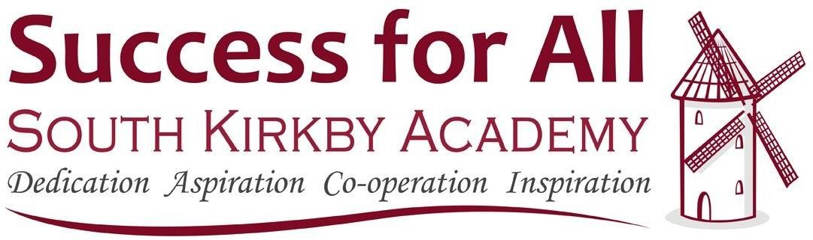

Uniform Policy 2019/2020

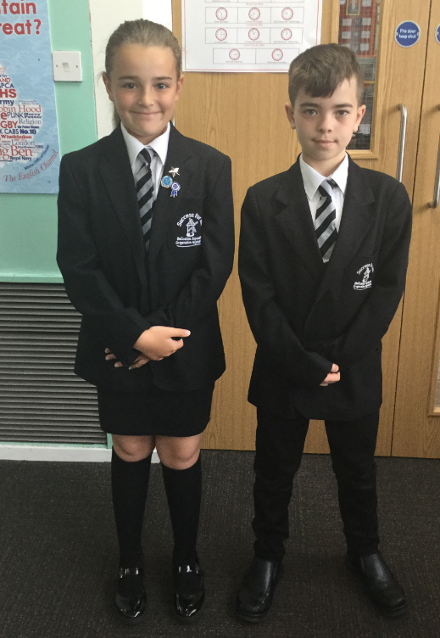
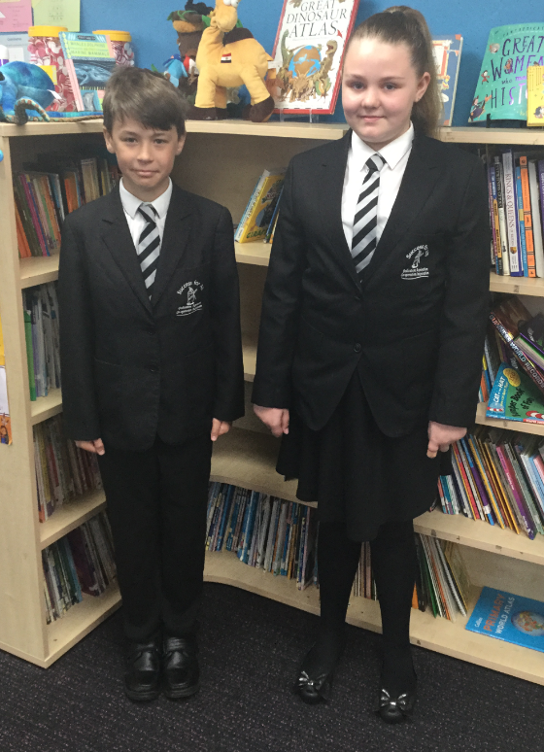

Uniform Policy
Our uniform policy reflects our values and reinforces our school’s culture of high expectations and academic achievement. All pupils must dress according to the uniform policy. Our School Uniform is important to us. It is one way in which we identify ourselves as a school community and it promotes a strong, cohesive school identity which supports high standards and expectations in all areas of school life. It promotes harmony between different groups represented in the school, and it enhances security.

Smartness and high standards of appearance are expected at all times.

We have a required school uniform for several reasons:

- Uniforms unite the school. Pupils make a commitment that when they put on their South Kirkby Academy uniform they will abide by the rules of the community.
- Uniforms reduce distractions. We are focused on achieving success. When pupils are allowed to wear their own clothing, there is the potential to talk about fashions and styles rather than learning.
- Uniforms make us all equal. Whether families have high incomes or low incomes, the pupils come to school looking the same way. No one has to feel bad about the clothes they have or don’t have.
- Uniforms look professional. Pupils look neat and ready to learn.
- Uniforms comply with the Health and Safety Policy and Safeguarding Policy.

We ask parents and carers to support all decisions by school staff regarding whether or not clothing is appropriate or inappropriate for school.

Non-compliance with the Uniform Policy
- Pupils will not be allowed to attend class if they are not dressed in the appropriate uniform.
- Parents and carers of pupils that do not wear their uniform correctly will be contacted and asked to bring a uniform.
- The parent or carer will then be expected to collect their child from the school office at the end of the school day to discuss the issue.
- Pupils whose parents refuse to bring the appropriate uniform in will be educated away from their class and parents and carers written to formally unless there are special circumstances.

There may be good reasons why a child is not wearing school uniform. In this case, parents and carers should share the reasons with the Headteacher either in person or by letter. The school will always be considerate in trying to establish why a pupil is not wearing the correct uniform. Pupils will not be made to feel uncomfortable, nor discriminated against, because their parents are unable to provide them with the required items of school uniform. In line with our culture of honest conversation with parents and carers, we encourage discussion with the school at the earliest opportunity if there are any difficulties

There will be occasions when the school decidesthat school uniform is not appropriate e.g. when taking part in a physical activity day, or wearing different clothes as a part of a fund raising event. Parents and carers will be notified in advance of what is the revised dress code on these days.

Racial Equality & Equal Opportunities
All children have equal access to wearing school uniform regardless of their culture, race, religion, gender, disability or ability. We ensure that the set uniform respects other policies such as Equality, Race relations, sex discrimination and allows for individual sets of circumstances of all groups and individuals. South Kirkby Academy is committed to creating a positive climate that will enable everyone to work free from racial intimidation and harassment and to achieve their full potential.

UNIFORM DETAILS
Autumn/Winter/Spring  Knitted Black V-neck jumper/cardigan/tank top*  White cotton buttoned shirt (No round collars or aertex tops)  School Tie*  Black skirt/Trousers/Pinafore dress/Skirts or Culottes Black or Grey tights  Black, Grey socks  Black Blazer* (optional in Years 3 and 4, compulsory in Years 5 and 6)  Summer  White, Grey or Black socks Plain baseball cap  PE Kit  Indoor & Outdoor (Summer)  Grey School T-shirt with logo  Plain black Shorts – not lycra leggings or cycling shorts  For PE appropriate footwear is essential:  Socks and trainers  or plimsolls should be worn or bare feet for gymnastics only. | .

Outdoor (Winter)
Grey School T-shirt with logo
Plain black tracksuit bottoms/sports trousers (no tight lycra or stretch materials please)
Tracksuit top/sports jacket/sweatshirt or hoodies – (outdoor PE only) Socks and Trainers with grips and laces for support

Gloves and plain woolly hats may also be worn

*Can be purchased from the school office prices available on request. We also have an ordering system set up for ALL uniform:

www.activ-apparel.co.uk , 07936762428
All items of uniform should be clearly marked with the child’s name with wash proof ink!

Outdoor clothing
Children should bring a coat to school each day, apart from during the hotter weather. Smart, showerproof, jacket-style coats, are advisable.

Footwear
Children must wear closed toed, hard-soled shoes. Shoes must also be plain black with a flat sole. Boots are not allowed inside of school as children’s feet become hot and uncomfortable especially if sitting on the floor during assemblies or other special events. Furthermore, many boots have sharp buckles and decorative objects attached which are above the ankle and pose a health and safety risk. For this reason, boots are not allowed in school. In adverse weather conditions, children may wear boots to school, but must change into appropriate school shoes once inside the building. Children may wear all black closed-toed sandals as part of the summer uniform only. Open-toed sandals should not be worn, even in the Summer Term. In support of the School Uniform Policy at Secondary School, black trainers or trainers with sports emblems are not allowed.

Footwear Examples
4
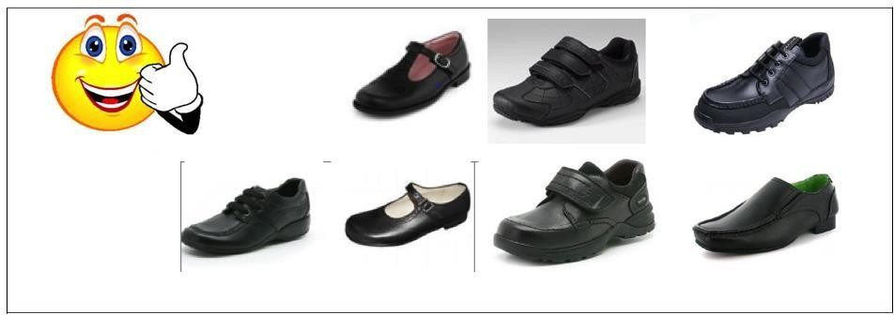
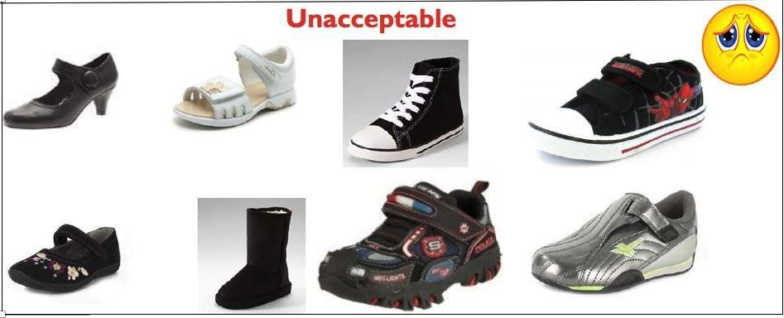
Acceptable

Unacceptable
Pupils are not allowed to wear hats, headscarves, or any other head covering inside the school building unless it is due to religious or cultural reasons. Any head covering for religious or cultural values or hair accessories that are worn such as slides, ribbons, bobbles etc. should be simple and BLACK in colour to match the uniform. A plain school baseball hat is available for both summer outdoor wear. These can be purchased from the school office.

Skirts
- Skirts must be knee length or sit just above the knee line.
- Tight/Lycra skirts or leggings must not be worn.

Hairstyles
Pupils’ hair should be neatly groomed and professional at all times. Long should be tied back neatly. This is not only for reasons of smartness, appearance and health and safety: Pupils’ faces should not be obscured as the teacher may not be able to judge their engagement with learning and to secure their participation in discussions and practical activities. Pupils may not wear designs or words cut into their hair or permanent or temporary coloured hair.

Fingernail Polish or Make-Up
Pupils are not allowed to wear fingernail polish or false nails. Make-up is not allowed, including false eyelashes or Tinted eyebrows.

Jewellery/Accessories
Pupils may not wear any jewellery except for:
- One watch only (no sound effects or games).
- One pair of stud earrings worn in the lower ear lobe. All studs must be removed for PE or taped. Please note that the school will be unable to take any responsibility for any watches or jewellery that are lost.

Body Piercing and Tattoos
Body piercing is prohibited, with the exception of single, standard ear piercing. No other forms of body piercing will be allowed for any pupil. Pupils are not allowed to have tattoos of any kind on their body.

Naming Clothing and Property
VERY IMPORTANT – Please ensure all clothing and property is clearly marked so that lost articles may be easily traced and returned. The school cannot accept responsibility for loss or damage of pupils’ property and valuables.

Lost Property
We endeavour to return all named property. All unclaimed lost property is disposed of at the end of term and given to a local children’s charity.

Last updated April 2019 and agreed by the Governing Body

