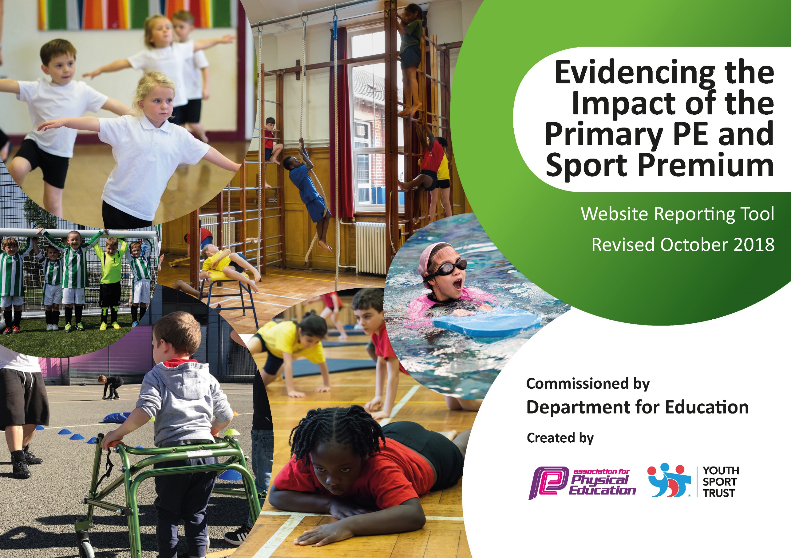
SKA Academy Sports Premium Impact and Evidence Report 2018-2019
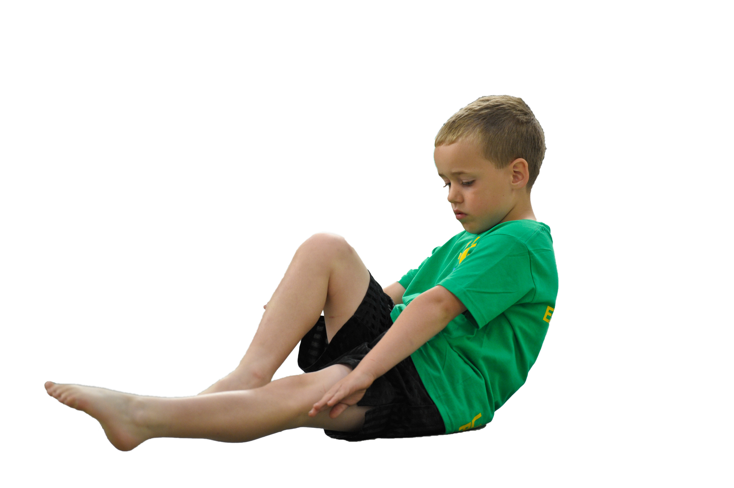
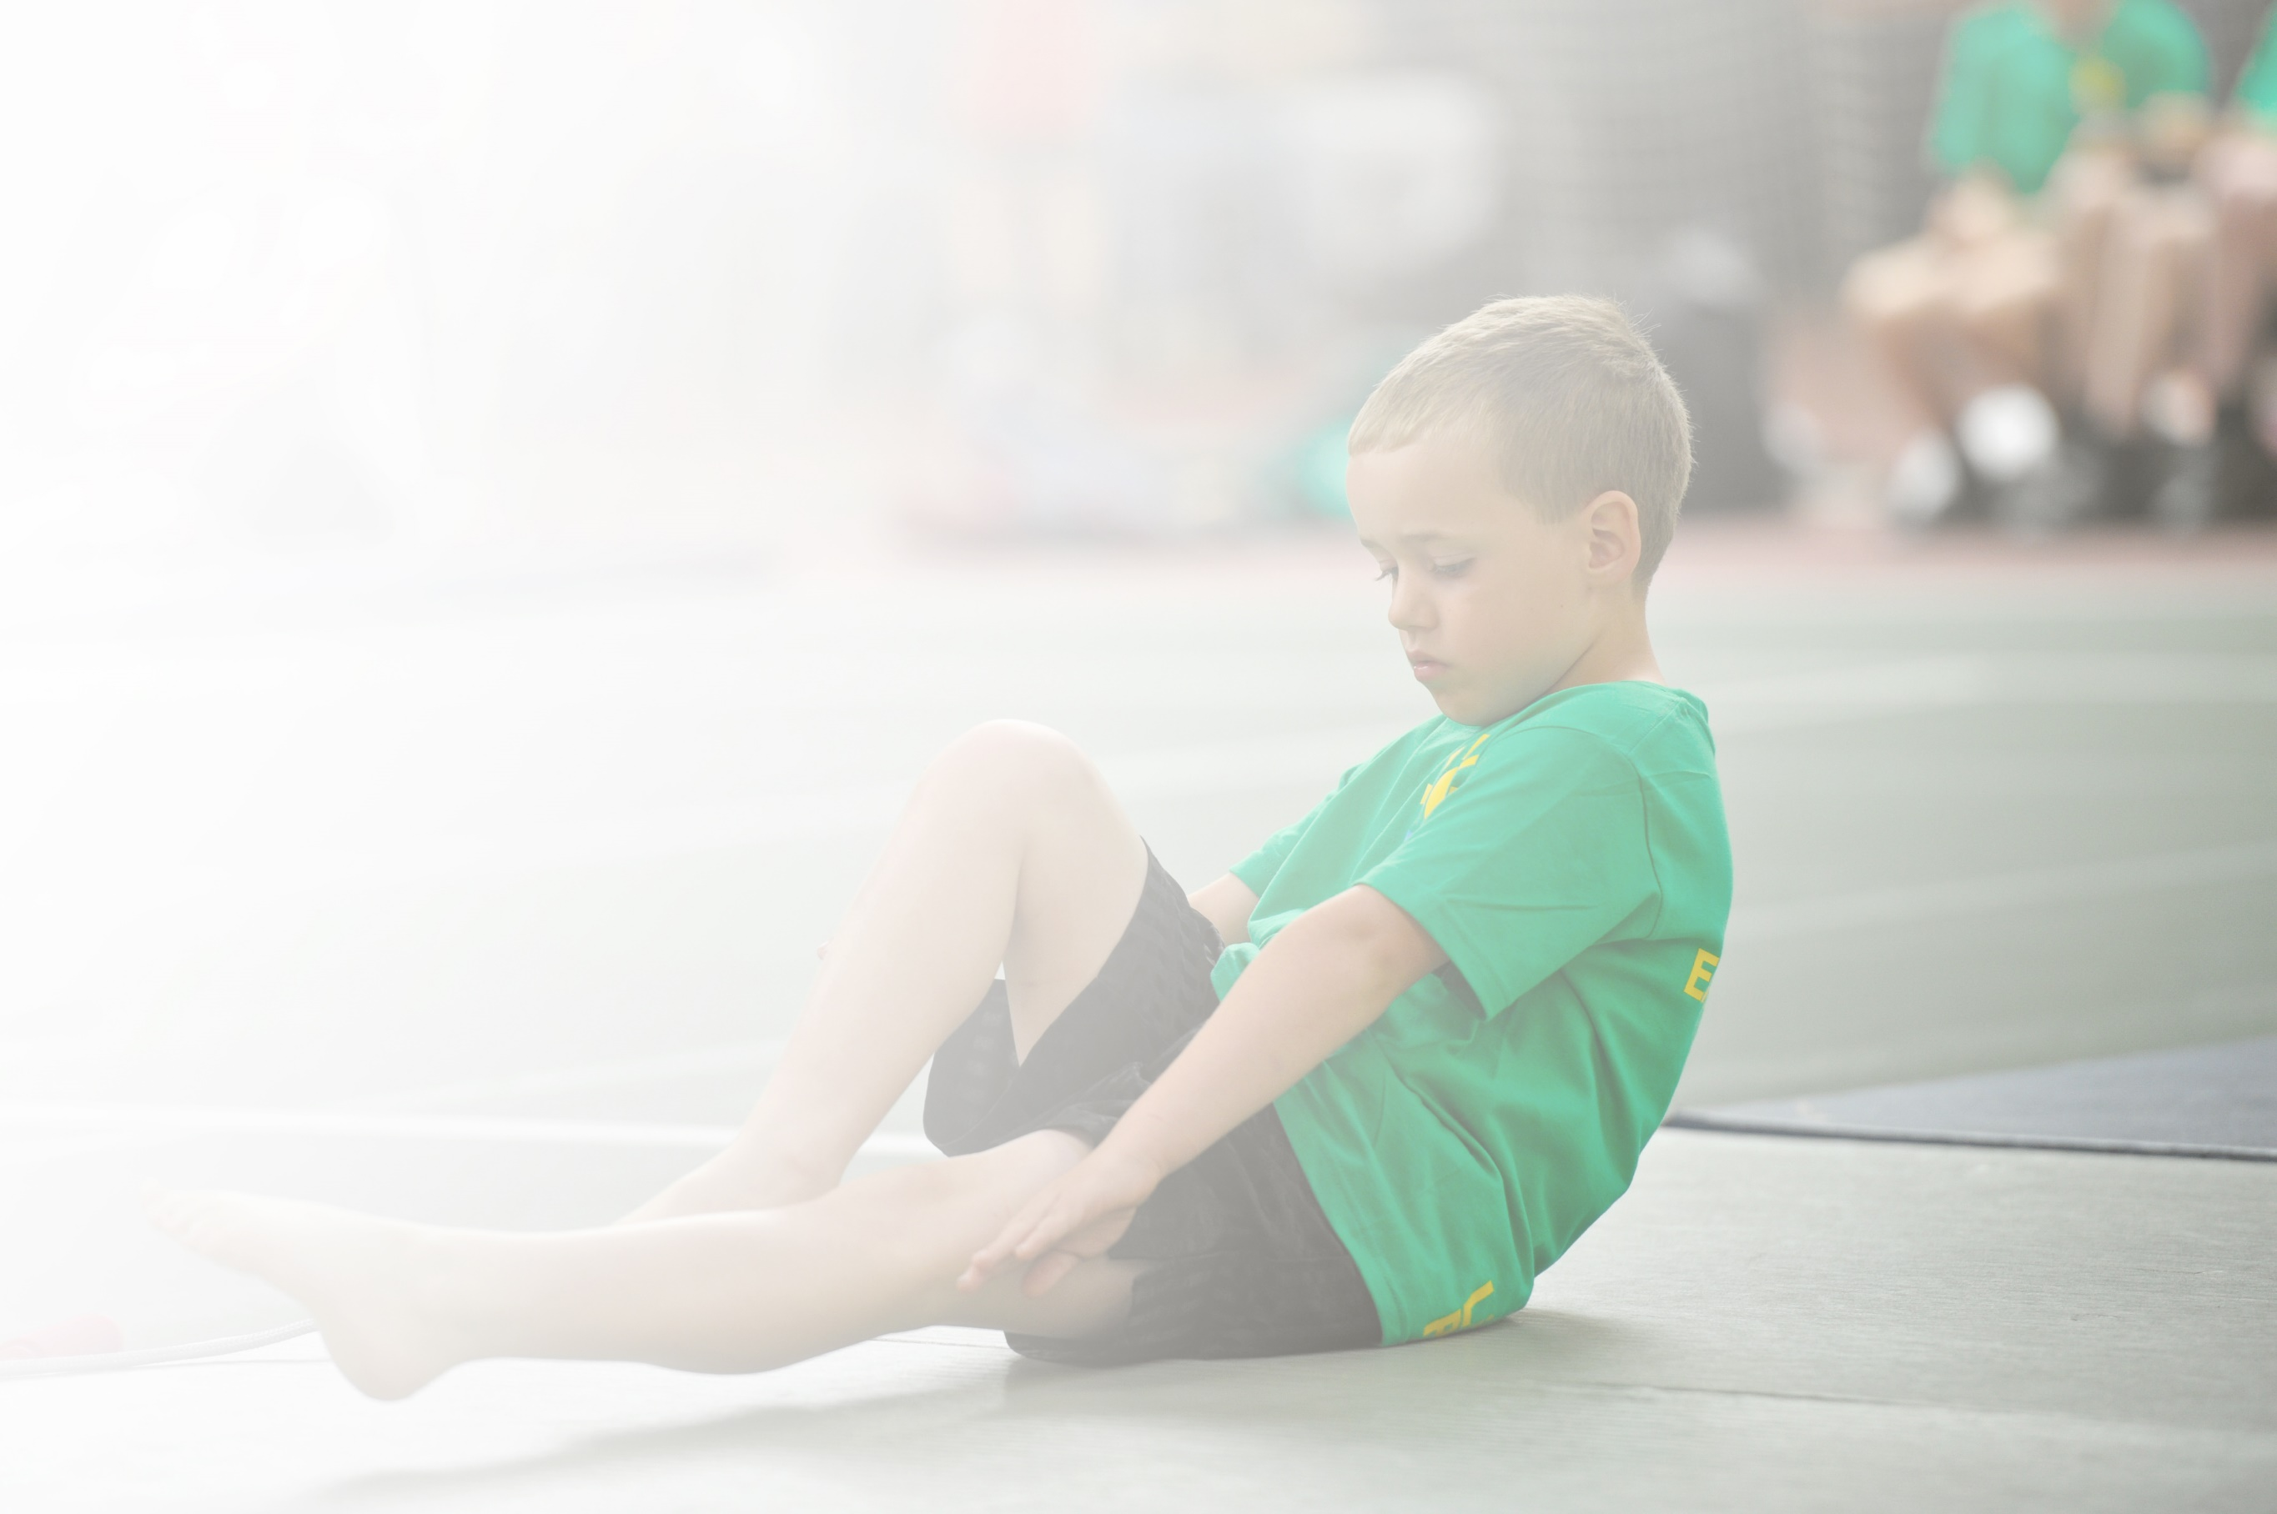
Schools must use the funding to make additional and sustainable improvements to the quality of Physical Education, Sport and Physical Activity (PESPA) they offer. This means that you should use the Primary PE and Sport Premium to:

- Develop or add to the PESPA activities that your school already offer
- Build capacity and capability within the school to ensure that improvements made now will benefit pupils joining the school in future years

Please visit gov.uk for the revised DfE guidance including the 5 key indicators across which schools should demonstrate an improvement. This document will help you to review your provision and to report
your spend. DfE encourages schools to use this template as an effective way of meeting the reporting requirements of the Primary PE and Sport Premium.

We recommend you start by reflecting on the impact of current provision and reviewing the previous
spend. Under the Ofsted Schools Inspection Framework, inspectors will assess how effectively leaders use the Primary PE and Sport Premium and measure its impact on outcomes for pupils, and how effectively governors hold them to account for this.

Schools are required to publish details of how they spend this funding as well as on the impact it has on pupils’ PE and sport participation and attainment by the end of the summer term or by 31 July 2019 at the
latest.
We recommend regularly updating the table and publishing it
on your website throughout the year, as evidence of your
ongoing review into how you are using the money to
secure maximum, sustainable impact. To see an
example of how to complete the table please
click HERE.

Support for review and reflection - considering the 5 key indicators from DfE, what development needs are a priority for your setting and your students now and why? Use the space below to reflect on previous spend, identify current need and priorities for the future.

Key achievements to date: | Areas for further improvement and baseline evidence of need:
Physical Activity: all children have access 60 minutes of high quality physical activity each day (KPI 1).  Physical Education (PE): all children have access 2 hours per week of high quality PE (KPI 1).  School Sport: all children have access to high quality physical activity after school and are given opportunities to engage in high quality competitive sport (KPI 4 + 5).  Health and Well-Being: all children have a good understanding of how to lead healthy lifestyles (KPI 1).  Staff CPD: Staff in school are growing in confidence and skill to deliver effective PE and are welcoming the CPD from the sports mentors (KPI 3).  Activity Provision: Improvements to the playground and outdoor area have improved the access to outdoor provision and the physical development of children during break and lunch times (KPI 1). | To use PE and Sport in school to promote academic improvement: to use PE and Sport to improve positive learning behaviour and pupil concentration which will impact on improved academic performance and progress (KPI 2).  Continuation of the CPD work is also required to ensure that staff confidence and expertise continues to improve (KPI 3)

Meeting national curriculum requirements for swimming and water safety | Please complete all of the below:
What percentage of your current Year 6 cohort swim competently, confidently and proficiently over a distance of at least 25 metres?  N.B. Even though your children may swim in another year please report on their attainment on leaving  primary school. | %
What percentage of your current Year 6 cohort use a range of strokes effectively [for example, front crawl, backstroke and breaststroke]? | %
What percentage of your current Year 6 cohort perform safe self-rescue in different water-based situations? | %
Schools can choose to use the Primary PE and Sport Premium to provide additional provision for swimming but this must be for activity over and above the national curriculum requirements. Have you used it in this way? | Yes/No

Action Plan and Budget Tracking
Capture your intended annual spend against the 5 key indicators. Clarify the success criteria and evidence of impact that you intend to measure to evaluate for students today and for the future.

Academic Year: 2018/19 | Total fund allocated: £ | Date Updated: September 2018
Key indicator 1: The engagement of all pupils in regular physical activity – Chief Medical Officer guidelines recommend that primary school children undertake at least 30 minutes of physical activity a day in school |  |  |  | Percentage of total allocation:
 |  |  |  | %
School focus with clarity on intended impact on pupils: | Actions to achieve: | Funding allocated: | Evidence and impact: | Sustainability and suggested next steps:
Building on and using the progress made from last year, build-on the opportunity for engagement and to ensure consistent sustainability, with a sharper focus on small number of children who are still to engage. | - Children to have the opportunity to access the playground equipment at break and lunch time.  - Children to have the opportunity to access structured activities at break and lunchtime.  - Children will have the opportunity to access a range of sporting activities marked on the playground to encourage health and wellbeing during lunch and break times.  - A professional coach used to ensure that children have the opportunity to access a range of skills throughout each PE session.  - Sports coaches are used to give all children the opportunity to take part in structured physical activities during the school day.  - Ensure that an inclusive sports curriculum is embedded within school, giving the opportunity for all children to participate in sports.
Key indicator 2: The profile of PESSPA being raised across the school as a tool for whole school improvement |  |  |  | Percentage of total allocation:
 |  |  |  | %
School focus with clarity on intended impact on pupils: | Actions to achieve: | Funding allocated: | Evidence and impact: | Sustainability and suggested next steps:
Within school, the rise of PE and Sports provision will impact pupil’s and whole school improvement, with a specific focus on:  - Whole School improvement targets  - Attendance and behaviour and social – sports clubs for them. | - To deliver high quality teaching throughout the whole school.  - Monitor the planning, differentiation and challenge provided to ensure children receive high quality PE teaching.  - Give children the opportunity to become ‘excited’ about sport and encourage them to fulfil any aspirations they may have to participate in any new sports.  - Staff to be given CPD PE sessions with the sporting coach to develop their confidence and skills in delivering the PE Curriculum.  - Increase the promotion of sporting events in school through assemblies, through displays and the opportunity to work with outside agencies.  - Continue with ‘sports week’ to ensure all children participate in a range of sports and develop their skills.  - PE Lead to monitor the quality of staff teaching of PE and plan support if required.

Key indicator 3: Increased confidence, knowledge and skills of all staff in teaching PE and sport |  |  |  | Percentage of total allocation:
 |  |  |  | %
School focus with clarity on intended  impact on pupils: | Actions to achieve: | Funding  allocated: | Evidence and impact: | Sustainability and suggested  next steps:
All staff to undertake a programme of CPD to develop their skills and understanding of a range of sports and physical activity and the potential benefits of pupil learning.  More experienced staff to take more of a coaching role within the CPD sessions.  Less experienced staff to be mentored by the sporting coach and experience staff when delivering sports and PE sessions. | ALL teachers will enhance their skills and understanding of sports teaching through:  - Targeted CPD provided in house by the sports leader  - Team teaching sessions provided by professional sports coaches.  - Sports observation and evaluation sessions to develop reflective practice in sports and PE.
Key indicator 4: Broader experience of a range of sports and activities offered to all pupils |  |  |  | Percentage of total allocation:
 |  |  |  | %
School focus with clarity on intended  impact on pupils: | Actions to achieve: | Funding  allocated: | Evidence and impact: | Sustainability and suggested  next steps:
Additional achievements:  Within an academic year, all children will have the opportunity to experience a high quality range of sport, with a focus on children who are not participating/excelling in sports. | - Encourage flexibility of the PE curriculum map so that PE sessions can reflect the particular sports.  - Ensure that the events offered by the Trust and Pyramid ensure a wide range of opportunities are available for all children  - Monitor and review of after-school sports clubs.  - Sign up to exciting initiatives to enhance the children activity levels.  - Take part in a ‘sports week’ in school with the opportunity to develop different sporting skills.  - Work closely with the head of PE at our Trust PE Leader to develop our PE coordinator and sports coach  - Provide events and opportunities for all children at South Kirkby to take part in.
Key indicator 5: Increased participation in competitive sport |  |  |  | Percentage of total allocation:
 |  |  |  | %
School focus with clarity on intended  impact on pupils: | Actions to achieve: | Funding  allocated: | Evidence and impact: | Sustainability and suggested  next steps:
Improved technical skills and fitness levels when taking part in inter and intra school tournaments.  Increased ability to work collaboratively and to show commitment to a team.  Better sense of feeling part of a community.  Internal competitions – inter-house groups.  Parental involvement in sports. | - To increase the % of children taking part in intra and inter school competitions.  - To continue to increase the participation in inter school competition by creating further opportunities for children through the creation of A, B and C Teams entered into planned tournaments.  - Transporting the children safely to the different events.

