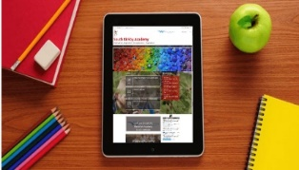
How to support your child with Home Learning
(A parent guide)

We understand how important it is to support your child with their education at this current time, particularly if your child is self-isolating at short notice. As you may be aware, Waterton Academy Trust have developed a new platform on which children can access learning resources, including files and pre-recorded lessons created by our teaching staff. Your child will have an account set-up already on Microsoft Teams and they should have been given a username and password. Please make sure you have these login details ready. Watch the link below (or scan the QR code) which will show both you and your child how to make use of your child’s account on this application.
https://watertonacademytrust.org/coronavirus-updates

Tips to help support your child with home learning:
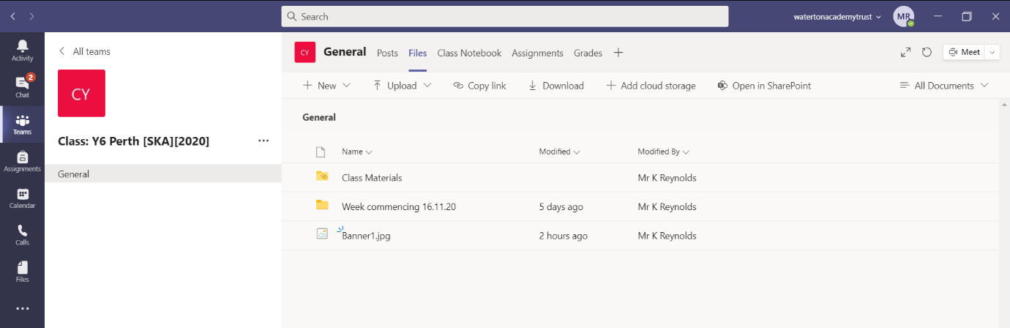
Help them check their learning resources from the Files Tab.

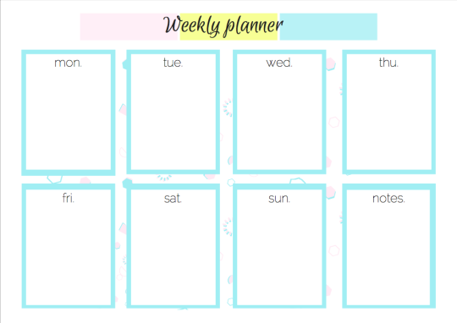
Set (and keep) a schedule and agree this with your child – this is really important as it makes clear the expectations. Create a daily plan of what you expect them to complete from their learning resources.
Remember to include breaks. Working little and often is usually found to be effective (provided your child is prompted to return to their work after their break).

Make sure they have any materials necessary to complete all assignments – pre-recorded videos should make it clear what resources are needed for the lesson/task.

Provide an environment conducive to learning (if possible, remove distractions, e.g. phones/games). Organise the learning environment – do they have somewhere to work, for example, access to a desk or table?
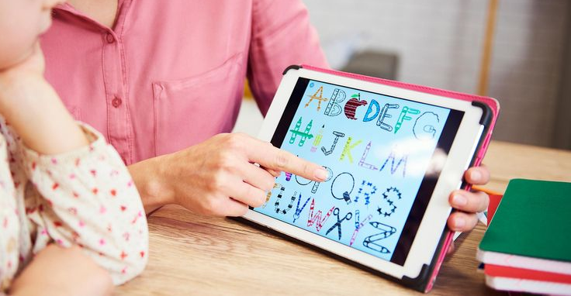
Help them understand (perhaps try doing the activity alongside your child to show what is expected of them and to help discuss ideas). Replay the pre-recorded video if need be to go over something that they may be finding difficult.

Offer small rewards as an incentive to complete the home learning that has been set – these can be however big or small you feel necessary to maintain your child’s motivation.

When work is completed, help you child upload it to the Files Tab on their Microsoft Teams accounts.

