Science
Curriculum

Science Overview
 | Autumn |  | Spring |  | Summer
 | Autumn 1 | Autumn 2 | Spring 1 | Spring 2 | Summer 1 | Summer 2
Year 3 | Plants  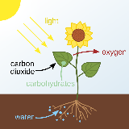 | 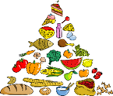  Food and our bodies | 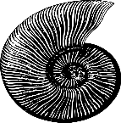  Rocks, soils and fossils | 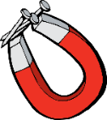  Forces and magnets | 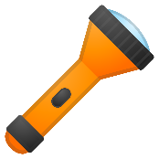  Light and shadows
Year 4 | Sound | 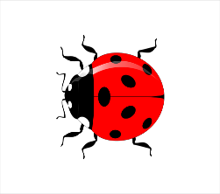  Living things | States of matter  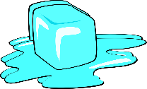 | Teeth and eating  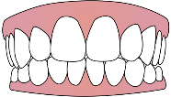 | Electricity  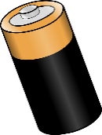 | Working Scientifically Project: The Big Build Challenge
Year 5 | 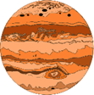  Space | Forces | Materials | 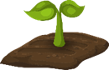  Circle of life | Growing up and growing old  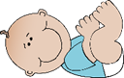
Year 6 | Light | 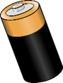  Electricity | Classification of living things  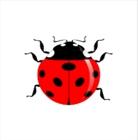 | 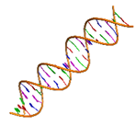  Evolution and inheritance | Healthy bodies

Year 3
 | Autumn |  | Spring |  | Summer
 | Autumn 1 | Autumn 2 | Spring 1 | Spring 2 | Summer 1 | Summer 2
Overview | Plants  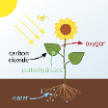 | 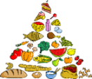  Food and our bodies | Rocks, soils and fossils | Forces and magnets | Light and shadows
Suggested Content | Understand what a plant needs for growth.  Describe the function of roots and stem.  Describe the function of leaves and flowers.  Investigate how much water plants need to stay healthy.  Explore the part that flowers play in the life cycle of flowering plants. | Explain animals need to eat food because they cannot make their own.  Recognise food groups and classify food into groups.  Name the position of a range of bones in the body.  Describe the functions of a skeleton.  Describe how muscles and bones work together | Understand what rocks are and how they can be classified.  Understand what fossils are and the legacy of Mary Anning.  Use dough to create fossils and describe how dough fossils are made.  Explain how fossils are formed.  Examine different types of soils and understand what it is made up of. | Compare how things move over different surfaces  Carry out a fair test and draw conclusions about which surface a toy car travels the furthest.  Examine which types of objects are magnetic.  Undertake experiments to measure the strengths of different magnets | Demonstrate that darkness is the absence of light.  Examine different sources of light.  Understand how light allows us to see different objects.  Identify surfaces which reflect light.  Explain how shadows are made.  Predict which materials make the darkest shadows.
Key Vocab | Air, Light, Water, Nutrients, Soil, Reproduction, Pollen, Root, Stem, Veins, Dispersal, Stamen, Ovary | Movement, Muscles, Bones, Skull, Nutrition, Skeleton, Protein, Carbohydrate, Fats, Diet | Fossils, Soils, Sandstone, Granite, , Pumice, Basalt, Chalk, Slate Impermeable, Permeable, Friable, Lustre | Observation, Magnetic, Force, Contact, Attract, Repel, Friction, Poles, Push, Pull | Light, Light source, Dark, Shadows, Mirror, Reflective, Reflection, Translucent, Transparent, Opaque
Scientific enquiry
Observing over time | What happens to celery when it is left in a glass of coloured water? |  |  |  | How do shadows change throughout a day?
Pattern seeking |  | Have girls or boys broken the most bones? |  | Does the size and shape of a magnet affect how strong it is? | Does the number of reflections increase as the angle between the mirror decreases?
Research |  |  | Who was Mary Anning?
Identifying and classifying | How do these seeds spread? | Which food groups do I eat? | Which rocks are impermeable, and which are permeable? | Which materials are magnetic?
Comparative and fair tests | Do plants need light to grow? |  |  | On which surface will a toy car travel the furthest? | Which materials are the best for making shadows?

 | Autumn |  | Spring |  | Summer
 | Autumn 1 | Autumn 2 | Spring 1 | Spring 2 | Summer 1 | Summer 2
Overview | Sound | Living things | States of matter | Teeth and eating | Electricity |  | Working Scientifically Project: The Big Build Challenge
Suggested Content | Identify how sounds are made.  Create a box guitar using cardboard and elastic bands.  Describe how to change pitch and volume of a sound.  Describe how sound changes in relation to distance.  Present data in graphical form.  Investigate which materials are the best at insulating sound. | Sort animals into different groups and explore different ways to classify.  Create classification key to sort biscuits.  Explore the use of classification keys to identify living thing.  Research how bees are good for the environment.  Suggest ways in which we can save our bees. | Sort materials into solids, liquids and gasses.  Build an ice tower and investigate why ice isn’t a good building material?  Observe that ice changes state when it is heated or cooled.  Investigate which type of chocolate melts the quickest.  Describe parts of the water cycle. | Identify the different human teeth.  Describe the functions of the different types of teeth.  Explain how to keep teeth healthy.  Make a functioning model of a digestive system.  Create food chains  Recognise food chains in the school ground | Sort objects that run on mains electricity and batteries.  Describe how to use electricity safely.  Identify components used in electrical circuits.  Investigate which materials are the best conductors of electricity.  Create functioning circuits |  | Investigate which shapes are the strongest for building bridges.  Apply understanding of structures to build spaghetti towers.  Research how common animals build homes, such as bird species and bees.
Key Vocab | Volume, Vibration, Wave, Pitch, Speaker | Vertebrates, Invertebrates, Fish, Amphibians, Reptiles, Birds, Mammals, Snails, Slugs, Worms, Spiders, Insects, Environment, Classify, Classification | Solid, Liquid, Gas, Evaporation, Condensation, Precipitation, Collection, Temperature, Freezing, Melting, Heating, Thermometer, Water Cycle | Mouth, Tongue, Teeth, Oesophagus, Stomach, Small Intestine, Large Intestine, Anus, Canine, Incisor, Molar, Enamel, Decay, | Wires, Bulbs, Switches, Buzzers, Battery, Cells, Circuit, Series, Conductors, Insulators |  | Structure, Tower
Scientific enquiry
Observing over time |  |  | What happens if we leave ice at room temperature? | What happens to eggshell when it is left in different liquids?
Pattern seeking | What are the rules for changing the pitch of a string instrument? |  |  | What food types cause damage to our teeth? |  |  | Which shapes are the used the most for bridge building?
Research |  | Why are bees good for the environment? |  | What is the function of each organ in the digestive system? |  |  | How do common animals in the local environment build their homes?
Identifying and classifying |  | Can we use classification keys to identify animals? | What state are different materials at room temperature? | How can we organise living things into food chains? | Which sources of electricity do appliances use?
Comparative and fair tests | Which materials are the best insulators of sound? |  | Which type of chocolate melts the fastest? |  | Which materials are the best conductors of electricity? |  | Which spaghetti tower is the strongest?
Year 4

 | Autumn |  | Spring |  | Summer
 | Autumn 1 | Autumn 2 | Spring 1 | Spring 2 | Summer 1 | Summer 2
Overview | 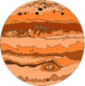  Space | Forces | Materials | Circle of life | Growing up and growing old
Suggested Content | Name and describe plants in the Solar System  Describe how planets orbit the sun at different speeds.  Explain the occurrence of day and night.  Explain why shadows change over the course of a day  Describe changes in the moon that they observe.  Research information about other plants in our Solar System. | Explain Newton and Galileo’s ideas about gravity.  Explore the effects of air resistance.  Investigate how air resistance is linked to surface area.  Understand the effects of water resistance and up-thrust.  Describe what happens and talk about friction as a force.  Investigate friction of different shoes. | Classify common materials according to properties.  Describe the properties of materials and how they relate to their uses.  Investigate which materials make the strongest carrier bag.  Identify materials that are thermal conductors.  Explain how crystals form from saturated solutions | Describe the life-cycle of a hen and frog.  Compare life-cycles of different groups of animals.  Carry out a dramatization of pollination.  Describe how new plants can be generated from old plants.  Investigate why some animals lay so many eggs.  Explain ideas of Scientists involved in conservation | Describe the changes from a baby to old age.  Describe visually how a child changes.  Identify key milestones from birth onwards.  Explain why changes occur during puberty and describe what those changes are in both sexes.  Design and conduct a survey to find out what age they think someone is old.
Key Vocab | Earth, Sun, Moon, Axis, Daytime, Night-time, Orbit, Planet, Star, Heliocentric. | Air resistance, Water resistance, Friction, Gravity, Newton, Gears, Pulleys | Hardness, Solubility, Conductivity, Magnetic, Filter, Elastic, Dissolving, Flexible, Mixing, Solution | Reproduction, Fertilisation, Offspring, Pollination, Metamorphosis, Larva, Asexual, Sexual | Foetus, Embryo, Uterus, Gestation, Toddler, Adolescent, Elderly, Growth, Development, Puberty, Menstruation
Scientific enquiry
Observing over time | How does shadow length change throughout the day? |  | How do crystals form from saturated salt solutions over time?
Pattern seeking | Is there a pattern between how long it takes a plant to orbit the sun and distance away from the sun? | Does size effect how quickly a cupcake case falls? |  | Are there similarities between life-cycles of different animals? | Is there a link between gestation period and animal size?
Research | What do we know about other plants in our Solar System? | What was Newton and Galileo’s ideas about gravity? |  | What was Jane Goodall’s contribution to Science? | What do older people think about getting old?
Identifying and classifying | Can you observe and identify all the phases in the cycle of the moon? |  | Which materials are thermal conductors?
Comparative and fair tests |  | Which shoes do you think have the most friction? Which material makes the strongest carrier | Which material makes the strongest carrier bag?
Year 5
Year 6
 | Autumn |  |  | Spring |  |  | Summer
 | Autumn 1 | Autumn 2 | Spring 1 |  | Spring 2 | Summer 1 |  | Summer 2
Overview | Electricity | Light | Classification of living things |  | 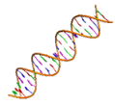  Evolution and inheritance | Healthy bodies
Suggested Content | Describe how the understanding of electricity developed.  Investigate the relationship between voltage and brightness of a bulb.  Measure amplitude from different energy sources.  Create an electromagnet.  Understand how static electricity is created.  Investigate the creation of static electricity. | Understand that light travels in straight lines.  Explain in detail how shadows are created and how they are different to reflections.  Investigate shadow size in relation to distance from light source.  Explore materials which are reflective.  Explain how refraction makes things look different. | Create classification keys and describe how items have been sorted.  Use Classification keys to identify species of invertebrates and plants.  Describe why classification and organisation is important and give examples.  Understand that living things are organised into Kingdom |  | Consolidate knowledge on fossils.  Describe that fossils provide us with evidence for what living things looked like millions of years ago.  Recognise that humans and other animals produce offspring of the same kind.  Understand that animals are adapted to their environment  Describe how variations become adaptations | Describe the circulatory system.  Understand the impact of smoking on the lungs  Describe how the heart pumps blood around the body.  Examine the effects of exercise on the pulse.  Explain the impact of a poor diet on the circulatory system
Key Vocab | Series, Parallel, Amps, Volts | Refraction, Spectrum, Rainbow, Colour, White light | Micro-organisms, Bacteria, Fungi, Pathogen, Kingdom |  | Fossils, Adaptation, Evolution, Extinction, Endangered, Characteristics, Genetics | Circulatory, Heart, Blood Vessels, Veins, Arteries, Oxygenated, Deoxygenated, Valve, Exercise, Respiration
Scientific enquiry
Observing over time | How have electrical appliances changed over the years? |  |  |  |  | How long does it take for pulse rate to return to normal after exercise?
Pattern seeking | How is bulb brightness and voltage linked? | Is there a relationship between shadow size and distance from light source? |  |  | Is there a pattern between the size and shape of a bird’s beak and the food it will eat?
Research | How have electrical appliances changed over the years? |  | What was Carl Linnaeus’ contribution to Science? |  | How are animals adapted to their environment? | What was John Orr’s contribution to Science?
Identifying and classifying |  |  | What identifiable features can be used to classify plants in our school environment? |  |  | Which organs of the body make up the circulatory system?
Comparative and fair tests | How does resistance wire effect the brightness of a bulb? | Which surfaces are the most reflective? |  |  |  | Does heartrate increase when exercising?

