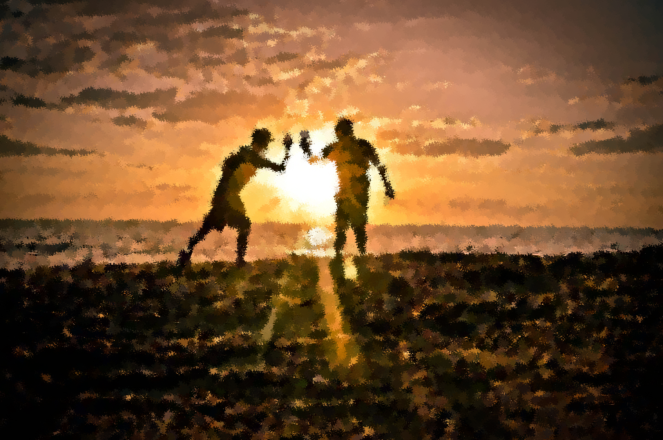
SMSC
Curriculum

 | Autumn |  | Spring |  | Summer
 | Autumn 1 | Autumn 2 | Spring 1 | Spring 2 | Summer 1 | Summer 2
Year 3 | Local Artists: Barbara Hepworth & Henry Moore | Rules for Keeping Safe  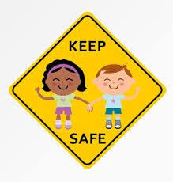 | Emergency Services  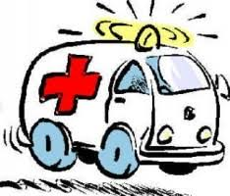 | The Iron Age and The Bronze Age  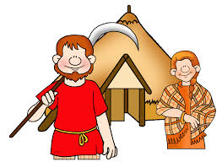 | Local Community  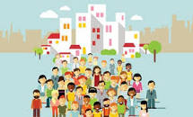 | Rights and Responsibilities  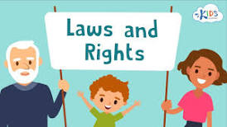
Year 4 | Ancient Egyptians  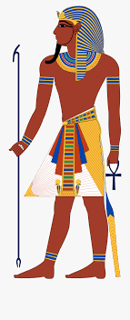 | Diversity  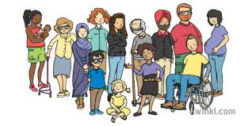 | 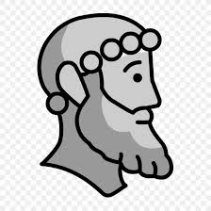  Ancient Greece | 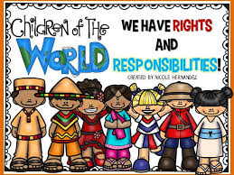  Right and Duties | Keeping Safe | 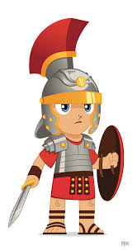  Romans
Year 5 | 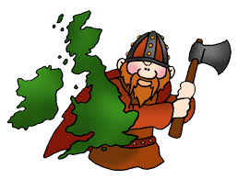  Anglo- Saxons | Sikhism  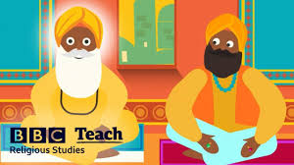 | Romans | Relationships  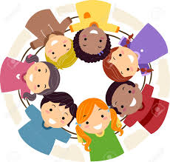 | Victorians (Coal Mining)  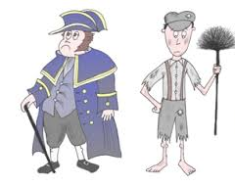 | Living in the Wider World
Year 6 | World Wars | World Wars | Mayans  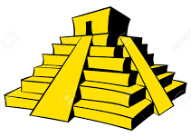 | Amazon Rainforest  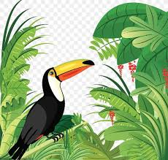 | Ancient Greece | Sustainable Development  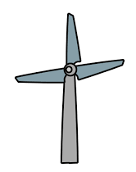
SMSC Overview
Year 3

 | Autumn |  | Spring |  | Summer
 | Autumn 1 | Autumn 2 | Spring 1 | Spring 2 | Summer 1 | Summer 2
Overview | Local Artists:  Barbara Hepworth & Henry Moore | Rules for Keeping Safe | Emergency Services | The Iron Age and The Bronze Age | Local Community | Rights and Responsibilities
Suggested Content | Appreciation of how art can be presented in a variety of forms – link to Anthony Brown ‘Into the Forest’. (Social)  Explore using different mediums in Art to support pupils to develop their creative/imaginative skills. (Spiritual)  Build self-confidence and self-worth through artistry skills. (Spiritual/Social)  Appreciation of local artists linked to surrounding community. (Social/Spiritual) | Show initiative of places which are safe and those which are not. (Spiritual /Social/Cultural)  Understand why rules are created and respect decisions made.  (Moral/social)  Encourage respect for others.  (Moral/Spiritual & Social)  Support pupils in developing decisions from right and wrong.  (Moral/Spiritual & Social) | Acquire knowledge of services around hem which keep them safe. (Moral & Social)  Show initiative to understand their behaviour can positively contribute to the lives of others.  (Social & Moral)  Develop respect for public services in the United Kingdom. (Moral/Spiritual)  Encourage respect for other people.  (Spiritual/Moral)  Rules for keeping healthy and safe.  (Moral) | Recognise and appreciate how society now is shaped by the past. (Cultural/Social)  Develop respect for different culture ways of life.  (Cultural/Social)  Understand the roles and rules of the past and how they have contributed to the Criminal Law of England.  (Cultural, Social and Moral)  Develop self-identity by looking at the past and linking to the local community i.e. Castleford.  (Cultural/Social)  Conflict and resolution through Iron Age and The Bronze Age.  (Moral) | Encourage pupils to take responsibility for their own behaviour. (Moral/Social)  Recognise how the past has shaped the local community. Explore the past of the local community. (Cultural/Social)  Explore whether there has been and changes made to the local area through requests of the community. (Social/Cultural)  Recognise that living within the rules and laws of an area supports the well being of its citizens. (Moral/Spiritual) | Understand how citizens can influence decision making through votes. I.E. Local Mayor elections/ local MP. (Social/Cultural/Moral)  An appreciation that living under the rule of law protects individual citizens and is essential for their wellbeing and safety. (Moral)  Encourage respect for democracy and support for participation in the democratic processes, including respect for the basis on which the law is made and applied in England. (Social/Moral/Spiritual/Cultural)
Key Vocab | Interpret, analyse, evaluate, explore, inspiration, experiences, lifestyles, lives, identities, belonging | Rules, health and safety, hygiene, appropriate, inappropriate, | Emergency, police, fire service, ambulance,  Rights, duties, rules, British values, mutual respect, diversity | Settlement, invasions, origins, culture, traditions, past, present, community. | Community, area, population, citizens, West Yorkshire, Identity, United Kingdom, region, families | Law, rules, rights, citizens, lawful, unlawful, democratic, power, services, responsibilities.
SMSC Strands
Develop Self-awareness, belonging and mindset  (Social  Spiritual) | Pupils to self-express themselves through Art.  Appreciate how belonging impacts on our own experiences/inspiration which can create art. | Recognise their importance to keep each other safe building towards a community ‘joined up’ mindset. | Build self-awareness and confidence in an emergency scenario. | Link events of the past and how they have shaped the community. | Identify what community means to each individual.  Nurture self-belonging looking ad different types of communities e.g. local/school/clubs. | Understand rights and responsibilities through self-awareness and belonging.
Awareness of Rules/Right and Wrong  (Moral) |  | Identify why rules are made and who they are for. | Understand procedures in an emergency. | Comparison between Iron Age/Bronze Age rules to the Criminal Law of England. Compare similarities and differences. | Understand how rules have been created and why – classroom rules/school rules and Criminal Law of England. | Appreciate how laws create rights and equality for humanity.
Build Harmony and tolerance between different religion’s and races  (Cultural) | Appreciate thoughts and opinions from variety of different critiques. Appreciate the backgrounds and influences of Henry Moore and Barbara Hepworth.  Speak respectfully to critique artwork. | Understand it is everyone’s responsibility to stay safe. | Build respect for public services. |  | Appreciate different races and religions in the community. | Appreciate how laws create rights and equality for humanity.

Year 4

 | Autumn |  | Spring |  | Summer
 | Autumn 1 | Autumn 2 | Spring 1 | Spring 2 | Summer 1 | Summer 2
Overview | Ancient Egyptians | Diversity | Ancient Greece | Right and Duties  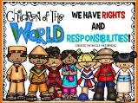 | Keeping Safe | Romans
Suggested Content | Appreciation of The Ancient Egyptians and comparison between life then and now.  (Cultural/Social)  Recognition of the water cycle from the river Nile’s irrigation system and comparison to other countries use of water and crop growth. (Cultural) | Developing tolerance and resect for the differences between all citizens including class mates. (Cultural/Social/Moral)  Accepting responsibility for their actions towards other people. (Moral)  Compare and debate different view points to recognise we all have our own opinion which is unique. (Moral/Social) | Beginning of democracy taking place in Ancient Greek times. (Social)  Looking at how Greek myths can show justice and creative thinking. (Spiritual)  Order and ruling through the beginning of the Olympics in Ancient Greece.  (Moral/Cultural) | Understanding what are Human Rights and who they apply to. (Moral)  Comparison between those being treated unfairly and why i.e. Fair Trade. (Moral/Spiritual)  Debate topical issues such as global warming / plastic pollution.  (Moral/Spiritual/Cultural) | Show initiative of places which are safe and those which are not.  (Cultural)  Understand why rules are created and respect decisions made.  (Moral)  Encourage respect for others.  (Moral/Spiritual)  Support pupils in developing decisions from right and wrong.  (Moral) | Create arguments about whether or not to invade or conquer.  (Moral)  Look at rules of lives for Roman soldiers.  (Spiritual/  Cultural)  Look at cultures and appreciate the differences between societies.  (Moral)  Discuss rules in Roman times and compare them to Criminal Laws of England.  (Cultural)
Key Vocab | Similarities, differences, unique, collaboration, ruler, hierarchy, hierarchical system. | Diversity, Prejudice, Perceived Stereotype, Empathy, Conscience, Label, Self-control, Choices, Bully, Conflict Challenge, Ostracised, Mental health, negotiation, compromise | Democracy, power, ruling, punishment, rights, myths. | Human rights, nations, law equality, declaration, articles, humanity, justice | Rules, health and safety, hygiene, appropriate, inappropriate, | Invasions, conquers, rules, discipline, criminal law, cultures
SMSC Strands
Develop Self-awareness, belonging and mindset  (Spiritual  /Social) | Appreciate society is founded by ancient civilisations | Recognition of belonging to a community and an accepted behaviour in which we act. | Creative thinking to develop their own myths. | Children’s opportunity to voice their opinions and beliefs. | Recognise their importance to keep each other safe building towards a community ‘joined up’ mindset. | Appreciate how the Roman’s have impacted on our wider society.
Awareness of Rules/Right and Wrong  (Moral) |  | Understanding appropriate behaviours and inappropriate behaviours. | Right and wrong demonstrated in Greek myths often through betrayal or greed. | Understand what being treated fairly looks like and identify when someone is something is not being treated fairly. | Identify why rules are made and who they are for. | Comparison between Roman Rules to the Criminal Laws of England.
Build Harmony and tolerance between different religion’s and races  (Cultural) | Tolerate and respect differing viewpoints from those of Ancient Civilizations and now. | Recognition of equality for all. |  | Recognise equality as a key factor in ensuring everyone is being treated fair. | Understand it is everyone’s responsibility to stay safe.

Year 5

 | Autumn |  | Spring |  | Summer
 | Autumn 1 | Autumn 2 | Spring 1 | Spring 2 | Summer 1 | Summer 2
Overview | Anglo- Saxons | Sikhism | Romans | Relationships | Victorians (Coal Mining) | Living in the Wider World
Suggested Content | Creating debates for conflict and possible solutions as Anglo-Saxon warriors/villagers. (Social/Moral)  Understanding and building tolerance to different cultures beliefs or values. E.g. Beowulf burial Sutton Hoo. (Moral)  Developing own opinions through use of Historical sources.  (Spiritual/Social)  Recognition of how the community has been shaped by Anglo-Saxon time period. A lot of the street names in South Kirkby are Anglo-Saxon based.  (Social/Spiritual) | Identify what it means to be a Sikh and how this effects lifestyle choices.  (Spiritual)  Explore how Sikhs show commitment to their Gods through the 5ks and religious worship.  (Spiritual)  Look at the values which underpin Sikhism – debate do the children think the values make Sikhs a good citizen.  (Social)  Discuss the children’s own personal beliefs do they believe in a religion or agree/disagree with any of the practises.  (Social) | Discover how the Roman Empire impacted on local areas such as Castleford.  (Social)  Compare similarities and differences between travel of Romans, Anglo-Saxon and today.  (Spiritual)  Look at Roman inventions e.g. aqueducts (Stanley Ferry Aqueduct) and compare to modern day structures.  (Social)  Develop thoughts and hypothesis through a variety of different sources.  (Spiritual) | Recognise and identify what makes a healthy relationship.  (Social)  Understand and identify behaviours which are acceptable and those which are not.  (Social/Moral)  Pupil’s to recognise they are responsible for their own behaviour.  (Moral)  Build understanding of how disputes can be settled and recognition of respectful / tolerant attitudes. (Moral) | Debate views on child slavery – link to modern slavery discussion around what the children think to this.  (Moral/Social)  Comparison to Victorian Britain to now.  (Social)  Identify rules set by society (Work houses/ school rules/classes)  (Moral / Cultural)  Draw comparisons between Rich and Poor Victoria times. Discuss children’s views. Does a divide still exist?  (Social)  Look at local area and how coal mining has impacted on South Kirkby.  (Cultural) | Pupils to identify and research current topics prevalent in the world. (Spiritual)  Debate existing solutions. Look at a variety of stake holders and their views or opinions e.g. deforestation.  (Spiritual)  Recognise how laws are created and why these are enforced. (Moral)  Look at the development of democracy through historic era taught to gain an understanding of why it has been established.  (Social)  Look at recent events where democracy has been used such as leaving the EU and trial of Donald Trump.  (Social)
Key Vocab | Invasion, settle, reconstruction, Dark Ages, pagan, plunder, Scandinavia, grave goods, archaeologist, excavation | Earnestly, Golden Temple of Amritsar,  Story of Kals,  Pilgrimage,  Guru | invade, invasion, conquer, republic, empire, emperor, status, glory, barbaric, legacy | Relationships Inappropriate Life cycle loving, civil partnership, healthy unhealthy committed consent marriage | Victorian era, upper class, lower class, rich, poor, workhouses, society, criminality. | Influences, resisting pressure, anti-social aggression personal safety, wellbeing Independence
SMSC Strands
Develop Self-awareness, belonging and mindset  (Social/  Spiritual) | Recognise how the past has shaped the local community. |  | Look at how the Roman Empire shaped the wider community. | Identify a self-awareness of own relationships. | Coal mining effects on the local community. | Understand issues which are meaningful.
Awareness of Rules/Right and Wrong  (Moral) | Understand how conflicts were settled.  Develop views or alternatives to how disputes could have been settled. |  | Look at how disputes were settled during Roman era.  Roman Rules and Ruling. | Understand the difference between healthy and unhealthy relationships.
Build Harmony and tolerance between different religion’s and races  (Cultural) | Develop respect and tolerance for differing views. |  |  | Recognise appropriate behaviours and those which are inappropriate. | Develop views and opinions between what children believe is right and wrong. | Build respect and tolerance in debating when listening to differing views.  Understand motives between differing view points.

Year 6

 | Autumn |  | Spring |  | Summer
 | Autumn 1 | Autumn 2 | Spring 1 | Spring 2 | Summer 1 | Summer 2
Overview | World Wars | World Wars | Mayans | Amazon Rainforest | Ancient Greece | Sustainable Development
Suggested Content | Understand differing views and opinions in WW2. (Moral)  Unpick Propaganda posters to understand how a view can be represented. (Social/Moral)  Look at rules during WW2 such as black outs. (Social)  Identify how war has impacted on our local community. Look over family names South Kirkby War memorial.  (Cultural/Social) | Debate whether local area would have been a good place to have been evacuated to.  (Social)  Discuss why concentration camps were used. Debate whether a human has the right to end another’s life?  (Moral)  Identify how someone’s action attempted to gain control through power. Determine how actions can effect others.  (Moral) | Unpick Ancient Civilizations beliefs compare to current beliefs – similarities and differences.  (Social/Spiritual)  Learn about lifestyle of the Myans. Look at rules/hierarchy. Compare to society now.  (Spiritual)  Identify how Mayan architecture has shaped current architecture.  (Spiritual) | Encourage pupils to accept their behaviours and understand their actions can impact on the environment.  (Moral/Social)  Study deforestation and understand how the opinions of others shape their actions looking at different roles of loggers/companies  Study endangered animals and recognise how humanities behaviour is accelerating or reducing this.  (Spiritual) | Beginning of democracy taking place in Ancient Greek times.  (Social)  Looking at how Greek myths can show justice and creative thinking.  (Social)  Order and ruling through the beginning of the Olympics in Ancient Greece.  (Social/Cultural) | Debate the importance of sustainable development.  (Moral)  Creatively develop ideas for how sustainable development might look in the future.  (Moral)  Understand differing viewpoints citizens may have towards sustainable development.  (Moral)
Key Vocab | Sources, evidence, reliability, bias, utility, memorial, thankful village, civilian, inscription, casualty, protected/reserved occupations, conscription, volunteer, Blitz, evacuee, Kindertransport, refugee | imports, rural, urban, propaganda, home guard, Zeppelins, Luftwaffe, barrage, shells, bombs, memorial, commemorate, symbolism | Religious, social, economic, cultural, political, civilisation, pyramid, temple, conclusion, evidence, reconstruction, archaeology, city state, sacrifice, Meso-America. | Continent, country, region, river, river basin, source, mouth | Democracy, power, ruling, punishment, rights, myths. | Sustainability, habitat destruction, endangered, extinction, conservation
SMSC Strands
Develop Self-awareness, belonging and mindset  (Spiritual/  Social) | Understanding of how War has impacted on local area. | Recognition of journeys of evacuees and veterans. | Identify how Mayan life is similar to life now. | Understand how actions can impact positively and negatively on the environment. | Creative thinking to develop their own myths. | Understand how actions can impact positively and negatively on the environment.
Awareness of Rules/Right and Wrong  (Moral) | Recognition of rules which happened during WW2. | Understanding of moral rules through right/wrong. |  |  | Right and wrong demonstrated in Greek myths often through betrayal or greed. | Discuss how rules are made and rules around sustainability.
Build Harmony and tolerance between different religion’s and races  (Cultural) | Appreciation of how prejudice and  discriminatory opinions can cause hatred. | Build empathy for those effected by War. | Develop tolerance between differing viewpoints and develop own viewpoints.

