Reading
Curriculum

Reading Overview

 | Autumn |  | Spring |  | Summer
 | Autumn 1 | Autumn 2 | Spring 1 | Spring 2 | Summer 1 | Summer 2
Year 3 | 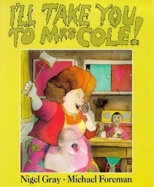  Fiction  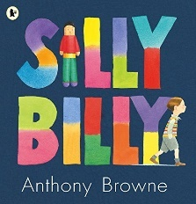  Fiction | 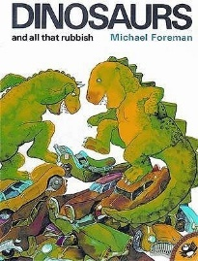  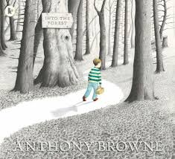  Fiction  Fiction | 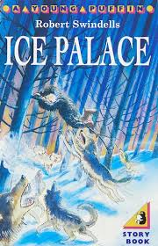  Fiction  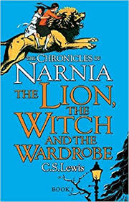  Fiction | 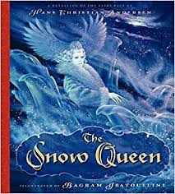  Fiction  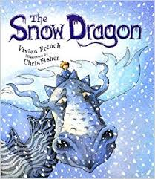  Fiction | 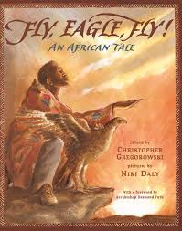  Fiction  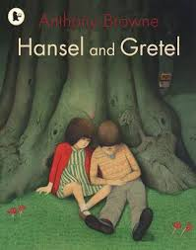  Fiction | Fiction  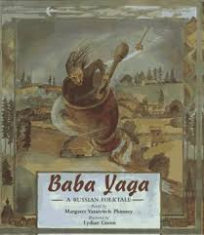  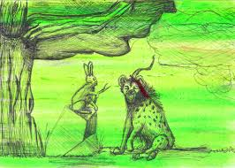  Fiction
 | Year 3 Sub-Focus Texts:  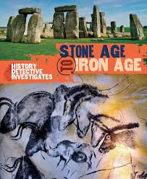  Fiction Non-fiction  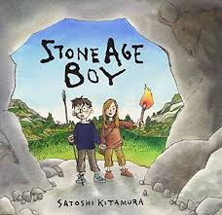 |  | Year 3 Sub-Focus Texts:  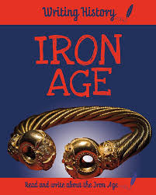  Non-fiction Non-fiction  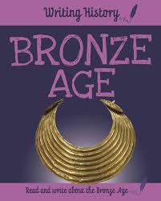 |  | Year 3 Sub-Focus Texts:  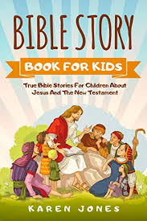  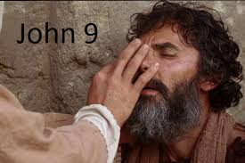  Non-fiction  Non-fiction
Year 4 | 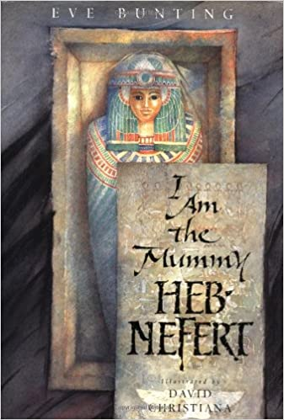  Fiction | 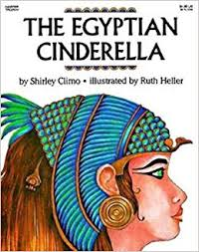  Fiction | 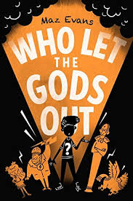  Fiction | Ancient Greek Mythology  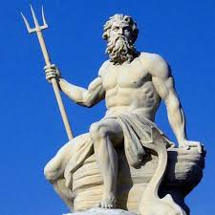  Non-fiction | 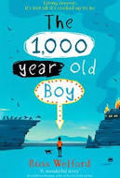  Fiction | 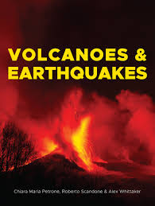  Non-fiction
 | Year 4 Sub-Focus Texts:  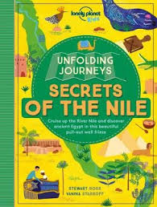  Non-fiction Non-fiction  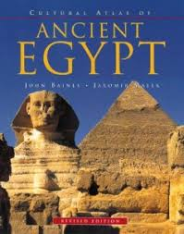 |  | Year 4 Sub-Focus Texts:  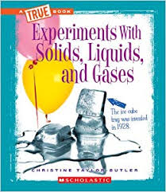  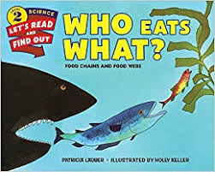  Non-fiction Non-fiction |  | Year 4 Sub-Focus Texts:  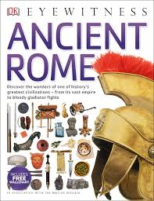  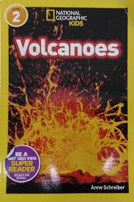  Non-fiction Non-fiction
Year 5 | 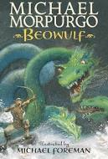  Fiction | 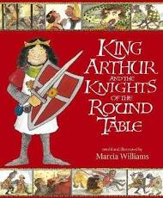  Fiction | 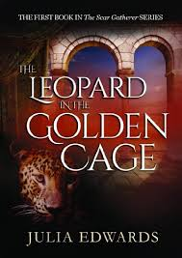  Fiction | 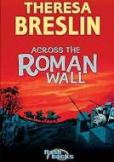  Fiction | 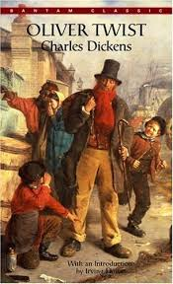  Fiction | 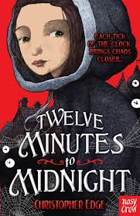  Fiction
 | Year 5 Sub-Focus Texts:  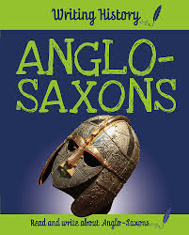  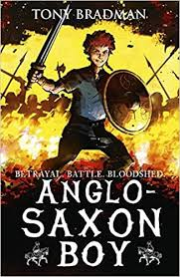  Fiction Non-fiction |  | Year 5 Sub-Focus Texts:  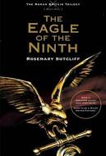  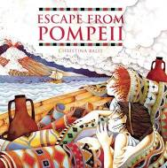  Non-fiction Fiction |  | Year 5 Sub-Focus Texts:  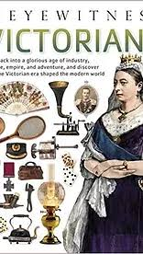  Fiction Non-fiction  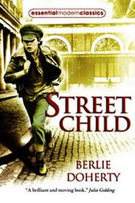
Year 6 | 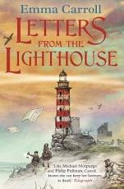  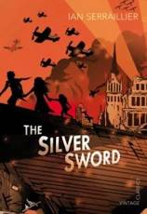  Fiction  Fiction | 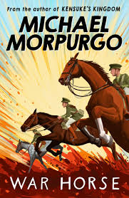  Fiction  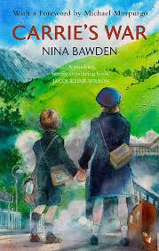  Fiction | 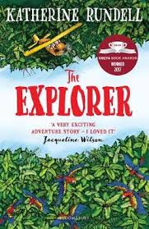  Fiction | 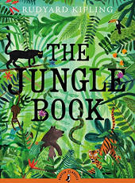  Fiction | 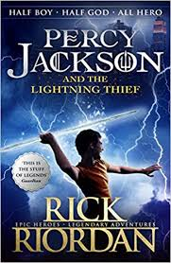  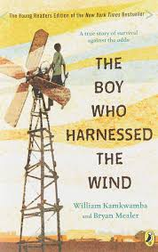  Fiction  Fiction | 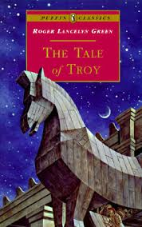  Fiction  Fiction
 | Year 6 Sub-Focus Texts:  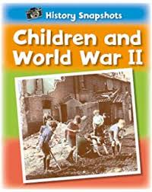  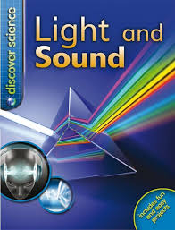  Non-fiction Non-fiction |  | Year 6 Sub-Focus Texts:  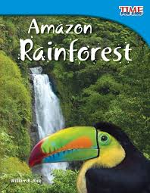  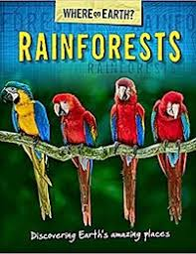  Non-fiction Non-fiction |  | Year 6 Sub-Focus Texts:  Ancient Greek  Mythology Non-fiction  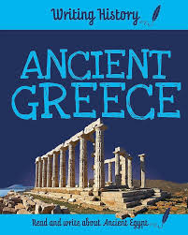  Non-fiction

