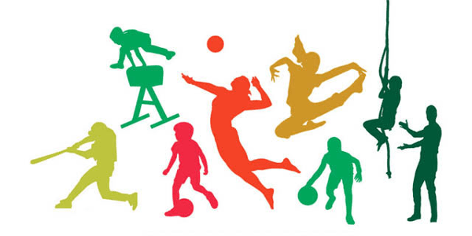
PE Curriculum
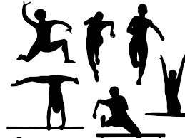
PE Overview
 | Autumn |  | Spring |  | Summer
 | Autumn 1 | Autumn 2 | Spring 1 | Spring 2 | Summer 1 | Summer 2
Year 3 | Dance  Rugby | 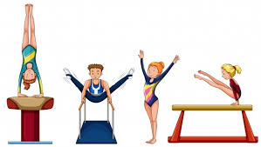  Football  Gymnastics | Tennis  Netball | 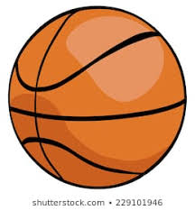  Basketball  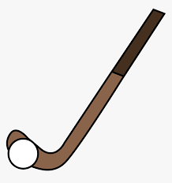  Hockey | 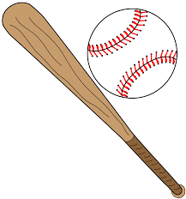  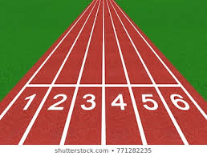  Athletics  Rounders | Rounders  Athletics
Year 4 | Dance  Rugby | Football  Gymnastics | Tennis  Netball | Basketball  Hockey | Athletics  Rounders | Rounders  Athletics
Year 5 | Dance  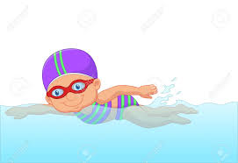  Swimming | Swimming  Gymnastics | Tennis  Swimming | Swimming  Hockey | Swimming  Rounders | Athletics  Swimming
Year 6 | Dance  Rugby | Football  Gymnastics | Tennis  Netball | Basketball  Hockey | Athletics  Rounders | Rounders  Athletics

Year 3
 | Autumn |  | Spring |  | Summer
 | Autumn 1 | Autumn 2 | Spring 1 | Spring 2 | Summer 1 | Summer 2
Overview | Dance  Rugby | Football  Gymnastics | Tennis  Netball | Basketball  Hockey | Athletics  Rounders | Rounders  Athletics
Suggested Content | I can begin to improvise independently to create a simple dance.  I can begin to improvise with a partner to create a simple dance.  I can translate ideas from stimuli into movement with support.  I can begin to compare and adapt movements and motifs to create a larger sequence.  I can use simple dance vocabulary to compare and improve work. | I can apply compositional ideas independently and with others to create a sequence.  I can copy, explore and remember a variety of movements and uses these to create my own sequence.  I can describe my own work using simple gym vocabulary.  I can begin to notice similarities and differences between sequences.  I can use turns whilst travelling in a variety of ways.  I can begin to show flexibility in movements  I can begin to develop good technique when travelling, balancing, using equipment etc | I can understand tactics and composition by starting to vary how they respond.  I can vary skills, actions and ideas and link these in ways that suit the games activity.  I can begin to communicate with others during game situations.  I can use skills with co-ordination and control.  I can develop my own rules for new games.  I can make imaginative pathways using equipment.  I can work well in a group to develop various games.  I can begin to understand how to compete with each other in a controlled manner.  I can begin to select resources independently to carry out different skills. | I can understand tactics and composition by starting to vary how they respond.  I can vary skills, actions and ideas and link these in ways that suit the games activity.  I can begin to communicate with others during game situations.  I can use skills with co-ordination and control.  I can develop my own rules for new games.  I can make imaginative pathways using equipment.  I can work well in a group to develop various games.  I can begin to understand how to compete with each other in a controlled manner.  I can begin to select resources independently to carry out different skills. | I can begin to run at speeds appropriate for the distance. e.g. sprinting and cross country  I can perform a running jump with some accuracy  I can perform a variety of throws using a selection of equipment.  I can use equipment safely and with good control. | I can begin to run at speeds appropriate for the distance. e.g. sprinting and cross country  I can perform a running jump with some accuracy  I can perform a variety of throws using a selection of equipment.  I can use equipment safely and with good control.

Year 4
 | Autumn |  | Spring |  | Summer
 | Autumn 1 | Autumn 2 | Spring 1 | Spring 2 | Summer 1 | Summer 2
Overview | Dance  Rugby | Football  Gymnastics | Tennis  Netball | Basketball  Hockey | Athletics  Rounders | Rounders  Athletics
Suggested Content | I can confidently improvise with a partner or on my own.  I can begin to create longer dance sequences in a larger group.  I can demonstrate precision and some control in response to stimuli.  I can begin to vary dynamics and develop actions and motifs.  I can demonstrate rhythm and spatial awareness.  I can modify parts of a sequence as a result of self-evaluation.  I can use simple dance vocabulary to compare and improve work. | I can link skills with control, technique, co-ordination and fluency.  I can understand composition by performing more complex sequences.  I can begin to use gym vocabulary to describe how to improve and refine performances.  I can strength, technique and flexibility throughout performances.  I can create sequences using various body shapes and equipment.  I can combine equipment with movement to create sequences. | I can vary skills, actions and ideas and link these in ways that suit the games activity.  I can show confidence in using ball skills in various ways, and can link these together. e.g. dribbling, bouncing, kicking  I can use skills with co-ordination, control and fluency.  I can take part in competitive games with a strong understanding of tactics and composition.  I can create my own games using knowledge and skills.  I can work well in a group to develop various games.  I can compare and comment on skills to support creation of new games.  I can make suggestions as to what resources can be used to differentiate a game.  I can use basic skills for attacking and defending.  I can use running, jumping, throwing and catching in isolation and combination. | I can vary skills, actions and ideas and link these in ways that suit the games activity.  I can show confidence in using ball skills in various ways, and can link these together. e.g. dribbling, bouncing, kicking  I can use skills with co-ordination, control and fluency.  I can take part in competitive games with a strong understanding of tactics and composition.  I can create my own games using knowledge and skills.  I can work well in a group to develop various games.  I can compare and comment on skills to support creation of new games.  I can make suggestions as to what resources can be used to differentiate a game.  I can use basic skills for attacking and defending.  I can use running, jumping, throwing and catching in isolation and combination. | I can begin to build a variety of running techniques and use with confidence.  I can perform a running jump with more than one component. e.g. hop skip jump (triple jump)  I can demonstrate accuracy in throwing and catching activities.  I can describe good athletic performance using correct vocabulary.  I can use equipment safely and with good control. | I can begin to build a variety of running techniques and use with confidence.  I can perform a running jump with more than one component. e.g. hop skip jump (triple jump)  I can demonstrate accuracy in throwing and catching activities.  I can describe good athletic performance using correct vocabulary.  I can use equipment safely and with good control.

Year 5
 | Autumn |  | Spring |  | Summer
 | Autumn 1 | Autumn 2 | Spring 1 | Spring 2 | Summer 1 | Summer 2
Overview | Dance  Swimming | Swimming  Gymnastics | Tennis  Swimming | Swimming  Hockey | Swimming  Rounders | Athletics  Swimming
Suggested Content | I can swim competently, confidently and proficiently over a distance of at least 25 metres  I can use a range of strokes effectively e.g. front crawl, backstroke and breaststroke.  I can perform safe self-rescue in different water-based situations. | I can swim competently, confidently and proficiently over a distance of at least 25 metres  I can use a range of strokes effectively e.g. front crawl, backstroke and breaststroke.  I can perform safe self-rescue in different water-based situations. | I can vary skills, actions and ideas and link these in ways that suit the games activity.  I can show confidence in using ball skills in various ways, and can link these together effectively. e.g. dribbling, bouncing, kicking  I can keep possession of balls during games situations.  I can consistently use skills with co-ordination, control and fluency.  I can take part in competitive games with a strong understanding of tactics and composition.  I can create their own games using knowledge and skills.  I can modify competitive games.  I can compare and comments on skills to support creation of new games.  I can make suggestions as to what resources can be used to differentiate a game.  I can apply knowledge of skills for attacking and defending.  I can use running, jumping, throwing and catching in isolation and in combination. | I can vary skills, actions and ideas and link these in ways that suit the games activity.  I can show confidence in using ball skills in various ways, and can link these together effectively. e.g. dribbling, bouncing, kicking  I can keep possession of balls during games situations.  I can consistently use skills with co-ordination, control and fluency.  I can take part in competitive games with a strong understanding of tactics and composition.  I can create their own games using knowledge and skills.  I can modify competitive games.  I can compare and comments on skills to support creation of new games.  I can make suggestions as to what resources can be used to differentiate a game.  I can apply knowledge of skills for attacking and defending.  I can use running, jumping, throwing and catching in isolation and in combination. | I can swim competently, confidently and proficiently over a distance of at least 25 metres  I can use a range of strokes effectively e.g. front crawl, backstroke and breaststroke.  I can perform safe self-rescue in different water-based situations. | I can begin to build a variety of running techniques and use with confidence.  I can perform a running jump with more than one component. e.g. hop skip jump (triple jump)  I can begin to record peers performances, and evaluate these.  I can demonstrate accuracy and confidence in throwing and catching activities.  I can describe good athletic performance using correct vocabulary.  I can use equipment safely and with good control.

#
Year 6
 | Autumn |  | Spring |  | Summer
 | Autumn 1 | Autumn 2 | Spring 1 | Spring 2 | Summer 1 | Summer 2
Overview | Dance  Rugby | Football  Gymnastics | Tennis  Netball | Basketball  Hockey | Athletics  Rounders | Rounders  Athletics
Suggested Content | I can confidently improvise with a partner or on my own.  I can begin to create longer dance sequences in a larger group.  I can demonstrate precision and some control in response to stimuli.  I can begin to vary dynamics and develop actions and motifs.  I can demonstrate rhythm and spatial awareness.  I can modify parts of a sequence as a result of self-evaluation.  I can use simple dance vocabulary to compare and improve work. | I can select and combine my skills, techniques and ideas.  I can apply combined skills accurately and appropriately, consistently showing precision, control and fluency.  I can draw on what I know about strategy, tactics and composition when performing and evaluating.  I can analyse and comment on skills and techniques and how these are applied in my own and others' work.  I can use more complex gym vocabulary to describe how to improve and refine performances.  I can develop strength, technique and flexibility throughout performances.  I can link skills with control, technique, co-ordination and fluency.  I can understand composition by performing more complex sequences | I can vary skills, actions and ideas and link these in ways that suit the games activity.  I can show confidence in using ball skills in various ways, and can link these together.  I can use skills with co-ordination, control and fluency.  I can take part in competitive games with a strong understanding of tactics and composition.  I can create their own games using knowledge and skills.  I can make suggestions as to what resources can be used to differentiate a game.  I can apply basic skills for attacking and defending.  I can use running, jumping, throwing and catching in isolation and combination. | I can vary skills, actions and ideas and link these in ways that suit the games activity.  I can show confidence in using ball skills in various ways, and can link these together.  I can use skills with co-ordination, control and fluency.  I can take part in competitive games with a strong understanding of tactics and composition.  I can create their own games using knowledge and skills.  I can make suggestions as to what resources can be used to differentiate a game.  I can apply basic skills for attacking and defending.  I can use running, jumping, throwing and catching in isolation and combination. | I can begin to build a variety of running techniques and use with confidence.  I can perform a running jump with more than one component. e.g. hop skip jump (triple jump)  I can begin to record peers performances, and evaluate these.  I can demonstrate accuracy and confidence in throwing and catching activities.  I can describe good athletic performance using correct vocabulary.  I can use equipment safely and with good control. | I can begin to build a variety of running techniques and use with confidence.  I can perform a running jump with more than one component. e.g. hop skip jump (triple jump)  I can begin to record peers performances, and evaluate these.  I can demonstrate accuracy and confidence in throwing and catching activities.  I can describe good athletic performance using correct vocabulary.  I can use equipment safely and with good control.

