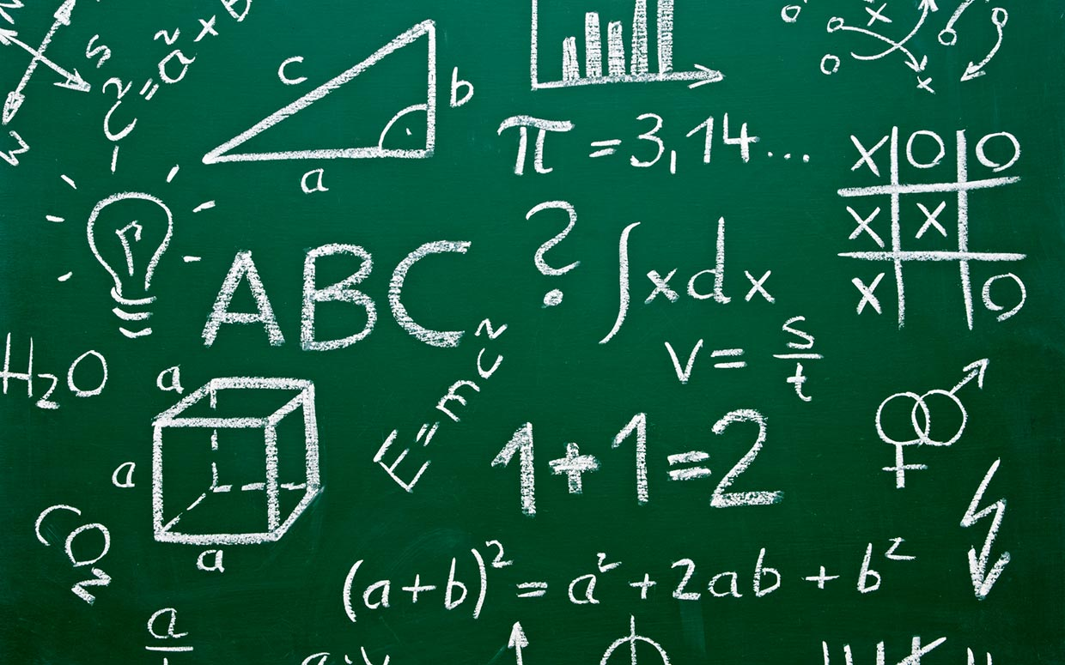

Maths
Curriculum

Maths Overview

 | Autumn |  | Spring |  | Summer
 | Autumn 1 | Autumn 2 | Spring 1 | Spring 2 | Summer 1 | Summer 2
Year 3 | Place Value  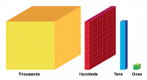  Addition and Subtraction | Addition and Subtraction  Multiplication and Division | Multiplication and Division  Money  Statistics | Length and Perimeter  Fractions  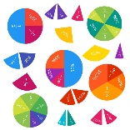 | Fractions  Time  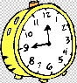 | Properties of shape  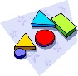  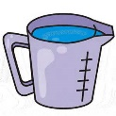  Mass and Capacity
Year 4 | Place Value  Addition and Subtraction | Length and Perimeter  Multiplication and Division | Multiplication and Division  Area  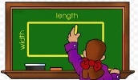 | Fractions  Decimals  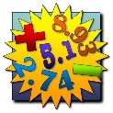 | Decimals  Money  Time | Statistics  Properties of Shape/Position and direction
Year 5 | Place Value  Addition and Subtraction  Statistics | Multiplication and Division  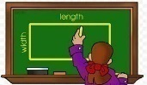  Perimeter and Area | Multiplication and Division  Fractions | Fractions  Decimals and Percentages  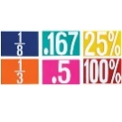 | Decimals  Properties of shape/Position and Direction | Converting units of measure  Volume  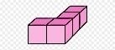
Year  6 | Place Value  Addition, Subtraction, Multiplication and Division  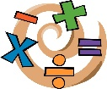 | Fractions  Position and Direction  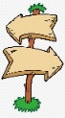 | Decimals and Percentages  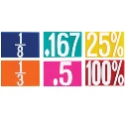  Algebra  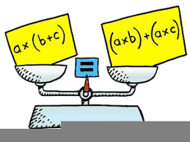 | Converting units of measure  Perimeter, Area and Volume  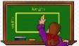  Ratio | Properties of shape  Problem Solving  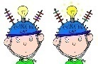 | Statistics  Investigations
Year 3
 | Autumn |  | Spring |  | Summer
 | Autumn 1 | Autumn 2 | Spring 1 | Spring 2 | Summer 1 | Summer 2
Overview | Place Value  Addition and Subtraction | Addition and Subtraction  Multiplication and Division | Multiplication and Division  Money  Statistics | Length and Perimeter  Fractions | Fractions  Time | Properties of shape  Mass and Capacity
Suggested Content/Material | 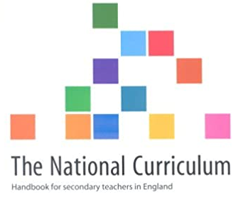

KPIs
Autumn | Spring | Summer
3.1.1 Identify, represent and estimate numbers using different representations  3.1.2 Find 10 or 100 more or less than a given number.  3.1.3 Recognise the place value of each digit in a 3 digit number  3.1.4 Compare and order numbers up to 1000  3.1.5 Read and write numbers to 1,000 in numerals and words  3.1.6 Solve number problems and practical problems involving the above ideas  3.1.8 Count from 0 in multiples of 50 and 100.  3.1.9 Add and subtract numbers mentally, including 3 digit numbers & ones (365+5)  3.1.10 Add and subtract numbers mentally, including 3-digit numbers & tens (365+10)  3.1.11 Add and subtract numbers mentally, including 3-digit numbers & hundreds (365 +432)  3.1.12 Add numbers with up to 3 digits, using formal written methods of columnar addition.  3.1.13 Subtract numbers with up to 3 digit, using formal written methods of columnar subtraction.  3.1.14 Estimate the answer to a calculation and use the inverse operations to check answers.  3.1.15 Solve problems including missing number problems, place value and more complex addition and subtraction.  3.1.16 Recall and use the multiplication and division facts for the 3, 4 and 8 tables. | 3.1.17 Write and calculate mathematical statements for multiplication using known multiplication tables, including 2-digit x 1-digit, using mental and progressing to formal written methods.  3.1.18 Write and calculate mathematical statements for multiplication and division using known multiplication tables, including use of money and length  3.1.19 Solve problems, including missing number problems, involving multiplication and division, including positive integer scaling problems and correspondence problems in which n objects are connected to m objectives.  3.2.1 Add and subtract amounts of money to give change using both £ and p in practical contexts.  3.4.1 Interpret and present data using bar charts  3.4.2 Interpret and present data using pictograms  3.4.3 Interpret and present data using tables  3.4.4 Read and present information from a bar chart that has a scale on the vertical axis  3.4.5 Solve 1-step and 2-step questions such as ‘How many more?’ and ‘How many fewer?’ using information presented in scaled bar charts pictograms and other graphs  3.2.2 Measure, compare, add & subtract lengths (m/cm/mm)  3.1.27 Add and subtract measures (length, weight and volume) with up to 3 digits, using formal written methods of columnar addition and subtraction.  3.2.5 Measure the perimeter of simple 2D shapes.  .1.20 Count up and down in tenths; recognise that tenths arise from dividing an object into ten equal parts and in dividing numbers or quantities by 10.  3.1.21 Recognise and use fractions as numbers: unit fractions and non-unit fractions with small denominators.  3.1.22 Recognise, find and write fractions of a discrete set of objects: unit fractions & non-unit fractions with small denominators | 3.1.23 Recognise and show, using diagrams, equivalent fractions with small denominators.  3.1.24 Compare and order unit fractions, and fractions with the same denominators.  3.1.25 Add and subtract fractions with the same denominator within one whole.  3.1.26 Solve problems that involve all of the fraction objectives above.  3.2.6 Tell and write the time from an analogue clock, including using Roman numerals from I to XII and 12 and 24 hour clocks  3.2.7 Estimate and read time with increasing accuracy to the nearest minute;  3.2.8 Record and compare time in terms of seconds, minutes, hours.  3.2.9 Use vocabulary such as o’clock, am/pm, morning, afternoon, noon and midnight.  3.2.10 Know the numbers of seconds in a minute and the number of days in each month, year and leap year.  3.2.11 Compare durations of events, for example to calculate time taken by particular events or tasks.  3.3.1 Recognise angles are a property of shape or a description of a turn.  3.3.2 Identify right angles; recognise that two right angles make a half-turn, three make three quarters & four a complete turn  3.3.3 Identify whether angles are greater than or less than a right angle  3.3.4 Identify horizontal and vertical lines and pairs of perpendicular & parallel lines.  3.3.5 Draw 2D shapes  3.3.6 Make 3D shapes using modelling materials  3.3.7 Recognise 3D shapes in different orientations; & describe them  3.2.3 Measure, compare, add & subtract mass (kg/g)  3.2.4 Measure, compare, add & subtract volume/ capacity (l/ml).

Year 4
 | Autumn |  | Spring |  | Summer
 | Autumn 1 | Autumn 2 | Spring 1 | Spring 2 | Summer 1 | Summer 2
Overview | Place Value  Addition and Subtraction | Length and Perimeter  Multiplication and Division | Multiplication and Division  Area | Fractions  Decimals | Decimals  Money  Time | Statistics  Properties of Shape/Position and direction
Suggested Content
KPIs
Autumn | Spring | Summer
4.1.1 Count in multiples of 6, 7, 9, 25 and 1000  4.1.2 Count in multiples of 25 and 1000  4.1.3 Find 1000 more or less than a given number  4.1.4 Recognise the place value of each digit in a four digit number  4.1.5 Compare and order numbers beyond 1000  4.1.6 Identify, represent and estimate numbers using different representations  4.1.7 Round any number to the nearest 10, 100 or 1000  4.1.8 Solve number and practical problems that involve all of the above with increasingly large positive numbers  4.1.9 Count backwards through zero to include negative numbers  4.1.10 Read Roman numerals to 100 and understand that over time, the numeral system changes to include the concept of zero and place value  4.1.11 Add numbers with up to 4 digits using the formal written methods of columnar addition and subtraction, where appropriate  4.1.12 Subtract numbers with up to 4 digits using the formal written methods of columnar addition and subtraction, where appropriate  4.1.13 Estimate and use inverse operations to check answers to a calculation  4.1.14 Solve addition and subtraction two-step problems in contexts, deciding which operations and methods to use and why  4.2.1 Measure and calculate the perimeter of a rectilinear figure (including squares) in cm and m  4.2.2 Convert between different units of measure (e.g. km to m; hr to min)  4.1.15 Recall multiplication and division facts for tables up to 12x12  4.1.16 Use place value, known and derived facts to multiply and divide mentally, including multiplying by 0 and 1; multiplying three numbers together | 4.1.15 Recall multiplication and division facts for tables up to 12x12  4.1.16 Use place value, known and derived facts to multiply and divide mentally, including multiplying by 0 and 1; multiplying three numbers together  4.1.17 Solve problems involving multiplying and adding, using the distributive law to multiply two digit numbers by 1 digit, integer scaling problems and harder correspondence problems such as n objects are connected to m objects  4.1.18 Recognise and use factor pairs and commutativity in mental calculations  4.1.19 Multiply 2-digit and 3-digit numbers by a 1-digit number using formal written layout  4.1.20 Divide 2-digit and 3-digit numbers by a 1-digit number using formal written layout with no remainder  4.2.3 Find the area of rectilinear shapes by counting squares  4.1.21 Recognise and show, using diagrams, families of common equivalent fractions  4.1.22 Count up and down in hundredths; recognise that hundredths arise from dividing an object into 100 equal parts and in dividing numbers or quantities by 100  4.1.23 Solve problems involving increasingly harder fractions to calculate quantities, and fractions to divide quantities including non-unit fractions where the answer is a whole number  4.1.24 Add and subtract fractions with the same denominator  4.1.25 Recognise and write decimals equivalents of any number of tenths or hundredths  4.1.26 Find the effect of dividing a 1-digit or 2-digit number by 10 and 100, identifying the value of the digits in the answer as ones, tenths and hundredths  4.1.31 Find the effect of multiplying a number with up to 2 decimal places by 10 and 100, identifying the value of the digits in the answer as ones, tenths and hundredths  4.1.32 Find the effect of dividing a number with up to 2 decimal places by 10 and 100, identifying the value of the digits in the answer as ones, tenths and hundredths | 4.1.27 Solve simple measure and money problems involving fractions and decimals to 2 decimal places  4.1.28 Compare numbers with the same number of decimal places up to two decimal places  4.1.29 Round decimals with one decimal place to the nearest whole number  4.1.30 Recognise and write decimal equivalents to ¼, ½ and ¾  4.2.4 Estimate, compare and calculate different measures including in pounds and pence  4.2.5 Solve simple measure and money problems involving fractions and decimals to 2 decimal places  4.2.6 Read, write & convert time between analogue and digital 12- and 24-hour clocks  4.2.7 Solve problems involving converting from hours to minutes; minutes to seconds; years to months; weeks to days  4.4.1 Interpret and present discrete and continuous data using appropriate graphical methods, including: -bar charts -time graphs  4.4.2 Solve comparison, sum and difference problems using information presented in bar charts, pictograms, tables and other graphs  4.3.1 Identify acute and obtuse angles and compare and order angles up to two right angles by size  4.3.2 Compare and classify geometric shapes, including quadrilaterals and triangles, based on their properties and sizes  4.3.3 Identify lines of symmetry in 2D shapes presented in different orientations  4.3.4 Complete a simple symmetric figure with respect to a specific line of symmetry  4.3.5 Describe positions on a 2D grid as coordinates in the first quadrant  4.3.6 Plot specified points and draw sides to complete given polygon  4.3.7 Describe movements between positions as translations of a given unit to the left/right and up/down

Year 5
 | Autumn |  | Spring |  | Summer
 | Autumn 1 | Autumn 2 | Spring 1 | Spring 2 | Summer 1 | Summer 2
Overview | Place Value  Addition and Subtraction  Statistics | Multiplication and Division  Perimeter and Area | Multiplication and Division  Fractions | Fractions  Decimals and Percentages | Decimals  Properties of shape/Position and Direction | Converting units of measure  Volume
Suggested Content

KPIs
Autumn | Spring | Summer
5.1.1 Read, write, order and compare numbers to at least 1,000,000 and determine the value of each digit  5.1.2 Count forwards or backwards in steps of powers of 10 for any given number up to 1,000,000  5.1.3 Interpret negative numbers in context, count forwards and backwards with positive and negative numbers including through zero  5.1.4 Round any number up to 1,000,000 to the nearest 10, 100, and 1000  5.1.5 Round any number up to 1,000,000 to the nearest 10000 or 100000  5.1.6 Solve number problems and practical problems that involve all of the above  5.1.7 Read Roman numerals to 1000 and recognise years written in Roman numerals  5.1.12 Add whole numbers with more than 4 digits including using formal written methods (columnar addition)  5.1.13 Subtract whole numbers with more than 4 digits including using formal written methods (columnar subtraction)  5.1.14 Use rounding to check answers to calculations and determine, in the context of a problem, levels of accuracy  5.1.15 Solve addition and subtraction multi-step problems in contexts, deciding which operations and methods to use and why  5.4.1 Solve comparison, addition and difference problems using information presented in a line graph  5.4.2 Complete, read and interpret information in tables, including timetables  5.4.3 Know how to construct a table from a set of given information  5.4.4 Know how to construct a table using only the relevant information  5.4.5 Construct own table and timetable making decision about labelling  5.1.15 Solve addition and subtraction multi-step problems in contexts, deciding which operations and methods to use and why  5.1.16 Multiply and divide numbers mentally drawing upon known facts. (12x12)  5.1.17 Multiply whole numbers and those involving decimals by 10, 100 and 1000  5.1.18 Divide whole numbers and those involving decimals by 10, 100 and 1000  5.1.19 Identify multiples and factors including finding all factor pairs of a number and common factors of two numbers up to 100  5.1.20 Recognise and use square numbers and cube numbers, and the notation for square2 and cubed3  5.1.21 Solve problems involving multiplication and division including using their knowledge of factors and multiples, squares and cubes  5.1.22 Know and use the vocabulary of prime numbers, prime factors and composite (non-prime) numbers  5.1.23 Establish whether a number up to 100 is prime and recall prime numbers up to 19  5.2.1 Measure and calculate the perimeter of composite rectilinear shapes in cm and m  5.2.2 Calculate & compare the area of rectangles (including squares, & including using standard units, square centimetres (cm2) and square metres (m2)  5.2.3 Estimate the area of irregular shapes  5.2.4 Calculate & compare the area of rectangles (including squares) including using standard units, square centimetres (cm2) and square metres (m2) & estimate the area of irregular shapes | 5.1.24 Multiply numbers up to 4-digits by a 1-digit using formal written methods  5.1.25 Multiply 2-digit number using a formal written method, including long multiplication for 2-digit numbers  5.1.26 Divide numbers up to 4-digits by a 1-digit number using the formal written method of short division  5.1.27 Interpret remainders appropriately for the context  5.1.28 Solve problems involving addition and subtraction, multiplication and division and a combination of these, including understanding the use of the equals sign  5.1.29 Compare and order fractions whose denominators are all multiples of the same number  5.1.30 Convert fractions with different denominators to have a common denominator  5.1.31 Identify, name and write equivalent fractions of a given fraction, represented visually, including tenths and hundredths  5.1.32 Recognise mixed numbers and improper fractions and convert from one form to the other and write mathematical statements  5.1.33 Add and subtract fractions with the same denominator and denominators that are multiples of the same number  5.1.34 Multiply proper fractions and mixed numbers by whole numbers, supported by materials and diagrams  .1.35 Read and write decimal numbers as fractions, e.g. 0.71 = 71/100  5.1.36 Solve problems involving multiplication and division, including scaling by simple fractions and problems involving simple rates  5.1.37 Read, write, order and compare numbers with up to three decimal places  5.1.38 Count up and down in thousandths; recognise that thousandths arise from dividing an object into 1000 equal parts and in dividing numbers or quantities by 1000  5.1.39 Recognise and use thousandths and relate them to tenths, hundredths and decimal equivalents  5.1.40 Round decimals with two decimal places to the nearest whole number and to one decimal place  5.1.41 Solve problems involving number up to three decimal places  5.1.42 Recognise the percent symbol (%) and understand that per cent relates to ‘number of parts per hundred’ and write percentages as a fraction with denominator 100, and as a decimal  5.1.43 Solve problems which require knowing percentage and decimal equivalents of 1/2, 1/4, 1/5, 2/5, 4/5 and those fractions with a denominator of a multiple of 10 or 25 | 5.1.44 Use all four operations to solve problems involving measure (length, mass, volume, money) using decimal notation, including scaling  5.3.4 Know angles are measured in degrees; estimate & compare acute, obtuse & reflex angles  5.3.5 Draw given angles & measure them in degrees  5.3.6 Identify angles at a point on a straight line & ½ a turn (total 180°)  5.3.7 Identify angles at a point & one whole turn (total 360°)  5.3.8 Identify other multiples of 90°  5.3.1 Identify 3D shapes, including cubes and other cuboids, from 2D representations  5.3.2 Use the properties of rectangles to deduce related facts & find missing lengths & angles  5.3.3 Distinguish between regular and irregular polygons based on reasoning about equal sides and angles  .2.5 Convert between different units of metric measure (e.g. km/m; cm/m; cm/mm; g/kg; l/ml)  5.2.6 Understand and use approximate equivalences between metric units and common imperial units such as inches, pounds and pints  5.2.7 Solve problems involving converting between units of time  5.2.8 Estimate volume (e.g. using 1 cm3 blocks to build cubes, including cuboids) & capacity (e.g. using water)  5.2.9 Use all four operations to solve problems involving measure

Year 6

 | Autumn |  | Spring |  | Summer
 | Autumn 1 | Autumn 2 | Spring 1 | Spring 2 | Summer 1 | Summer 2
Overview | Place Value  Addition, Subtraction, Multiplication and Division | Fractions  Position and Direction | Decimals and Percentages  Algebra | Converting units of measure  Perimeter, Area and Volume  Ratio | Properties of shape  Problem Solving | Statistics  Investigations
Suggested Content
KPIs
Autumn | Spring | Summer
6.1.1 Read, write, order and compare numbers up to 10,000,000 and determine the value of each digit  6.1.2 Round any whole number to the required degree of accuracy  6.1.3 Use negative numbers in context and calculate intervals across zero  6.1.4 Solve number and practical problems that involve rounding, negative numbers and  comparing numbers up to 10 000 000  6.1.5 Solve addition and subtraction multi step problems in contexts, deciding which operations and methods to use and why  6.1.6 Multiply multi-digit numbers up to 4-digits by a 2-digit whole number using the formal written method of long multiplication  6.1.7 Divide numbers up to 4-digits by a 2-digit whole number using the formal written method of long division, and interpret remainders as whole number remainders, fractions, or by rounding, as appropriate for the context  6.1.8 Divide numbers up to 4-digits by a 2-digit number using the formal written method of short division, where appropriate, interpreting remainders according to the context  6.1.9 Perform mental calculations, including mixed numbers and large numbers in multiplication and division  6.1.10 Identify common factors, common multiples and prime numbers  6.1.11 Use their knowledge of the order of operations to carry out calculations involving the four operations  6.1.12 Consolidate all learning in relation to the four operations using formal efficient methods at all times  6.1.13 Use estimation to check answers to calculations and determine, in the context of a problem, levels of accuracy  6.1.14 Use common factors to simplify fractions; use common multiples to express fractions in the same denomination  6.1.15 Compare and order fractions, including fractions >1  6.1.16 Generate and describe linear number sequences  6.1.17 Add fractions with different denominators and mixed numbers, using the concept of equivalent fractions  6.1.18 Subtract fractions with different denominators and mixed numbers, using the concept of equivalent fractions  6.1.19 Divide proper fractions by whole numbers  6.3.1 Describe positions on the full coordinate grid, all four quadrants  6.3.2 Draw and translate simple shapes on the coordinate plane and reflect them in the axes | 6.1.20 Associate a fraction with division and calculate decimal fraction equivalents (for example 0.375) for a simple fraction (for example 3/8)  6.1.23 Multiply one digit numbers with up to 2 decimal places by whole numbers  6.1.24 Use written division methods in cases where the answer has up to 2 decimal places  6.1.25 Solve problems which require answers to be rounded to specifies degrees of accuracy  6.1.21 Recall and use equivalences between simple fractions, decimals and percentages, including different contexts  6.1.26 Solve problems involving the calculation of percentages of whole numbers or measures such as 15% of 360 and the use of percentages for comparison  6.1.27 Use simple formulae to solve problems  6.1.28 Express missing number problems algebraically  6.1.29 Find pairs of numbers that satisfy an equation with two unknowns  6.1.30 Enumerate possibilities of combinations of two variables  6.1.31 Solve problems involving the relative sizes of two quantities where missing values can be found by using integer multiplication and division facts  6.2.1 Solve problems involving the calculation and conversion of units of measure, using decimal notation to three decimal places where appropriate  6.2.2 Use, read, write and convert between standard units, converting measurements of length, mass, volume and time from a smaller unit of measure to a larger unit, and vice versa, using decimal notation to three decimal places  6.2.3 Convert between miles & km  6.1.31 Solve problems involving the relative sizes of two quantities where missing values can be found by using integer multiplication and division facts  6.1.32 Solve problems involving similar shapes where the scale factor is unknown or can be found  6.1.33 Solve problems involving unequal sharing and grouping using knowledge of fractions and multiples  6.1.34 Perform mental calculations, including with mixed operations and large numbers using efficient strategies such as manipulating expressions using commutative and distributive properties to simplify the calculation | 6.3.3 Draw 2D shapes (triangles, quadrilaterals, pentagons, hexagons) using given dimensions and angles  6.3.4 Compare and classify geometric shapes based on their properties and sizes  6.3.5 Find unknown angles in any triangles, quadrilaterals, and regular polygons  6.3.6 Recognise, describe and build simple 3D shapes, including making nets  6.3.7 Recognise angles where they meet at a point, are on a straight line, or are vertically opposite, and find missing angles  6.4.1 Interpret and construct: Pie charts, line graphs and use these to solve problems  6.4.2 Calculate and interpret the mean as an average (Mean, mode and median, range)

