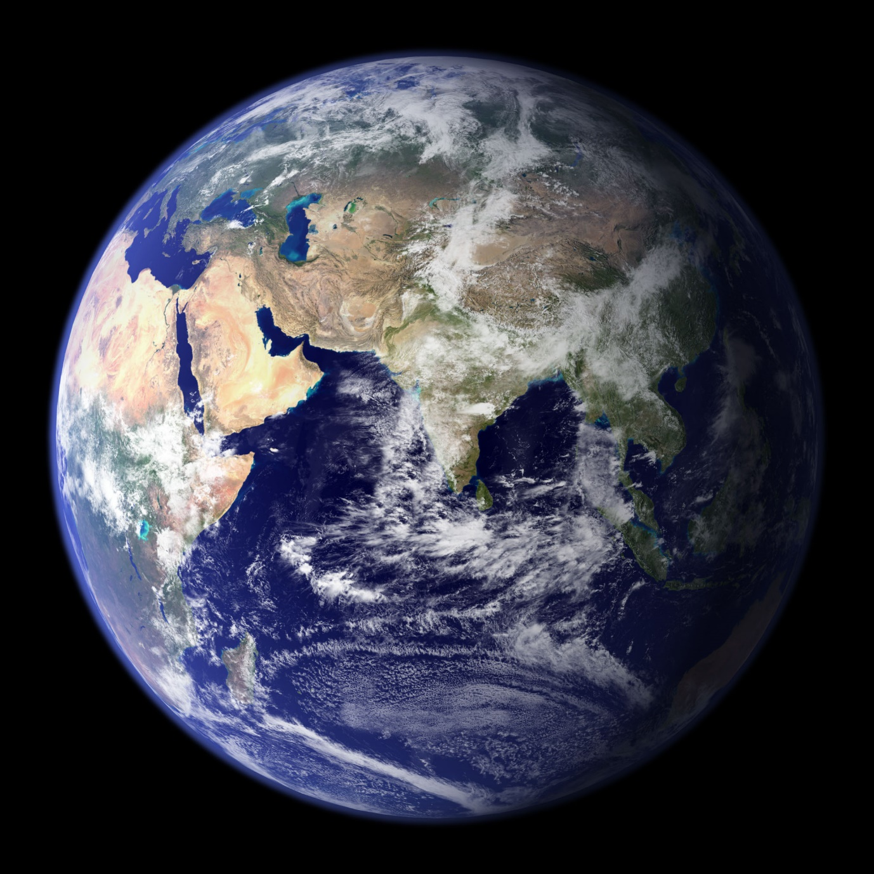

Geography and History Curriculum

Humanities Overview
 | Autumn |  | Spring |  | Summer
 | History | Geography | History | Geography | History | Geography
Year 3 | The Stone Age  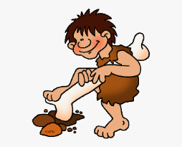 | The World | The Iron and Bronze Age  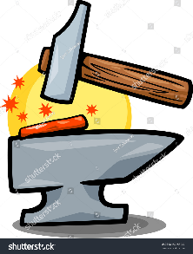 | Climate and Weather  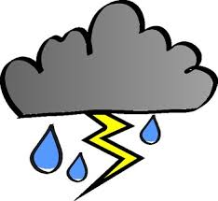 | Local History | Coastal Study  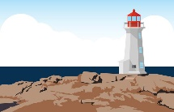
Year 4 | Ancient Egypt  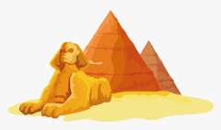 | Rivers  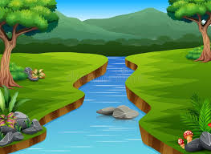 | Ancient Greece | Modern Greece  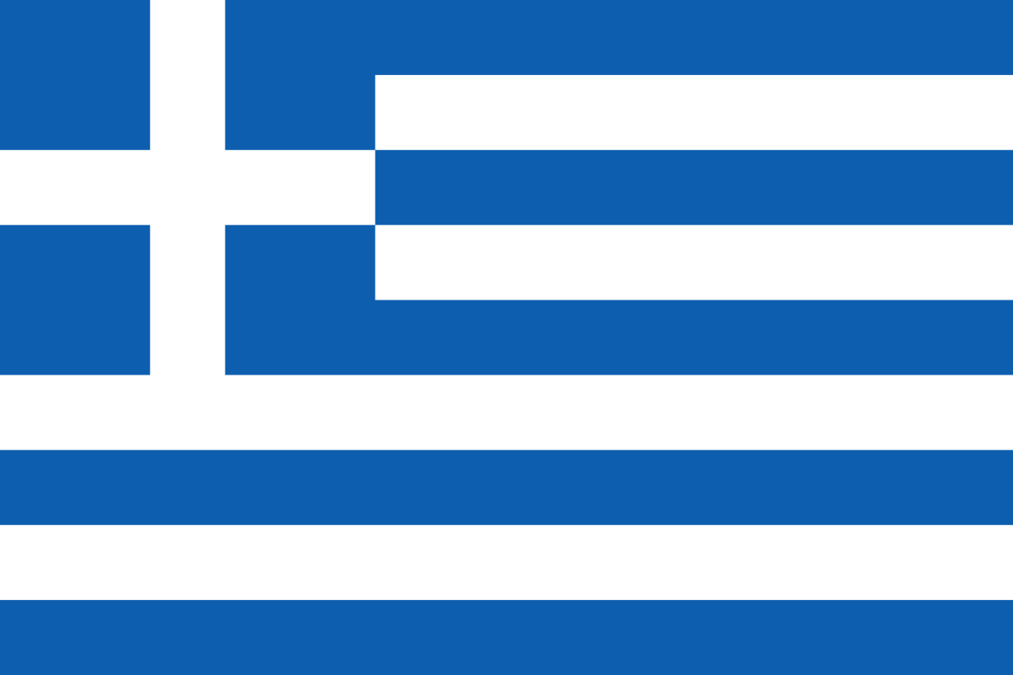 | Roman Britain  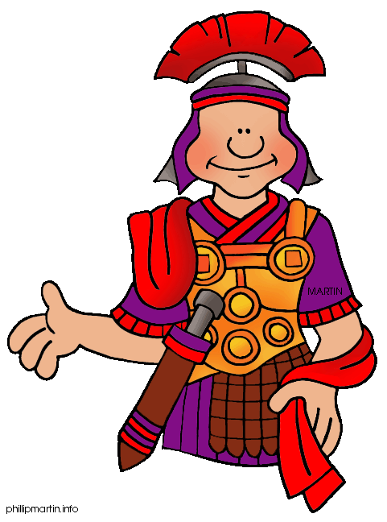 | UK Settlements  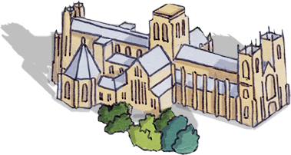
Year 5 | Anglo Saxons  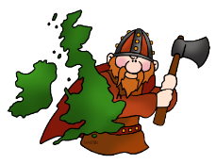 | Coasts  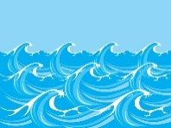 | Rome  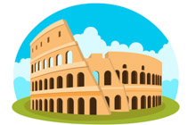 | Volcanoes  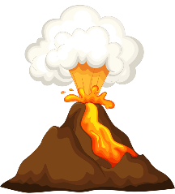 | Victorian Britain  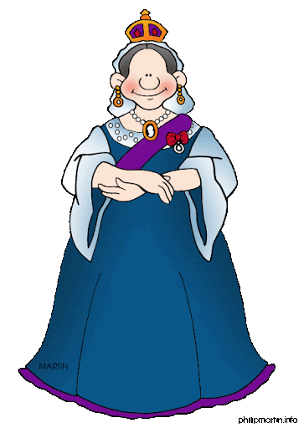 | Our local area
Year 6 | The World Wars  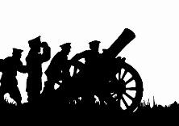 | European Geography | Mayan Civilization  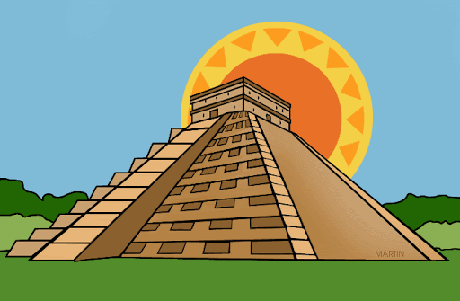 | Amazon Rainforest | Ancient Greece | Settlements
U
Year 3

 | Autumn | Spring | Summer
Overview | The World | Climate and Weather | Coastal Study
Suggested Content | Explain the relationship between globes and maps understand the significance of longitude and latitude correctly use most of the key vocabulary  Geographical regions; locational knowledge through identifying the position and significance of for example latitude, longitude, the Equator etc… | Research weather data from around the world.  Plot biomes on world maps. Understand how the climate dictates the biome  Describe and give examples of the variety of biomes.  Make links to science and habitats to understand animals adaptions to biomes | Describe several coastal environments in the UK and in other continents.  Explain how coasts change including the process of cave to stump.  Locate some major ports on maps  Identify the oceans and major seas on a world map.  Look at human uses of the seaside including tourism.
Key Vocab | Maps, globes, Tropics of Cancer, Tropics of Capricorn, equator, latitude, longitude, Earth’s rotation, axis, clockwise, anti- clockwise, Greenwich / Prime Meridian | Deserts, forest, grasslands, tundra environments. Climate soil, organisms, flora and fauna, polar, weather, climate, biomes, vegetation belts. | Coastal, change, region, human, physical. Settlement, economic, trade, distribution, energy, food, minerals, erosion, deposition
Geographical skills
Key questions | How can we describe where places are on the Earth’s surface?  What are the Tropics of Cancer and Capricorn? | What are weather, climate and biomes?  Which climate zone and biome do we live in? | What other features and activities can be seen around UK coasts?  Which sort of seaside would you choose?
Skills and fieldwork | Locate the names and counties and cities of the U.K. Use maps, atlases and globes. | Make predictions on climate based on places location in the world – proximity to equator etc. | Identify and explain some advantages and disadvantages of living by the coast.
Year 4

 | Autumn | Spring | Summer
Overview | Rivers | Modern Greece | UK Settlements
Suggested Content | Learn about famous rivers around the world.  A detailed study of The Nile (link to Ancient Egypt)  Understand why the Nile was Vital to the Ancient Egyptians and why it remains so important to Modern Egypt.  Understand the journey of a river from source to mouth.  Learn about the water cycle including key vocabulary. | Interpret a range of maps and aerial views of Athens, Greece and the Mediterranean region and apply this information to their understanding of it.  Understand topical issues in this region and consider the reliability of sources.  Learn about ways in which the location and distinctive features of Greece region compare with other places studies.  Understand how modern day Greece | Name and locate cities of the United Kingdom, geographical regions and their identifying human and physical characteristics.  Compare and contract land uses in different settlements  Study of Roman settlements (link to history)  Study and visit to York to look at land uses through time.  OS map work on Roman settlements and transport links.
Key Vocab |  | Tourism, coastline, culture, human features, physical features | Settlement, function, site, land use, accessibility, market, pattern, settlement pattern
Geographical skills
Key Questions | Why was the Nile important to Ancient Egyptians?  Why don’t we run out of water?  Where do rivers flow to? | Why is tourism important for the region?  What part does the climate play in the land use in Greece?  How does the Mediterranean Sea influence Greece? | What are the important features of a settlement site?  Why was York a key Settlement in Roman Britain?  Can you identify transport links on a map?  How has the settlement changed over time?
Skills and fieldwork | Describe and understand key aspects of physical geography, Inc., rivers and the water cycle. | Understand, use and apply appropriate geographical vocabulary to describe the location and distinctive features of modern Greece | Use fieldwork to observe, measure and record the human and physical features in the local area using a range of methods, sketch maps, plans and graphs and digital technology.

Year 5

 | Autumn | Spring | Summer
Overview | Coasts  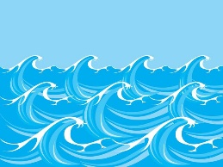 | Volcanoes  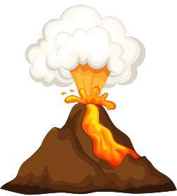 | Our local area
Suggested Content | Learn about key topographical or physical features of coasts to understand how some of these aspects developed, are hanging now and have changed over time including caves, arches, stacks etc.  Learn about the power of the sea – erosion/transportation  A study of a coastal community - Bridlington | Describe and understand the key aspects of volcanoes and earthquakes  Study the eruption of Pompeii.  Understand that the distribution of earthquakes and volcanoes follows a pattern  Plot and map tectonic plates and understand how they link to volcanoes and earthquakes  Learn about the ‘Pacific Ring of Fire’ | Study the changes in our local area  Understand geographical similarities and differences through the study of human and physical geography of a region of the UK  Use maps, atlases, globes and digital/computer mapping to locate countries and describe features  Use the eight points of a compass, four- and six-figure grid references, symbols and key
Key Vocab | Abrasion, arch, erosion, cliff, current, longshore drift, stack, stump | Magma, Lava, vent, eruption, tectonic, plate, conversion, subduction, diverting | How and why has the local area changed?  What evidence is there of Victorian influence in our local environment?
Geographical skills
Key Questions | What affect does the sea have upon the land?  How is does the land use of a coastal community differ from our own? | Why do people choose to live near disaster zones?  Why do volcanoes and earthquakes happen is similar areas? | How and why has the local area changed?  What evidence is there of Victorian influence in our local environment
Skills and fieldwork | Understand similarities and differences through the study of human and physical geography of a region of the UK | Understand that the distribution of earthquakes and volcanoes follows a pattern due to tectonic plates | Understand why and how the local area has changed  Use the eight point compass and six figure grid reference to describe location

 | Autumn | Spring | Summer
Overview | European Geography | Amazon Rainforest  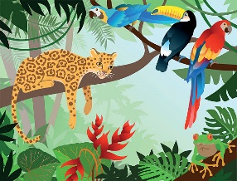 | Settlements
Suggested Content | Study of modern day Europe including map work on capitals and major cities.  Contrast between modern and 1930 Germany and UK  Use maps to show allied/axis movement through 1940s Europe.  Understand the geographical reasons of the World wars, | Understand life in the Amazon and compare this to life in the city of Manaus.  Plot the course of the Amazon through South America.  Investigate and describe the layers of the rainforest.  Investigate the pros and cons of deforestation and the effect it is having on the wider world | Create a plan for the future of the local area, considering the wider community’s needs (housing, public services and industries) and present their geographical ideas.  Look at land uses in an urban area including CBD and green belts.  Look at council planning developments.  Investigate how settlements have changed through time and the reasons for this.
Key Vocab | Grid reference, capital, industry, land use, administrate centre, European Union | Amazon basin, canopy, emergent, under canopy, continent, tropical, deciduous, logging, deforestation, carbon dioxide | Administrative centre, built environment, congestion, consultation, developer, development, economy  finance, green belt  greenhouse gases, nuclear power, planning  suburb, sustainable development
Geographical skills
Key Questions | How did the geography of Europe play a part in the outcome of WW2? | What is life like in the Amazon?  How does the agriculture compare to our locality? | How will our world look in the future?  How does land use vary around the world?
Skills and fieldwork | Plot capitals and major cities on a European Map. Identify locations using grid references. | Use maps, atlases, globes and digital/ computing mapping to locate countries and describe features studied. | Fieldwork – observe/ measure/ record human and physical features of settlements

Year 6

Year 3 | Autumn | Spring | Summer
Overview | 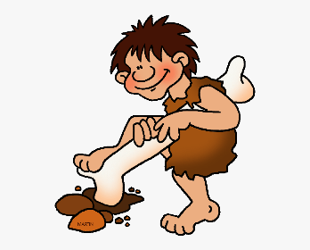  The Stone Age | The Iron Age and Bronze Age | Local Study
Suggested Content | Use of timeline to develop chronology of period.  Visit to Castleford Museum- Stepping into the Stone Age Workshop.  Examine and analyse Stone Age artefacts to understand what life was like and make comparisons.  Examine how monuments were constructed and create your own.  Create a Stone Age dwelling outside. | Link between previous learning of the Stone Age.  Come to conclusions about how life developed within the periods.  Use a variety of sources, including archaeological evidence.  Explore and compare written accounts and reconstruction drawings of both periods.  Link to physical geographical features of the location of communities or hill forts. | Explore the local area, focusing on the types of buildings and street names.  Develop a chronologically secure knowledge of the local history.  Conduct independent research using a variety of sources, like history books, street directories and census returns.
Key Vocab | Stone Age, prehistory, prehistoric, Neolithic, archaeology, flint, artefacts, Ice Age, quarry, forage, domesticated, reconstruction evidence, settlement, community, sacred, monument, megalith, significant, revolution. | Smelting, bronze, hoard, ore, mould, status, beaker, evidence, interpretations, radiocarbon dating, DNA testing, beliefs, afterlife, inference, marine archaeology. | Significant, listed, period names, architecture, names of features related to the buildings, architectural terms, terms related to time periods, campaign, migration, leisure, worship, heritage.
Historical Enquiry
Key questions | Why is it called the Stone Age? How much progress was made in the Stone Age? | Similarities and differences between Stone Age and Iron and Bronze Age? | What brought people to the local area? What is important about the locality?
Skills | Develop the appropriate use of historical terms, and note connections and contrasts over time. | Address historically valid questions about change, similarity and difference. | Develop a chronologically secure knowledge and understanding of British and local history.

Year 4

 | Autumn | Spring | Summer
Overview | 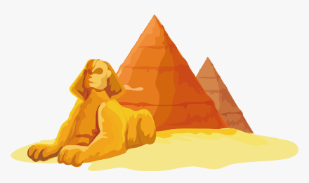  Ancient Egypt | Ancient Greece | Roman Britain
Suggested Content | Determine if the Ancient Egyptians were one of the most important early civilizations.  Compare with other ancient civilizations, as well as linking to what was happening at the same time in Britain.  Explore the uses of the River Nile and understand why this was important to Egypt.  Physical geography of Egypt- plotting location of cities on a map.  Understand mummification process. | Compare the similarities and differences between the Ancient Greeks and Ancient Egyptians.  Understand who held the power in Greece and how this compares to UK.  Investigate the topic using sources to understand what life was like in Ancient Greece.  Understand the story of how the Olympics began.  Research independently to compare Greek and Egyptian Gods. | Understand how much impact the Roman invasion had on the lives of the Celts.  Consider whether Roman settlement was a positive experience for all involved.  Investigate the topic through sources and artefacts.  Analyse written sources and consider why events were interpreted in a particular way.  Link to prior learning of Bronze and Iron Age.
Key Vocab | Ancient, civilisation, fertile, shaduf, irrigation, achievement, hieroglyph, archaeologists, cartouche, antiquities, scribes, society, seals, sarcophagus, excavation, inscription, papyrus, mummification, role, achievement, hierarchy, priest, farmer, agriculture, scribe, pharaoh, archaeobotanical, pyramid, engineering, technology, stonemason | Minoan, Mycenaean, Classical, Hellenistic, Roman Greek, city-state, democracy, architecture, empire, culture, terrain, predict, polis, agora, trireme, monarchy, oligarchy, citizens, slaves, suffrage, stadium, Olympic, revival, marathon, myth, temple, priest, hoplite, phalanx (strong block formation), interpret, legacy, impact. | Invade, invasion, conquer, republic, empire, emperor, status, glory, barbaric, legacy, resistance, primary evidence, interpretations, conquer, client kings, centurion, tablet, Picts, heritage, forts, garrisons, camber, groma, impact, transport system, positive, negative, significant, representation, interpretation, legions, legionaries, auxiliaries.
Historical Enquiry
Key questions | How much did the Ancient Egyptians achieve? | How important were the Gods in the daily lives of the Greeks? | What happened when the Romans came to Britain?
Skills | Study the achievements of the earliest civilisations. | Consistently answer and ask historically valid questions about similarity and difference. | Understand how our knowledge of the past is constructed from a range of source.

Year 5 | Autumn | Spring | Summer
Overview | 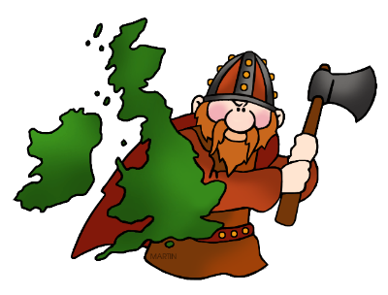  Anglo Saxons | The Roman Empire | The Victorians
Suggested Content | Examine and analyse sources to understand how people lived during this period.  Provide context to archaeological findings by linking to written sources from the time.  Links to geography with mapwork to show where the Saxons came from and where they settled.  Explore how physical geography effected settlements.  Hold balanced debates about the Anglo Saxons. | Make comparisons with the Romans and previous learning.  Analyse artefacts to understand how people lived in Pompeii.  Understand the physical geography to understand how people escaped from Mt Vesuvius eruption.  Understand how the Romans invaded other countries.  Carry out independent research to compile reports on the Roman Army. | Compile research from a range of sources to draw conclusions about the Victorian period.  Use timelines to develop chronology of period.  Explore the class system and how life differed across Victorian society.  Understand that the work of individuals can change aspects of society.  Understand how the industrial revolution transformed the local area and Britain.
Key Vocab | Invasion, settle, reconstruction, Dark Ages, pagan, plunder, Scandinavia, grave goods, archaeologist, excavation, function, sceptre, garnet, millefiori, hoard, metal detecting, saga, chronicle, illuminated manuscript, ecclesiastical, conversion, monastery, Old English, proof, evidence, counter argument. | invade, invasion, conquer, republic, empire, emperor, status, glory, barbaric, legacy, Pompeii, aqueduct, centurion, helmet, chariot, amphitheatre, toga, Colosseum, baths, gladiator, dictator, legion, plebeian, senate, forum | Victorian, Penny Black, telephone, chimney sweep, railway, locomotive, mining, factory, Houses of Parliament, flat iron, washboard, camera, steam engine, Queen Victoria, Charles Dickens, Prince Albert, reign, industrial revolution, workhouse, orphan, cotton mill, spinning top, gentlemen
Historical Enquiry
Key questions | Does the Anglo-Saxon period deserve to be called the Dark Ages? | What made the Romans successful? | Who were the Victorians and how did they live?
Skills | Construct informed responses that involve thoughtful selection and organisation of relevant historical information. | Address historically valid questions about change, cause and significance. | Develop a chronologically secure knowledge and understanding of British and world history.

Year 6

 | Autumn | Spring | Summer
Overview | 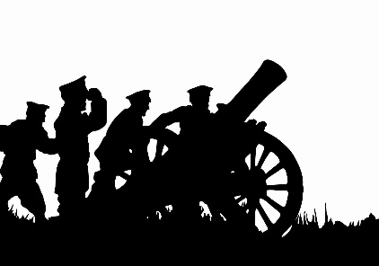  The Impact of War | Mayan Civilisation | Ancient Greece
Suggested Content | Use timelines to establish a clear chronology of both World Wars.  Research opportunities to explore how world wars impacted the local community.  Visits around local community to gather evidence or check accuracy.  Visit to Murton Park.  Understand the life of an evacuee and their experiences. | Analyse a news article about the discovery of the Maya.  Examine Mayan artefacts to develop understanding of daily life of people during that period.  Question reliability of sources that can be found online.  Compare lives of Maya today to the lives of Ancient Maya.  Geographical link- how does a change in climate effect a society? | Use timeline to gather chronology of this period.  Identify the influence that the Greeks have had on Western civilisation.  Look at how the Greek God’s still play a role in the world today.  Independently research and compile a fact file for Greek Gods.  Compare Greek Gods to world religion today.
Key Vocab | Sources, evidence, reliability, bias, utility, memorial, thankful village, civilian, inscription, casualty, protected/reserved occupations, conscription, volunteer, Blitz, evacuee, Kindertransport, refugee, logbook, rationing, imports, rural, urban, propaganda, home guard, Zeppelins, Luftwaffe, barrage, shells, bombs, memorial, commemorate, , mourning. | Religious, social, economic, cultural, political, civilisation, pyramid, temple, conclusion, evidence, reconstruction, archaeology, city state, sacrifice, Meso-America, nobles, creation, hierarchy, sacrifice, bloodletting, conquistadors, technology, culture, glyphs, agriculture, astronomy, calendar, trade, interpretations, theory, climate change, conquer, decline, codex/codices, pagan, scribe, significance | Minoan, Mycenaean, Classical, Hellenistic, Roman Greek, city-state, democracy, architecture, empire, culture, terrain, predict, polis, agora, trireme, monarchy, oligarchy, citizens, slaves, suffrage, stadium, Olympic, revival, marathon, myth, temple, priest, hoplite, phalanx (strong block formation), interpret, legacy, impact.
Historical Enquiry
Key questions | Did WWI or WWII have the biggest impact on our locality? | Why should we remember the Maya? | What did the Greeks do for us?
Skills | Continue to develop a chronologically secure knowledge and understanding of world history. | Regularly address historically valid questions about similarity and difference and significance. | Construct informed responses that involve thoughtful selection and organisation of historical information.

