DT
Curriculum

DT Overview
 | Autumn |  | Spring |  | Summer
 | Autumn 1 | Autumn 2 | Spring 1 | Spring 2 | Summer 1 | Summer 2
Year 3 | Where does food come from?  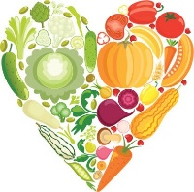  Cooking and Nutrition  What does healthy eating look like? |  | Outdoor Shelters  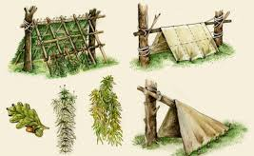  Design, Make and Evaluate  What is the purpose of your shelter? Which materials will you select? How will you make your structure? |  | Beach Bags  Design, Make and Evaluate  What will your bag need to carry? What will you put on your design? How will you carry your bag? How will it fasten?
Year 4 | Egyptian Shaduf  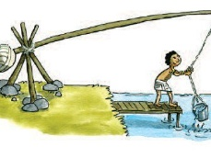  Design, Make and Evaluate  How did the Egyptians take clean water from the Nile? |  | Labyrinth/ Greek Food  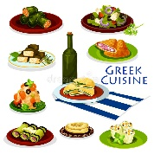  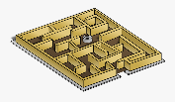  Design, Make and Evaluate  Cooking and Nutrition  What was the purpose of a labyrinth? |  | Roman Draw String Bag/ Roman coins  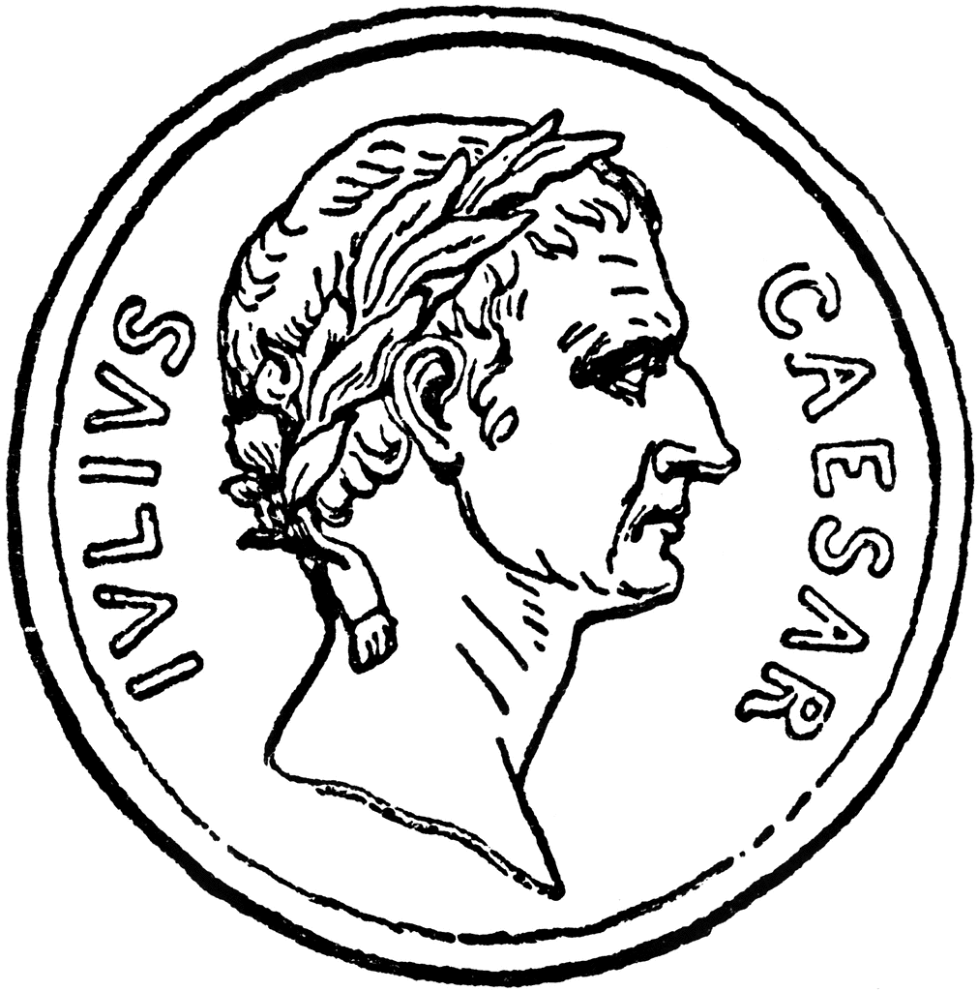  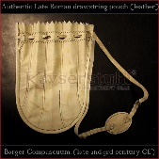  Design, Make and Evaluate  Where do you keep your money?
Year 5 | Saxon Shields  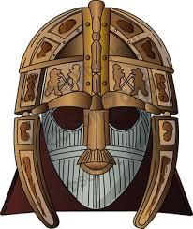  Design, Make and Evaluate  What were the reasons behind shield designs? |  | Volcanic Eruptions/ Roman Bread  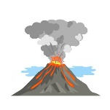  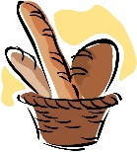  Design, Make and Evaluate  Cooking and Nutrition  How can we incorporate a pneumatic mechanism into our design? |  | Brunel’s Bridges  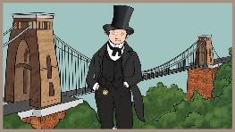  Design, Make and Evaluate  How can we take inspiration from others?
Year 6 | Electrical Systems  Design, Make and Evaluate  How could we create a circuit to power a lighthouse from a sustainable power source? |  | Investigate Architecture/ Mayan Food  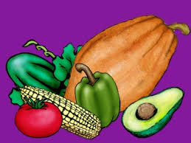  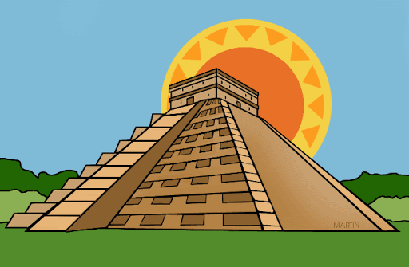  Design, Make and Evaluate  Cooking and Nutrition  How does the structure of a Mayan temple link to the Mayan religion?  What did the Maya eat? Where can these items/dishes be found today? |  | Sandals  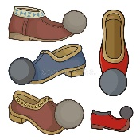  Design, make and Evaluate  What factors would an Ancient Greek sandal designer have to consider?

Year 3

 | Autumn |  | Spring |  | Summer
 | Autumn 1 | Autumn 2 | Spring 1 | Spring 2 | Summer 1 | Summer 2
Overview | Where does food come from?  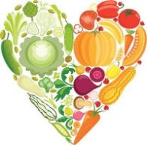 |  | Outdoor Shelters |  | Beach Bags
Suggested Content and Outcome | What does healthy eating look like?  How do we make a balanced meal?  What are local ingredients?  To develop a love of cooking and apply the principles of nutrition. |  | What is the purpose of your shelter?  Which materials will you select?  How will you make your structure?  To create a shelter that can support itself and protect from the elements. |  | What will your bag need to carry?  What will you put on your design?  How will you carry your bag?  How will it fasten?  To create a functional bag in accordance with the given criteria and apply their knowledge to evaluate based on function and aesthetic qualities.
Key Vocab | Nutrition, healthy, balanced, local ingredients |  | Design, Make, Evaluate, Technical Knowledge, Cutting, shaping, joining, finishing, materials, components, construction |  | Cutting, shaping, joining, finishing, materials, components, construction, textiles, function, aesthetic qualities.
National Curriculum Programme of Study
Design |  |  | Use research and develop design criteria to inform the design of innovative, functional, appealing products that are fit for purpose, aimed at particular individuals or groups. |  | Use research and develop design criteria to inform the design of innovative, functional, appealing products that are fit for purpose, aimed at particular individuals or groups.
Make |  |  | Select from and use a wider range of materials and components, including construction materials, textiles and ingredients, according to their functional properties and aesthetic qualities |  | Select from and use a wider range of tools and equipment to perform practical tasks [for example, cutting, shaping, joining and finishing], accurately
Evaluate |  |  | Evaluate their ideas and products against their own design criteria and consider the views of others to improve their work. |  | Investigate and analyse a range of existing products  Evaluate their ideas and products against their own design criteria and consider the views of others to improve their work
Technical Knowledge | Understanding where food comes from. To understand and apply the principles of nutrition and know how to cook. |  | Apply their understanding of how to strengthen, stiffen and reinforce more complex structures |  | Understand and use mechanical systems in their products.
Cooking and nutrition | Understand and apply the principles of a healthy and varied diet.
Year 4
 | Autumn |  | Spring |  | Summer
 | Autumn 1 | Autumn 2 | Spring 1 | Spring 2 | Summer 1 | Summer 2
Overview | Egyptian Shaduf |  | Labyrinth/ Greek Food |  | Roman Draw String Bag/ Roman coins
Suggested Content and Outcome | How did the Egyptians take clean water from the Nile?  To design, model and make a Shaduf |  | What is the purpose of a labyrinth?  What will you need to create your labyrinth?  Work out how many pieces of each length of barrier you will need. |  | Where do you keep your money?  What do you keep it in?  What is it like?  Design and make a simple Roman coin purse using a series of simple steps.
 |  |  | What key ingredients will you need to make a flatbread?  Could you add a modern twist to it?  What tools or equipment will you need? |  | How do you think you could make a purse like this?  How will your embroidery look?  How could I improve the design?  Design a Roman coin.
Key Vocab | Design, Make, Evaluate, Technical Knowledge. |  | Design, Make, Evaluate, Technical Knowledge. Cutting, shaping, joining, finishing, materials, components, construction |  | Design, Make, Evaluate, Technical Knowledge.
National Curriculum Programme of Study
Design | Design purposeful, functional, appealing products for themselves and other users based on design criteria. |  | Use research and develop design criteria to inform the design of innovative, functional, appealing products that are fit for purpose, aimed at particular individuals or groups. |  | Use research and develop design criteria to inform the design of innovative, functional, appealing products that are fit for purpose, aimed at particular individuals or groups.
Make | Select from and use a wider range of materials and components, including construction materials, textiles and ingredients, according to their functional properties and aesthetic qualities. |  | Select from and use a wider range of tools and equipment to perform practical tasks. |  | Select from and use a wider range of materials and components, including construction materials, textiles and ingredients, according to their functional properties and aesthetic qualities.
Evaluate | Evaluate their ideas and products against their own design criteria and consider the views of others to improve their work. |  | Evaluate their ideas and products against their own design criteria and consider the views of others to improve their work. |  | Evaluate their ideas and products against their own design criteria and consider the views of others to improve their work.
Technical Knowledge | Understand and use mechanical systems in their products [for example, gears, pulleys, cams, levers and linkages]. |  | Build structures, exploring how they can be made stronger, stiffer and more stable.
Cooking and nutrition |  |  | Prepare and cook a variety of predominantly savoury dishes using a range of cooking techniques

Year 5

 | Autumn |  | Spring |  | Summer
 | Autumn 1 | Autumn 2 | Spring 1 | Spring 2 | Summer 1 | Summer 2
Overview | Saxon Shields |  | Volcanic Eruptions/ Roman Bread |  | Brunel’s Bridges  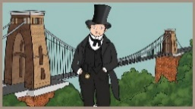
Suggested Content and Outcome | What were the reasons behind shield designs?  Design and create shield to a specific criteria. |  | How can we improve our designs?  Create a working model volcano. |  | How can we overcome challenges in the design process?  How can we take inspiration from others?  Create a bridge using a range of resources inspired by Brunel.
 |  |  | Make Roman Spelt bread
Key Vocab | Evaluate, Prototype. Designs.  Exploded diagram |  | Pneumatic, air pressure, vent, mechanism, model, cross section |  | Create, test, modify and store instructions to control events, e.g., enter and store instructions
National Curriculum Programme of Study
Design | Use research and develop design criteria to inform the design of innovative, functional, appealing products that are fit for purpose. |  | Generate, develop, model and communicate their ideas through discussion, annotated sketches, cross-sectional and exploded diagrams, prototypes, pattern pieces and computer-aided design. |  | Use research and develop design criteria to inform the design of innovative, functional, appealing products that are fit for purpose.
Make | Select from and use a wider range of materials and components, including construction materials, textiles and ingredients, according to their functional properties and aesthetic  Qualities. |  | Select from and use a wider range of materials and components, including construction materials, textiles and ingredients, according to their functional properties and aesthetic qualities. |  | Select from and use a wider range of materials and components, including construction materials, textiles and ingredients, according to their functional properties and aesthetic  qualities.
Evaluate | Understand how key events and individuals in design and technology have helped shape the world. |  | Investigate and analyse a range of existing products. |  | Understand how key events and individuals in design and technology have helped shape the world.
Technical Knowledge |  |  | Learn techniques for making simple pneumatic systems. |  | Apply their understanding of how to strengthen, stiffen and reinforce more complex structures.
Cooking and nutrition |  |  | Prepare and cook a variety of predominantly savoury dishes using a range of cooking techniques.

Year 6
 | Autumn |  | Spring |  | Summer
 | Autumn 1 | Autumn 2 | Spring 1 | Spring 2 | Summer 1 | Summer 2
Overview | Electrical Systems |  | Investigate Architecture/ Mayan Food |  | Sandals
Suggested Content | How could we create a circuit to power a lighthouse from a sustainable power source?  Create a working circuit that uses hydropower (a dynamo which produces current from the flow of water) and fit it inside lighthouse housing. |  | How does the structure of a Mayan temple link to the Mayan religion?  Construct a prototype of a Mayan temple, considering the shape, structure and joints used. |  | What factors would an Ancient Greek sandal designer have to consider?  Create Ancient Greek sandals that fit and are durable.
What did the Maya eat? Where can these items/dishes be found today?
Research Maya food, and make and cook tortillas.
Key Vocab | Evaluate, Analyse, Critique, Reinforce, Strengthen, Triangular |  | Construct, Structure, Model  Prototype, Joint, Mitre, Savoury, Knead, Nutrition |  | Sole, Upper, Insole, Heel, Materials  Construction
National Curriculum Programme of Study
Design | Use research and develop design criteria to inform the design of innovative, functional, appealing products that are fit for purpose, aimed at particular individuals or groups |  | Use research and develop design criteria to inform the design of innovative, functional, appealing products that are fit for purpose, aimed at particular individuals or groups. |  | Use research and develop design criteria to inform the design of innovative, functional, appealing products that are fit for purpose, aimed at particular individuals or groups.
Make | Select from and use a wider range of materials and components, including construction materials, textiles and ingredients, according to their functional properties and aesthetic qualities |  | Select from and use a wider range of tools and equipment to perform practical tasks [for example, cutting, shaping, joining and finishing], accurately. |  | Select from and use a wider range of materials and components, including construction materials, textiles and ingredients, according to their functional properties and aesthetic qualities.
Evaluate | Investigate and analyse a range of existing products.  Evaluate their ideas and products against their own design criteria and consider the views of others to improve their work. |  | Understand how key events and individuals in design and technology have helped shape the world. |  | Evaluate their ideas and products against their own design criteria and consider the views of others to improve their work.  Understand how key events and individuals in design and technology have helped shape the world.
Technical Knowledge | Understand and use electrical systems in their products [for example, series circuits incorporating switches, bulbs, buzzers and motors] |  | Apply their understanding of how to strengthen, stiffen and reinforce more complex structures |  | Apply their understanding of how to strengthen, stiffen and reinforce more complex structures.
Cooking and nutrition |  |  | Prepare and cook a variety of predominantly savoury dishes using a range of cooking techniques.

