Computing
Curriculum

Computing Overview
 | Autumn |  | Spring |  | Summer
 | Autumn 1 | Autumn 2 | Spring 1 | Spring 2 | Summer 1 | Summer 2
Year 3 | 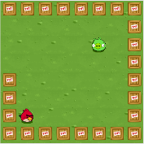  Coding:  Basic Programming  (Course B) | Word Processing Skills | 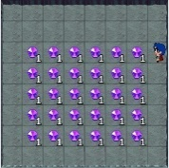  Coding:  Basic Sequencing  (Course B) | Presentation Skills | 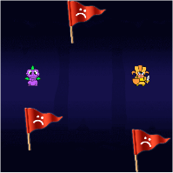  Coding:  Basic Loops  (Course B) | Internet Research and Communication
Year 4 | Coding: Sequencing  (Course C) | Word Processing | 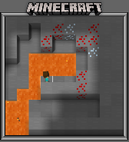  Coding: Loops and Events  (Course C) | Scratch Questions and Quizzes | 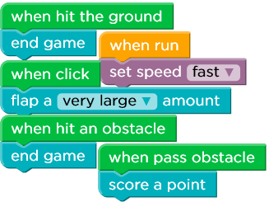  Coding: Binary & Story Creation  (Course C) | Animation
Year 5 | 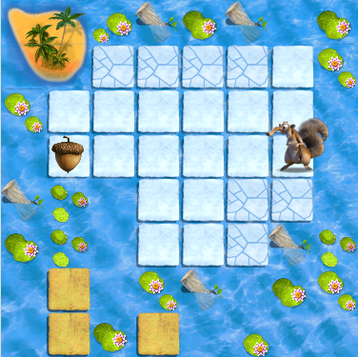  Coding: Loops  (Course D) | Internet Research and Webpage Development | 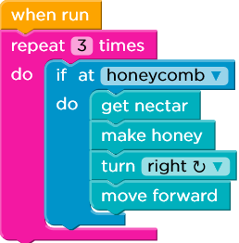  Coding: Conditionals  (Course D) | Radio Station | 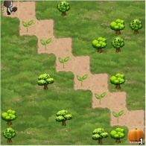  Coding: Events and Game Creation  (Course D) | 3D Modelling Sketch Up
Year 6 | 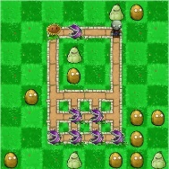  Coding: Debugging & Spite Lab  (Course E) | Spreadsheets | 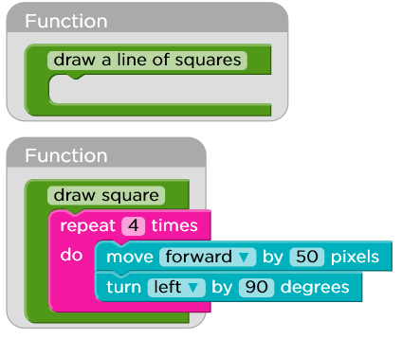  Coding: Functions  (Course E) | Film-making | 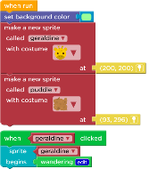  Coding: Capstone Project  (Course E) | Scratch Animated Stories

Year 3
 | Autumn |  | Spring |  | Summer
 | Autumn 1 | Autumn 2 | Spring 1 | Spring 2 | Summer 1 | Summer 2
Overview | Coding:  Basic Programming  (Course B) | Word Processing Skills | Coding:  Basic Sequencing  (Course B) | Presentation Skills | Coding:  Basic Loops  (Course B) | Internet Research and Communication
Suggested Content | Pupils to access Code.org accounts.  Suitable for pre-readers.  Pupils learn the basics of computer science and internet safety. At the end of the course, they create their very own game or story they can share.  Online Safety links:  *'Your digital footprint'  *'It's great to create and play fair.  Online Safety focus: see ‘Google Be Internet Legends’ scheme of work. | Children will learn basic processing skills such as  specific typing and layout skills, changing case, taking screenshots, using bullets and numbering, using advanced select, using text boxes and creating passwords. | Pupils to access Code.org accounts.  Suitable for pre-readers.  Pupils learn the basics of computer science and internet safety. At the end of the course, they create their very own game or story they can share.  Online Safety links:  *'Your digital footprint'  *'It's great to create and play fair.  Online Safety focus: see ‘Google Be Internet Legends’ scheme of work. | Using presentation applications such as Microsoft Powerpoint, pupils will create an animated story that uses design themes, transitions, action settings and audio. | Pupils to access Code.org accounts.  Suitable for pre-readers.  Pupils learn the basics of computer science and internet safety. At the end of the course, they create their very own game or story they can share.  Online Safety links:  *'Your digital footprint'  *'It's great to create and play fair.  Online Safety focus: see ‘Google Be Internet Legends’ scheme of work. | Through safe, supervised exploration online, pupils will understand concepts of searching the Internet such as the importance of word order, order of returned results, and saving and sharing online. Through investigation, they will also learn about how we can communicate online.
Key Vocab | Algorithm, program, sequence, code, command, bug/debug, loops, input/output, run, repeat, username/password, Wi-Fi. | Caps lock, keyboard, document, save, edit, file, design, layout, cursor, format, landscape, portrait, A4, A3, scroll, zoom. | Algorithm, program, sequence, code, command, bug/debug, loops, input/output, run, repeat, username/password, Wi-Fi. | Transition, animate, affect caps lock, keyboard, document, save, edit, file, design, layout, cursor, format, landscape, portrait, A4, A3, scroll, zoom, wordwrap, ruler, tab, tabulation, selection bar, print layout, edit, draft, double click, default, onion-skinning. | Algorithm, program, sequence, code, command, bug/debug, loops, input/output, run, repeat, username/password, Wi-Fi. | Browser, webpage, Internet Explorer, Chrome, Microsoft Edge, Safari, HTTP and HTTPS (Hypertext Transfer Protocol Secure), email, spam, social media, download, upload, firewall, filtering, phishing, blogs.
Links to N.C. 2014 | Design, write & debug programs to accomplish specific goals, including controlling/simulating physical systems; solve problems through decomposition, selection & repetition. Work with variables & forms of input/output. Use logical reasoning to explain simple algorithms, & detect & correct errors. | Use technology safely, respectfully and responsibly. Select, use and combine a variety of software on digital devices to design/create programs, systems and content that accomplish goals. | Design, write & debug programs to accomplish specific goals, including controlling/simulating physical systems; solve problems through decomposition, selection & repetition. Work with variables & forms of input/output. Use logical reasoning to explain simple algorithms, & detect & correct errors. | Use technology safely, respectfully and responsibly. Select, use and combine a variety of software on digital devices to design/create programs, systems and content that accomplish goals. | Design, write & debug programs to accomplish specific goals, including controlling/simulating physical systems; solve problems through decomposition, selection & repetition. Work with variables & forms of input/output. Use logical reasoning to explain simple algorithms, & detect & correct errors. | Use search technologies effectively, appreciate how  results are selected and ranked, and be discerning in  evaluating digital content.  Use technology safely, respectfully and responsibly;  recognise acceptable/unacceptable behaviour; identify  a range of ways to report concerns about content and  contact.

Year 4
 | Autumn |  | Spring |  | Summer
 | Autumn 1 | Autumn 2 | Spring 1 | Spring 2 | Summer 1 | Summer 2
Overview | Coding: Sequencing  (Course C) | Word Processing | Coding: Loops and Events  (Course C) | Scratch Questions and Quizzes | Coding: Binary & Story Creation  (Course C) | Animation
Suggested Content | Pupils to access Code.org accounts.  Pupils create programs with sequencing, loops, and events. Pupils translate their initials into binary, investigate different problem-solving techniques, and learn how to respond to cyberbullying. At the end of the course, pupils create their very own game or story they can share.  Online Safety links:  *'Screen out the mean'.  Online Safety focus: see ‘Google Be Internet Legends’ scheme of work. | Through creating a poster, a letter to parents and/or rota for a cake sale, pupils will recap basic processing skills such as: selecting, editing manipulate text in different ways; inserting images; using formatting tools; inserting simple tables; changing the page size; suggest improvements; add/delete rows and learn to type at an appropriate speed. More advanced skills include formatting borders, changing the background colour, formatting and insert hyperlinks. | Pupils to access Code.org accounts.  Pupils create programs with sequencing, loops, and events. Pupils translate their initials into binary, investigate different problem-solving techniques, and learn how to respond to cyberbullying. At the end of the course, pupils create their very own game or story they can share.  Online Safety links:  *'Screen out the mean'.  Online Safety focus: see ‘Google Be Internet Legends’ scheme of work. | Pupils will create quiz questions through use of Pyonkee (iPad Scratch equivalent) which will allow them to further apply their understanding of designing, writing coding, debugging a program as well as using repetition and selection, combining different effects and decompose it. | Pupils to access Code.org accounts.  Pupils create programs with sequencing, loops, and events. Pupils translate their initials into binary, investigate different problem-solving techniques, and learn how to respond to cyberbullying. At the end of the course, pupils create their very own game or story they can share.  Online Safety links:  *'Screen out the mean'.  Online Safety focus: see ‘Google Be Internet Legends’ scheme of work. | Through use of Powerpoint, pupils will create an animation linked to their curriculum theme. Slides will be copied, pasted and adjusted slightly over numerous slides to create the animation effect (i.e. a ‘stop-motion’ animation) when slides are transitioned at high speed. Pupils will evaluate the pros and cons of the animation software.
Key Vocab | Algorithm, program, sequence, code, command, bug/debug, loops, input/output, run, repeat, username/password, Wi-Fi, workspace, URL, servers, search engine, online/offline, Internet, if-statement, drag/drop, decompose, call, data. | Caps lock, keyboard, document, save, edit, file, design, layout, cursor, format, landscape, portrait, A4, A3, scroll, zoom, wordwrap, ruler, tab, tabulation, selection bar, print layout, edit, draft, double click, default. | Algorithm, program, sequence, code, command, bug/debug, loops, input/output, run, repeat, username/password, Wi-Fi, workspace, URL, servers, search engine, online/offline, Internet, if-statement, drag/drop, decompose, call, data. | Algorithm, program, sequence, code, command, bug/debug, loops, input/output, run, repeat, username/password, Wi-Fi, workspace, URL, servers, search engine, online/offline, Internet, if-statement, drag/drop, decompose, call, data. | Algorithm, program, sequence, code, command, bug/debug, loops, input/output, run, repeat, username/password, Wi-Fi, workspace, URL, servers, search engine, online/offline, Internet, if-statement, drag/drop, decompose, call, data. | Transition, animate, affect caps lock, keyboard, document, save, edit, file, design, layout, cursor, format, landscape, portrait, A4, A3, scroll, zoom, wordwrap, ruler, tab, tabulation, selection bar, print layout, edit, draft, double click, default, onion-skinning.
Links to N.C. 2014 | Design, write & debug programs to accomplish specific goals, including controlling/simulating physical systems; solve problems through decomposition, selection & repetition. Work with variables & forms of input/output. Use logical reasoning to explain simple algorithms, & detect & correct errors. | Select, use and combine a variety of software on a range of digital  devices to design a range of programs, systems and content that  accomplish specific goals. | Design, write & debug programs to accomplish specific goals, including controlling/simulating physical systems; solve problems through decomposition, selection & repetition. Work with variables & forms of input/output. Use logical reasoning to explain simple algorithms, & detect & correct errors. | Create content that accomplish given goals. Solve  problems by decomposing them into smaller parts. Design, write and debug programs that accomplish specific goals. Use sequence and selection in programs. Work with variables. | Design, write & debug programs to accomplish specific goals, including controlling/simulating physical systems; solve problems through decomposition, selection & repetition. Work with variables & forms of input/output. Use logical reasoning to explain simple algorithms, & detect & correct errors. | Analyse, evaluate and present data and information. Use a variety of software to design and create content  that accomplish given goals. Select, use and combine a variety of software including  analysing, evaluating and presenting data and information.

Year 5 | Autumn |  | Spring |  | Summer
 | Autumn 1 | Autumn 2 | Spring 1 | Spring 2 | Summer 1 | Summer 2
Overview | Coding: Loops  (Course D) | Internet Research and Webpage Development | Coding: Conditionals  (Course D) | Radio Station | Coding: Events and Game Creation  (Course D) | 3D Modelling Sketch Up
Suggested Content | Pupils to access Code.org accounts.  Students develop their understanding of nested loops, conditionals, and events. Beyond coding, students learn about digital citizenship.  Online Safety links:  *'Digital citizenship'  Online Safety focus: see ‘Google Be Internet Legends’ scheme of work. | In this unit, pupils will identify the context of a webpage, understand the layout of a Google website, understand context of images, hyperlinks and how to publish a webpage. | Pupils to access Code.org accounts.  Students develop their understanding of nested loops, conditionals, and events. Beyond coding, students learn about digital citizenship.  Online Safety links:  *'Digital citizenship’  Online Safety focus: see ‘Google Be Internet Legends’ scheme of work.' | Children will use a recording software such as Audacity to combine existing sounds with their own unique voice content to create sounds in the style of a radio jingle as well as planning and recording podcasts, understanding advertising features and design their own as part of their podcast/radio station, and present to their peers. | Pupils to access Code.org accounts.  Students develop their understanding of nested loops, conditionals, and events. Beyond coding, students learn about digital citizenship.  Online Safety links:  *'Digital citizenship'  Online Safety focus: see ‘Google Be Internet Legends’ scheme of work. | Using apps such as SketchUp, pupils will draw, manipulate and add detail to 3D shapes such as furniture and create their own 3D furniture models.
Key Vocab | Algorithm, program, sequence, code, command, bug/debug, loops, input/output, run, repeat, username/password, Wi-Fi, workspace, URL, servers, search engine, online/offline, Internet, if-statement, drag/drop, decompose, call, data, computational thinking, abstraction, binary, binary alphabet, bit, block-based programming, byte, computer science. | URL (Uniform Resource Locators), IP (Internet Protocol) address, malware (malicious software), browser, webpage, Internet Explorer, Chrome, Microsoft Edge, Safari, HTTP and HTTPS (Hypertext Transfer Protocol Secure), email, spam, social media, download, upload, firewall, filtering, phishing, blogs. | Algorithm, program, sequence, code, command, bug/debug, loops, input/output, run, repeat, username/password, Wi-Fi, workspace, URL, servers, search engine, online/offline, Internet, if-statement, drag/drop, decompose, call, data, computational thinking, abstraction, binary, binary alphabet, bit, block-based programming, byte, computer science. | Record, jingle, podcast, cut, cue, distortion, fade in/out, mic, script, volume, splice, compressor, EQ (equaliser), interface, mixer, noisefloor, submit, upload, USB, bitrate, amplitude, back-up, glitch, Hertz, hum, sync, synthesis. | Algorithm, program, sequence, code, command, bug/debug, loops, input/output, run, repeat, username/password, Wi-Fi, workspace, URL, servers, search engine, online/offline, Internet, if-statement, drag/drop, decompose, call, data, computational thinking, abstraction, binary, binary alphabet, bit, block-based programming, byte, computer science. | 3D, model, faces, edges, vertices, vertex, topology, pivot, pivot point, construct, push/pull, bridge, CGI (Computer Generated Imagery), clone, CAD (Computer Aided Design).
Links to N.C. 2014 | Design, write & debug programs to accomplish specific goals, including controlling/simulating physical systems; solve problems through decomposition, selection & repetition. Work with variables & forms of input/output. Use logical reasoning to explain simple algorithms, & detect & correct errors. | Use search technologies effectively, appreciate how  results are selected and ranked, and be discerning in  evaluating digital content. Select, use and combine a variety of software on digital devices to design/create programs, systems and content that accomplish goals. | Design, write & debug programs to accomplish specific goals, including controlling/simulating physical systems; solve problems through decomposition, selection & repetition. Work with variables & forms of input/output. Use logical reasoning to explain simple algorithms, & detect & correct errors. | Select, use and combine a variety of software on a range  of digital devices to create content that accomplish given  goals, including collecting, analysing, evaluating and  presenting data and information. | Design, write & debug programs to accomplish specific goals, including controlling/simulating physical systems; solve problems through decomposition, selection & repetition. Work with variables & forms of input/output. Use logical reasoning to explain simple algorithms, & detect & correct errors. | Select, use and combine a variety of software on digital devices to design/create programs, systems and content that accomplish goals, including collecting, analysing, evaluating and presenting data and information.

Year 6
 | Autumn |  | Spring |  | Summer
 | Autumn 1 | Autumn 2 | Spring 1 | Spring 2 | Summer 1 | Summer 2
Overview | Coding: Debugging & Spite Lab  (Course E) | Spreadsheets | Coding: Functions  (Course E) | Film-making | Coding: Capstone Project  (Course E) | Scratch Animated Stories
Suggested Content | Pupils to access Code.org accounts.  In this part of course E, pupils recap and practise debugging and Sprite creation to support them in designing and creating a capstone project they can share with their friends.  Online Safety links:  *'Private and personal information'  *'Digital sharing'  Online Safety focus: see ‘Google Be Internet Legends’ scheme of work. | Children are given an understanding of spreadsheets and how they can be used. Children learn skills in formatting and entering specific formulas as well as investigative  skills in using a spreadsheet to solve specific problems. Examples include number calculations, sports league tables, test scores, and budget planning. Pupils can design their own spreadsheet, with ideas and direction  provided for particular purposes. | Pupils to access Code.org accounts.  In this part of course E, pupils practice using functions to then be able to design and create a capstone project they can share with their friends.  Online Safety links:  *'Private and personal information'  *'Digital sharing'  Online Safety focus: see ‘Google Be Internet Legends’ scheme of work. | Children will explore various aspects of film-making. They must choose and use appropriate  software in order to complete tasks such as writing a script, researching information, filming and editing. As well as using digital devices  for recording (video camera or tablet), children work through pre- and post-production stages, planning good-quality interviews for a  documentary and completing the process with use of video editing software. | Pupils to access Code.org accounts.  In this part of course E, pupils design and create a capstone project they can share with their friends.  Online Safety links:  *'Private and personal information'  *'Digital sharing'  Online Safety focus: see ‘Google Be Internet Legends’ scheme of work. | This unit is designed to help children in continuing to develop their skills in writing their own algorithms as well as editing and debugging  existing codes. New skills are introduced to structure code and animate characters and scenes, gradually building to create a short  animated story. These lessons are intended for use in conjunction with Pyonkee (iPad Scratch equivalent) software installed.
Key Vocab | Algorithm, program, sequence, code, command, bug/debug, loops, input/output, run, repeat, username/password, Wi-Fi, workspace, URL, servers, search engine, online/offline, Internet, if-statement, drag/drop, decompose, call, data, computational thinking, abstraction, binary, binary alphabet, bit, block-based programming, byte, computer science, crowd sourcing, cyberbullying, conditionals, functions, DSL/cable, event, event handler, iteration, nested loops, parameter, toolbox. | Spreadsheet, formulae, cell, active/inactive cell, cell name, data, column, row, enter key, fill, filter, freezing columns/rows, gridlines, labels, name box, sheet tabs, Tab key, values, workbook, worksheet. | Algorithm, program, sequence, code, command, bug/debug, loops, input/output, run, repeat, username/password, Wi-Fi, workspace, URL, servers, search engine, online/offline, Internet, if-statement, drag/drop, decompose, call, data, computational thinking, abstraction, binary, binary alphabet, bit, block-based programming, byte, computer science, crowd sourcing, cyberbullying, conditionals, functions, DSL/cable, event, event handler, iteration, nested loops, parameter, toolbox. | Camera, production, filter, zoom, lens, special effects, lighting (natural, hard, fill) glare, shot, viewpoint, focal length, camera angle, time-lapse, close/medium/wide angle, background, picture composition, perspective, take. | Algorithm, program, sequence, code, command, bug/debug, loops, input/output, run, repeat, username/password, Wi-Fi, workspace, URL, servers, search engine, online/offline, Internet, if-statement, drag/drop, decompose, call, data, computational thinking, abstraction, binary, binary alphabet, bit, block-based programming, byte, computer science, crowd sourcing, cyberbullying, conditionals, functions, DSL/cable, event, event handler, iteration, nested loops, parameter, toolbox. | Algorithm, program, sequence, code, command, bug/debug, loops, input/output, run, repeat, username/password, Wi-Fi, workspace, URL, servers, search engine, online/offline, Internet, if-statement, drag/drop, decompose, call, data, computational thinking, abstraction, binary, binary alphabet, bit, block-based programming, byte, computer science, crowd sourcing, cyberbullying, conditionals, functions, DSL/cable, event, event handler, iteration, nested loops, parameter, toolbox.
Links to N.C. 2014 | Design, write & debug programs to accomplish specific goals, including controlling/simulating physical systems; solve problems through decomposition, selection & repetition. Work with variables & forms of input/output. Use logical reasoning to explain simple algorithms, & detect & correct errors. | Select, use and combine a variety of software (including internet  services) on a range of digital devices to design and create a  range of programs, systems and content that accomplish given  goals, including collecting, analysing, evaluating and presenting  data and information | Design, write & debug programs to accomplish specific goals, including controlling/simulating physical systems; solve problems through decomposition, selection & repetition. Work with variables & forms of input/output. Use logical reasoning to explain simple algorithms, & detect & correct errors. | Understand computer networks including the internet  and the opportunities they offer for communication  and collaboration. Use search technologies effectively, appreciate how  results are selected and ranked, and be discerning in  evaluating digital content. | Design, write & debug programs to accomplish specific goals, including controlling/simulating physical systems; solve problems through decomposition, selection & repetition. Work with variables & forms of input/output. Use logical reasoning to explain simple algorithms, & detect & correct errors. | Design, write and debug programs that accomplish specific  goals, including controlling or simulating physical systems;  solve problems by decomposing them into smaller parts.  Use sequence, selection, and repetition in programs; work  with variables and various forms of input and output.  Use logical reasoning to explain how some simple  algorithms work and to detect and correct errors in  algorithms and programs.

